**WISE-EC FAQ**

|  |  |  |  |
| --- | --- | --- | --- |
| **Category** | WISE-EC | **Date** | 2018/04/18 |
| **Keyword** | WISE-1510,mbed compiler, compiler error, window OS | | |

* **Question:**

How to solve compiling error when compiling wise-1510 SDK ?

* **Error:**

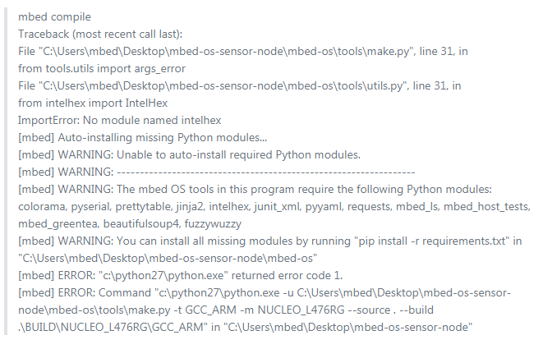

* **Instructions :**

Step 1

Install following command one by one to install missing packet

pip install mbed-cli IntelHex jinja2 bs4 fuzzywuzzy prettytable colorama pyserial junit_xml pyyaml requests mbed_ls

pip install setuptools_scm

pip install mbed-host-tests

pip intall mbed-greentea

Step 2

Execute “make.sh” script file to compile again,then you will see the procedure will proceed until generating image file.

