**Technical Document**

|  |  |  |  |
| --- | --- | --- | --- |
| **Category** | WISE-PaaS/OTA | **Date** | 2017/12/27 |
| **Topic** | How to create and setup FTP server for OTA server with FileZilla?  (FileZilla Server currently only supports Windows OS) | | |
| **Keyword** | OTA, OTA server 3.0.9, FTP server, FileZilla, Windows | | |

* **Suggestion:**

Instructions in this FAQ will walk you through on how to setup FTP server for OTA server with FileZilla (3rd party software) to store software packages. *FileZilla FTP server could be created on the same PC where OTA server was installed or on other PCs*

**Step 1: Download and Install FileZilla Server on the PC you’d like it to be FTP server**

Step 1-1:

Go to <https://filezilla-project.org/download.php?type=server> and download latest FileZilla Server

(Please note the version shown in screenshot may vary by the time you see this document)

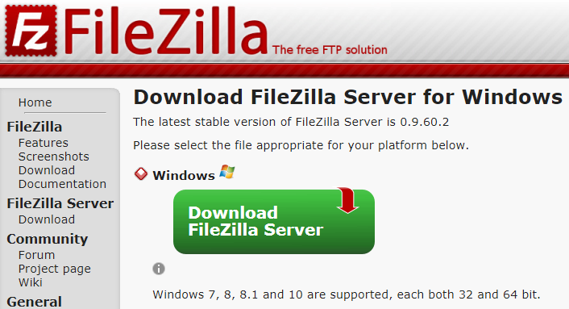

Step 1-2: Install FileZilla Server (following default setting will suffice)

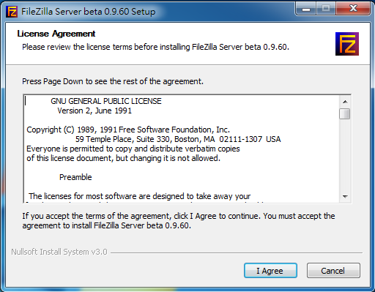

**Step 2: Configure FileZilla Server**

Step 2-1: Upon seeing window pop out after launching FileZilla, click “Connect”

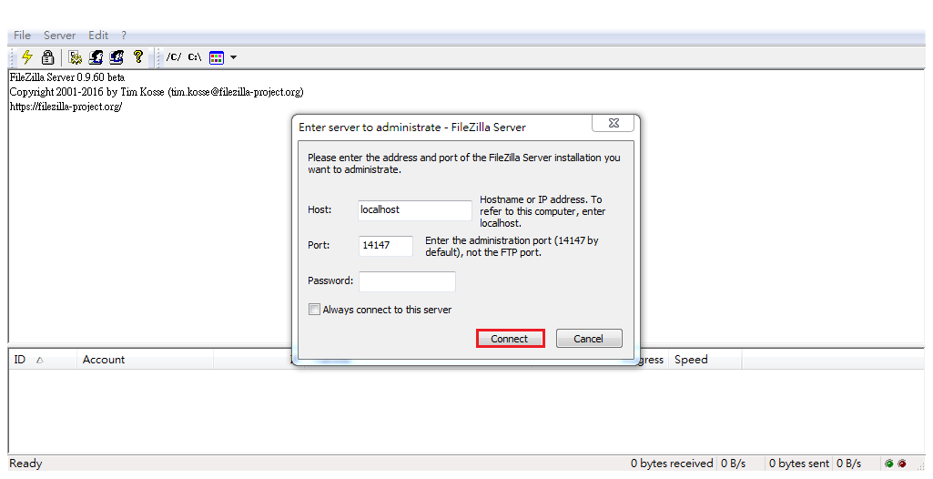

Step 2-2: “Edit” tab 🡪 “Users”

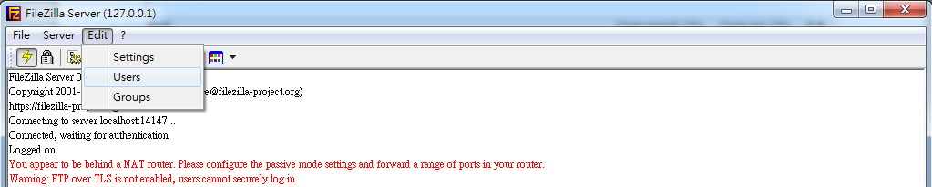

Step 2-3: Select “General” in the left box, then click “Add” on the right hand to create user account

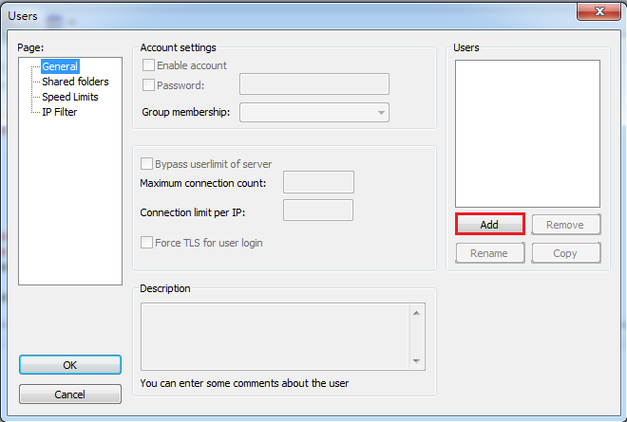

Step 2-4: enter username for the account you’re creating then click “OK” to proceed

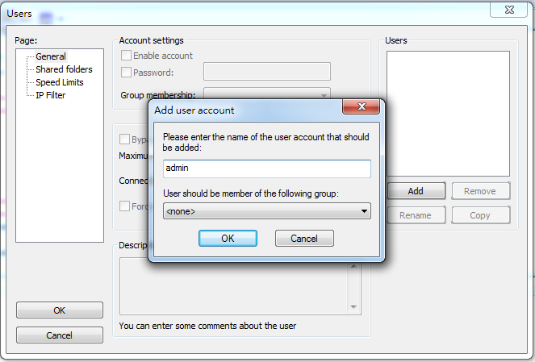

Step 2-5: Check “Password” box and enter password for this account in the blank

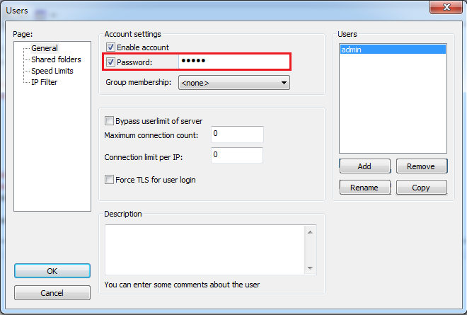

Step 2-6: Choose “Shared folders” on the left, then click “Add” to define shared folders

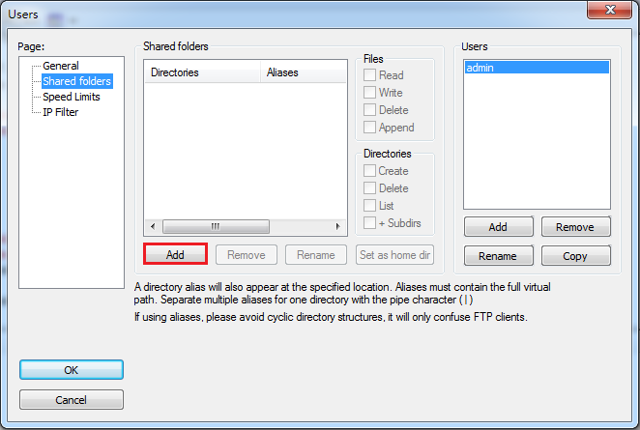

Step 2-7:

Choose the location of the folder that packages are to be stored, then click “Ok” to proceed

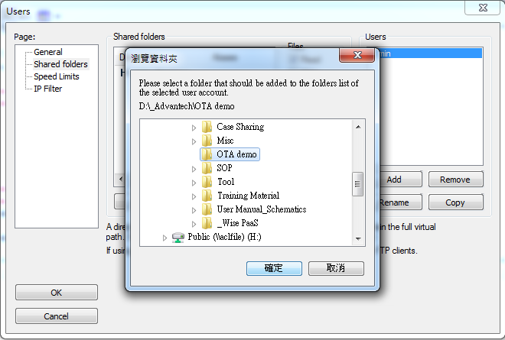

Step 2-8:

Check Files and Directories permissions accordingly (*you have to at least check “Write” box in Files otherwise you packages won’t be able to be uploaded due to lack of permission*) the click “OK” to close the configuration window.

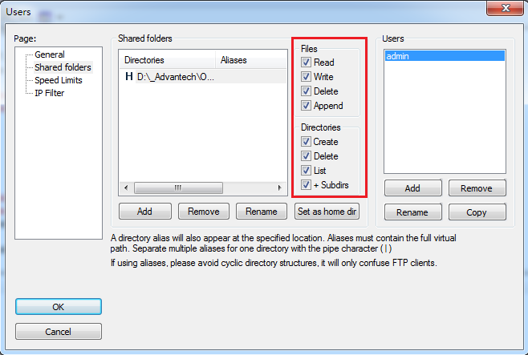

**Step 3: Create FTP Storage on OTA Server Web Console**

Step 3-1: Launch browser and login OTA server

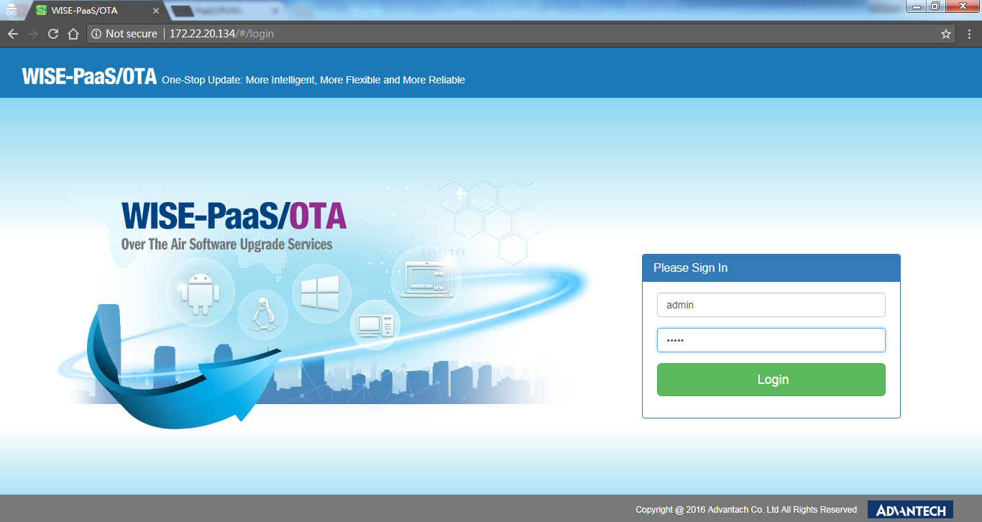

Step 3-2: Click “Storage” on the left pane and click “Add” to add storage

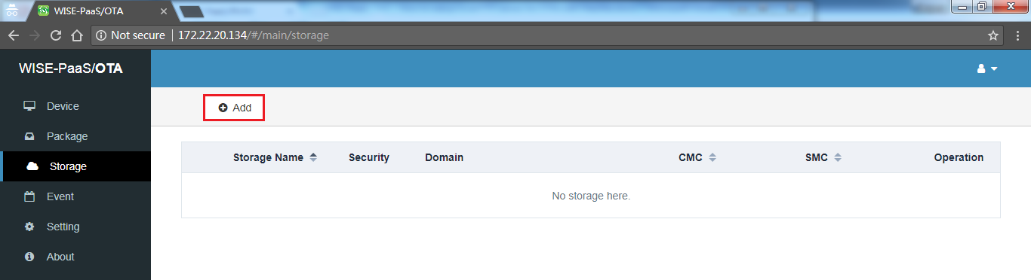

Step 3-3:

Enter storage information

**Storage name** 🡪 name of your storage

**Security** 🡪 default is “NONE”, FTPS or FTPES can be selected if FTP server side is setup accordingly

**Domain** 🡪 IP or URL of the FTP server (if it’s local, enter 127.0.0.1 otherwise enter its addres)

**Port** 🡪 21

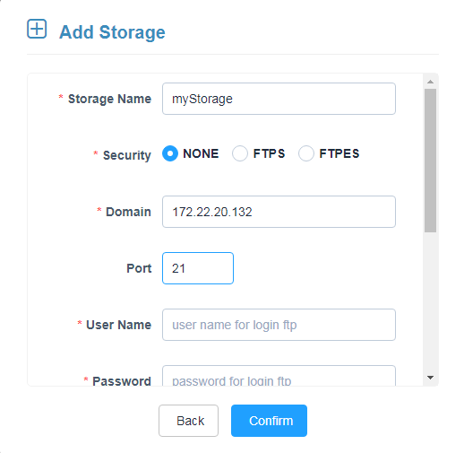

**Username**: enter the username created in Step 2-4

**Password**: enter the password created in Step 2-5

**Root path**: leaving the “/” slash mark meaning the package will be uploaded and stored in the directory you selected in Step 2-7

**CMC**: Client-side maximum connections

**SMC**: Server-side maximum connections

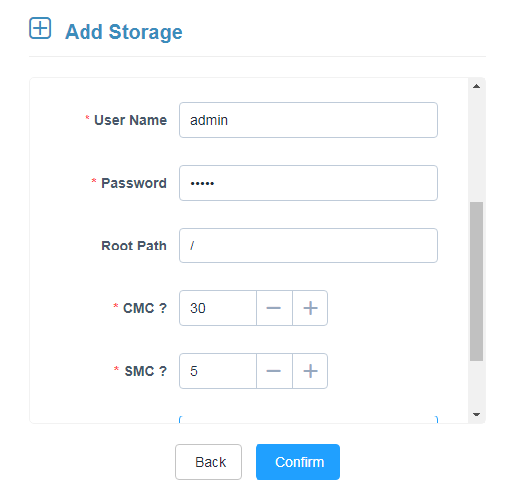

Step 3-4:

After clicking “Confirm” you will see “Success” window followed storage info and details that we just created



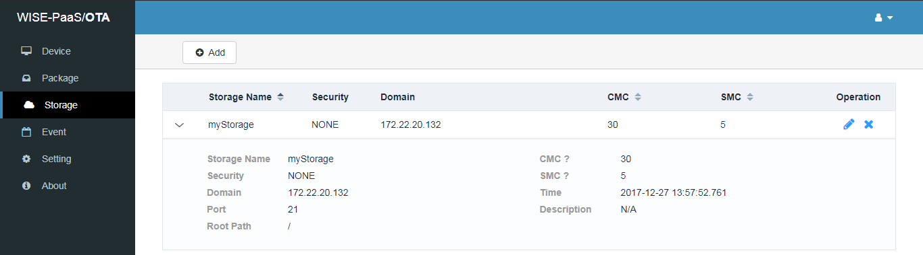

**Step 4: Upload Package on FTP (Storage) Server**

Step 4-1: Click “Package” on the left pane and click “Upload” icon

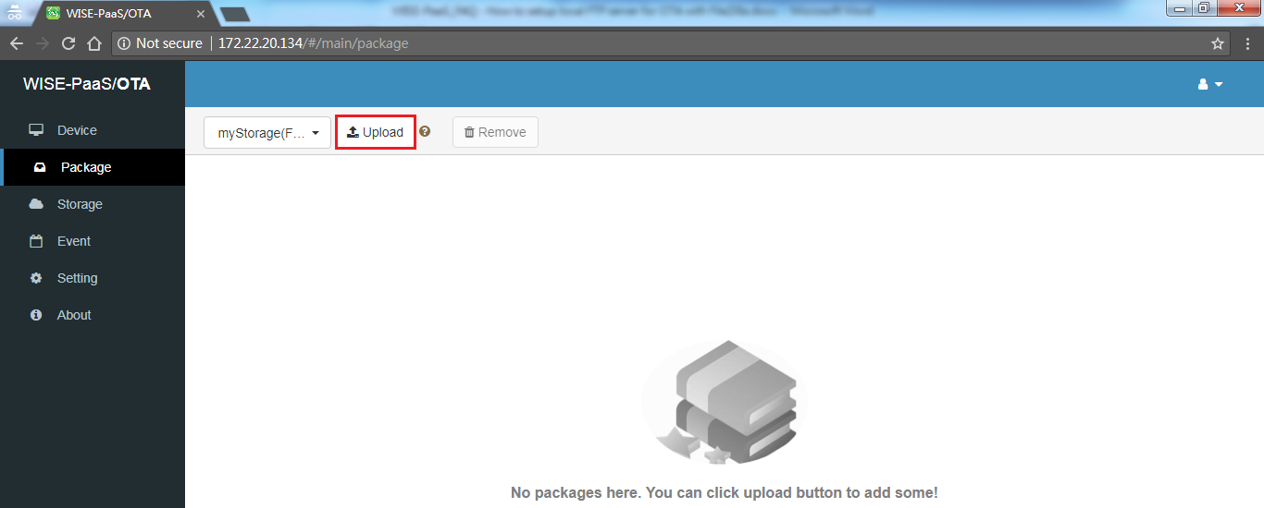

Step 4-2: Select package to be uploaded (all packages must be generated by OTAPackager)

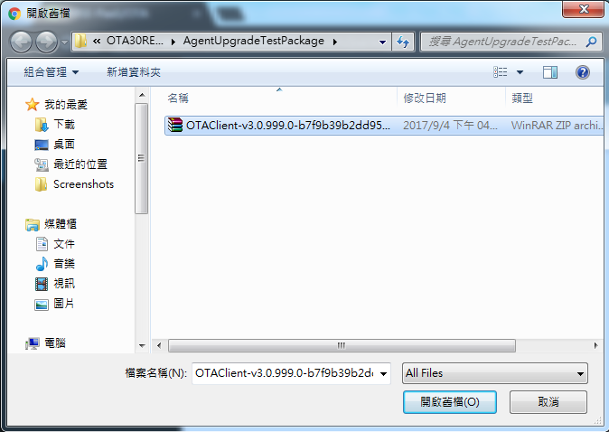

Step 4-3: Uploading progress/status bar will be seen on the bottom-right corner of the page

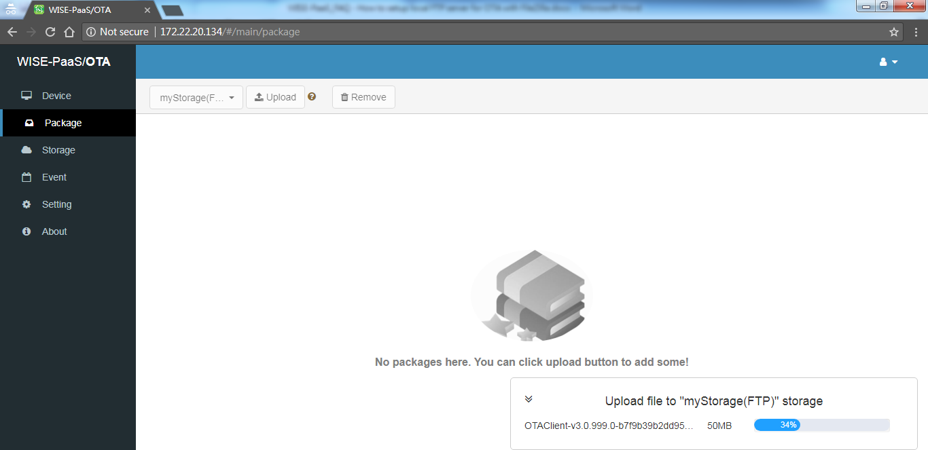After uploading succeeds, details of the uploaded package could be expanded and seen

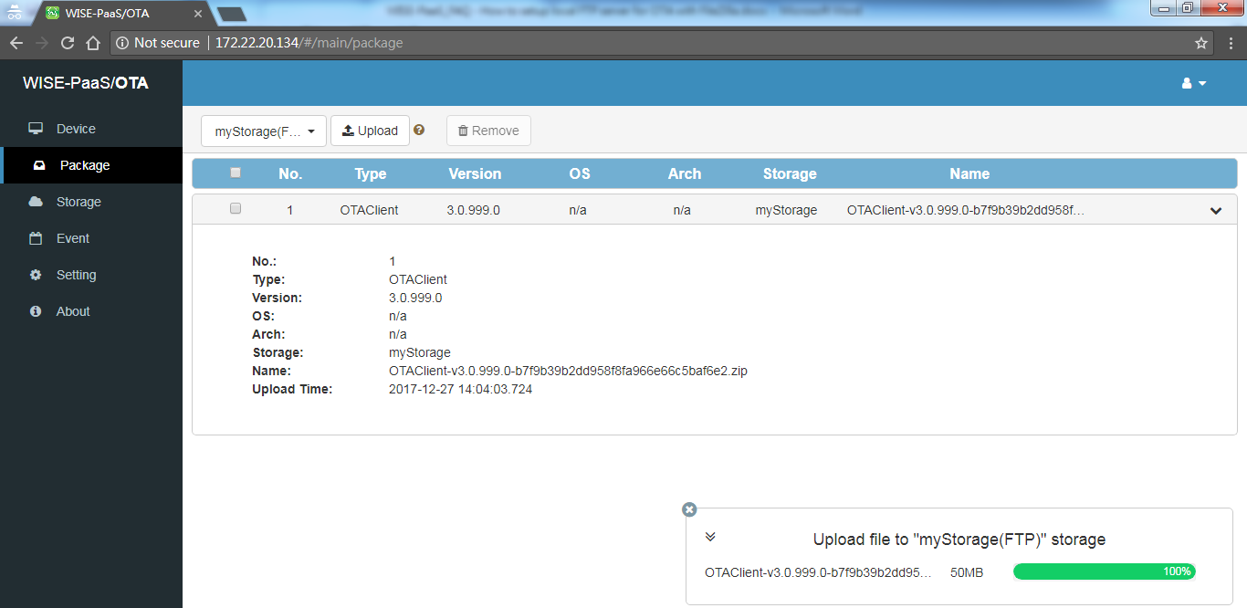

Step 4-4: Double check in the folder selected in Step 2-7 to make sure it’s correctly uploaded

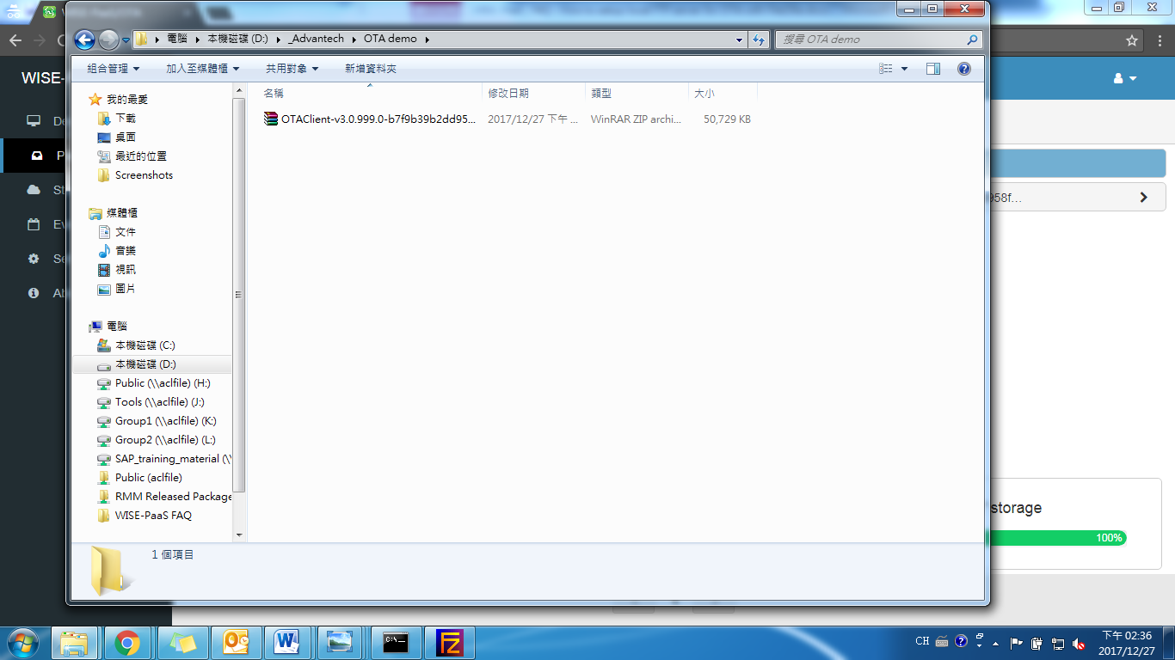

During the uploading process, you can also see activity log in FileZilla Server message console

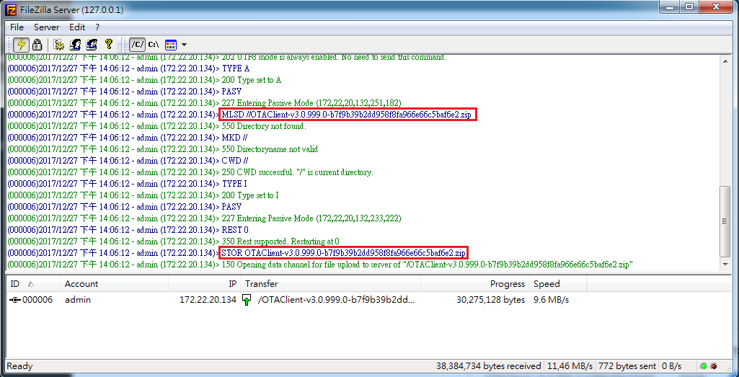

Now that you’ve setup FTP server for your OTA, you can proceed and deploy packages to your connected devices with ease.