Please remove and update “(1) ,(2)and (3)” in u-boot-2009.08/drivers/mtd/spi/imx_spi_nor_m25pxx.c .
- In struct imx_spi_flash_params.

Remove
#ifdef CONFIG_ADVANTECH
u32 idcode2;
u32 idcode3;
#endif

- In struct imx_spi_flash.

Remove
#ifdef CONFIG_ADVANTECH
.idcode2 = 0x16,
.idcode3 = 0xEF,
#endif

Old version New version
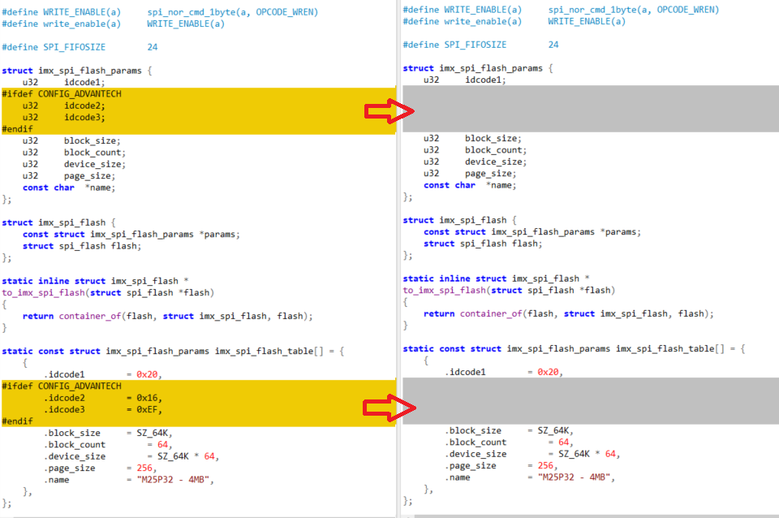

(3) Please follow the new version and update it.
struct spi_flash *spi_flash_probe(unsigned int bus, unsigned int cs, unsigned int max_hz, unsigned int spi_mode)
Old version New version
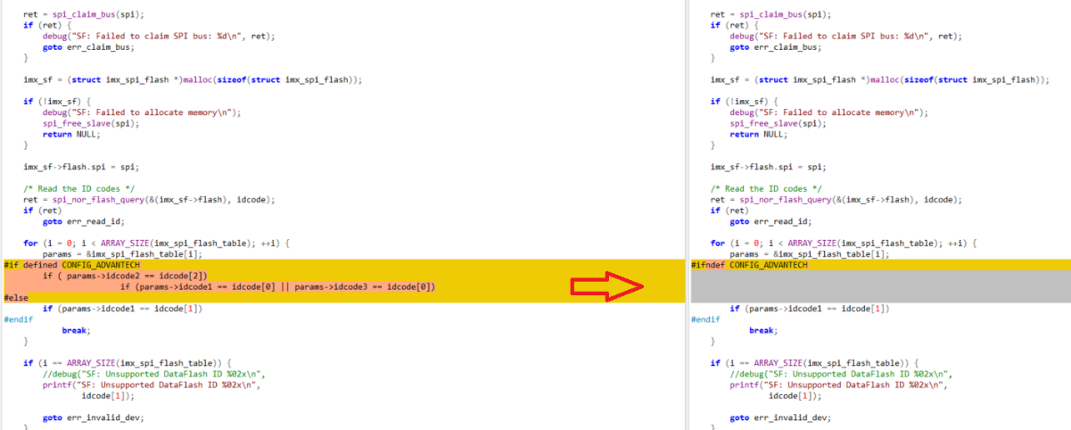
Download the new spi driver (imx_spi_nor_m25pxx.c).
https://www.dropbox.com/s/julel9ttrb3vvh9/imx_spi_nor_m25pxx.c?dl=0
Please check your uboot(2009.08) and update new version. (SPI)

