**How to Setup Network with AIW-356**

**Prerequisite**

* AIMB-229

We use the power adaptor with DC output 12V 5A and please check the jumper “PSON1” setting to AT mode as below.

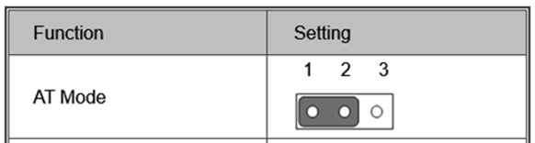

* Setup Windows 10

**Install Driver**

* Device driver

Please make sure that has capability to connect internet by Ethernet, then run the “Windows update” and the driver will be installed automatically.

**Check Device**

After “Windows update” done, you will see the snapshot as below.

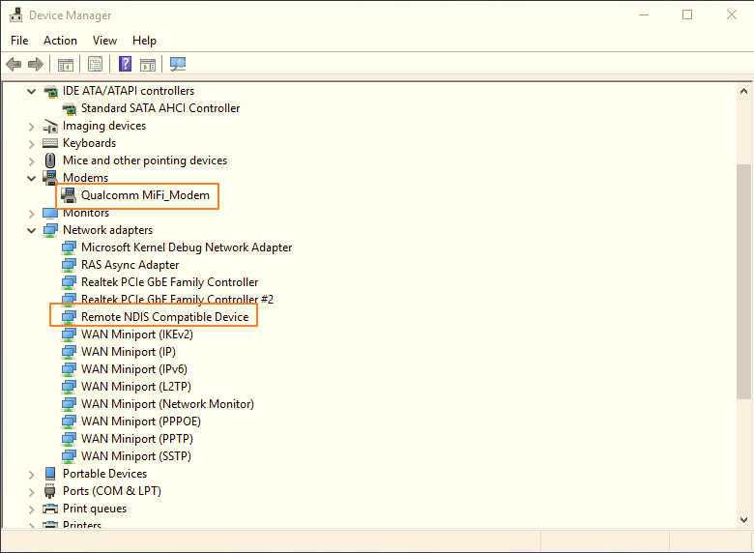

**The LED status with AIW-356**

* The position of LEDs on AIW-356.

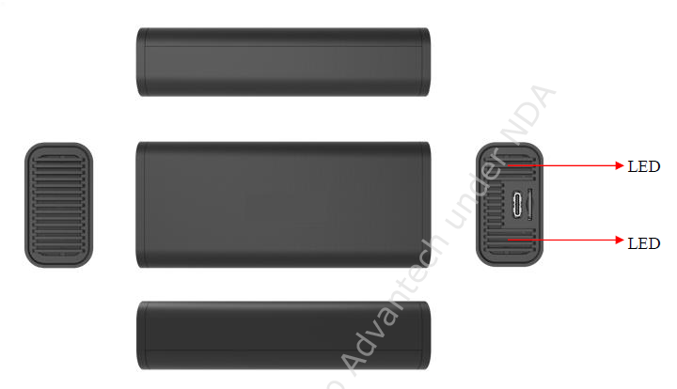

* The status of the list with LEDs

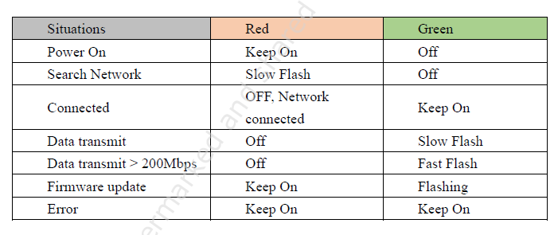

**Function Test**

1. Speed test

This is only for reference.

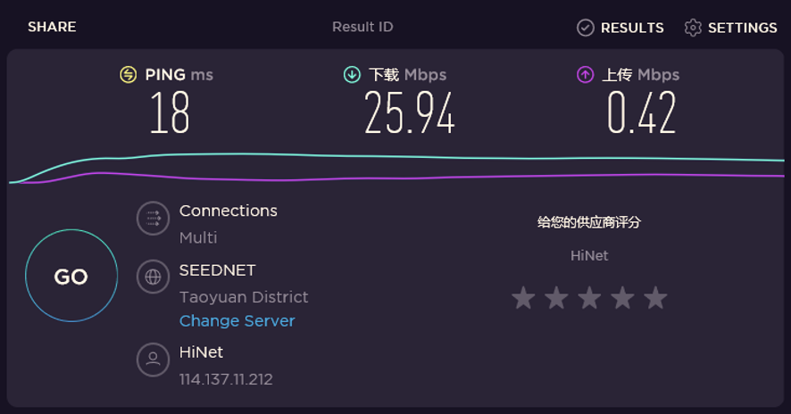

1. Reliability

Observe the ping test at least 6 hours.

1. AT command
2. Check the number of COM port with AIW-356 in device manager.

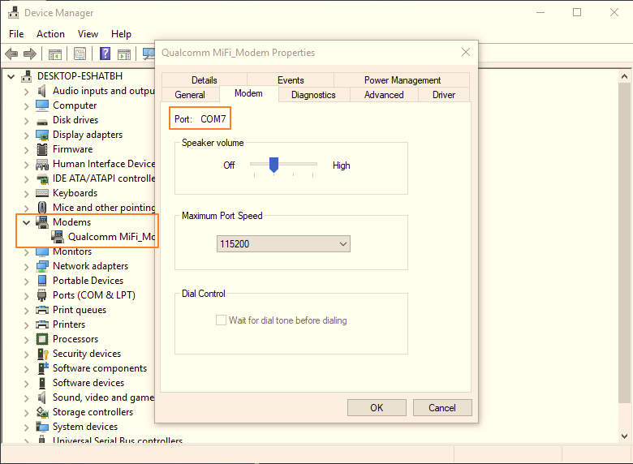

1. Access to AT command through terminal like putty.

Please make setting as below:

* + Baud Rate “9600”
  + Data bits "8"
  + Stop bits "1"
  + Parity "None"
  + Flow Control "None"

