How to Setup WiFi/Bluetooth with EWM-W176
Prerequisite
MIO-5272/ MIO-5373 and build-in Windows 10 on it.

Install Driver
- WiFi
Please select install driver directory to “wcn6855-win-1-0_r00082.1_WIN10_V1229\Driver\WLAN\x64\” directory after extract the file “wcn6855-win-1-0_r00082.1_WIN10_V1229.zip” and follow the prompt to install driver.
- Bluetooth
Please install driver with BtFilter.inf underlying “wcn6855-win-1-0_r00082.1_WIN10_V1229\Driver\BT\x64\” directory after extract the file “wcn6855-win-1-0_r00082.1_WIN10_V1229.zip” and follow the prompt to install driver.

Check Device
- Before driver installed, the unknown device is displayed in “Device Manager”
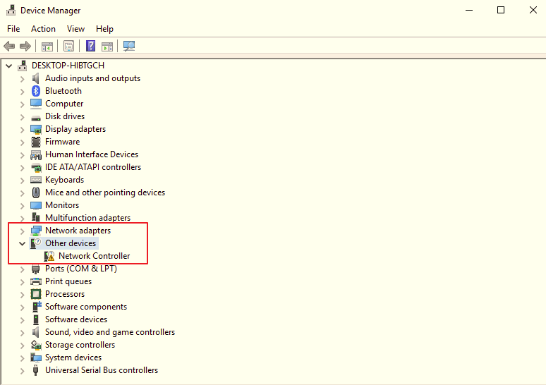

- After driver installed, you will see the snapshot as below
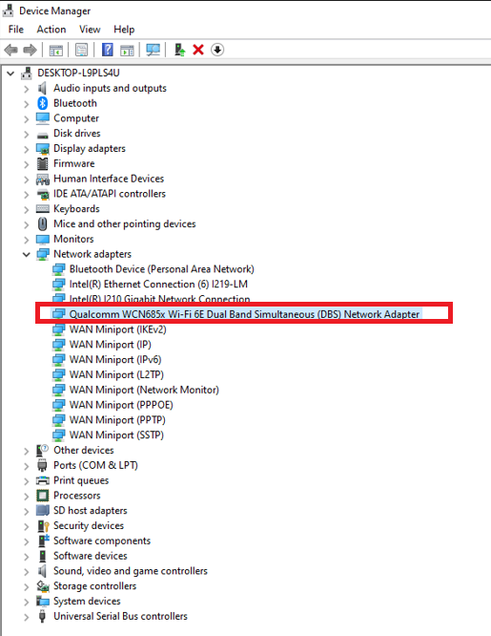

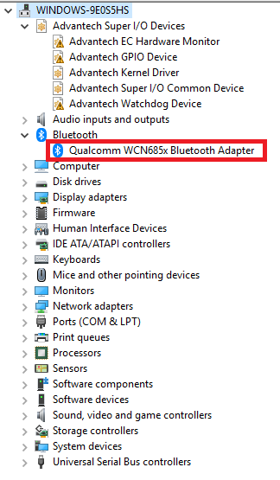
Function Test
- WiFi
Setup WiFi on Windows 10 and run the WiFi connection test with internet by Google Fiber Speed Test.
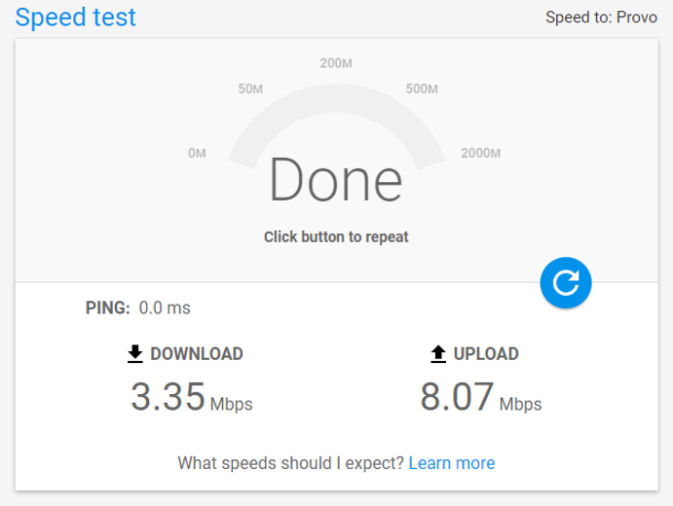

- Bluetooth
Scan devices by settings on Windows 10.
Start menu button and select Settings -> Devices -> Bluetooth & other devices