**EPD FAQ**

|  |  |  |  |
| --- | --- | --- | --- |
| **Category** | EPD-662 | **Date** | 2021/3/15 |
| **Keyword** | EPD-662, WISE-3220 | | |

* **Question:**

How to connect EPD-662 to ePaper Manager with other WiFi AP?

* **Suggestion:**

Prepare:

If the customer want to deploy EPD-662 with other AP, they have to have a WISE-3220 first. When the EPD-662 reset to default, it will reconnect to WISE-3220 first. By using WISE-3220, it can set EPD-662 to connect other WiFi AP.

Step 1: Login WISE-3220 web page and select “ePaper Manager->EPD Deployment”.

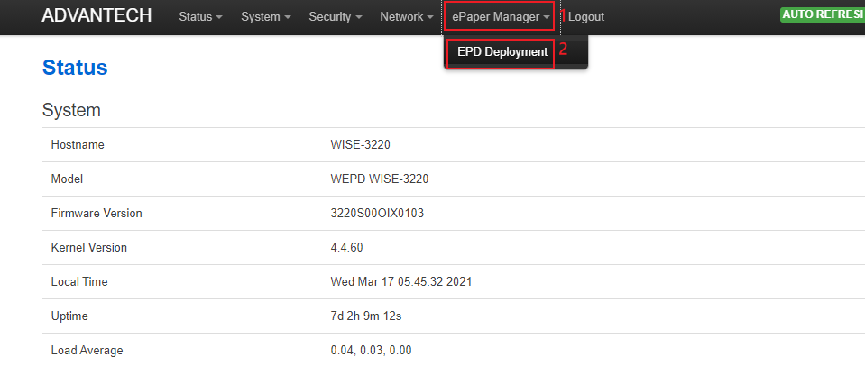

Step 2: Find the EPD-662 which you want to connect to other AP and click “Edit”

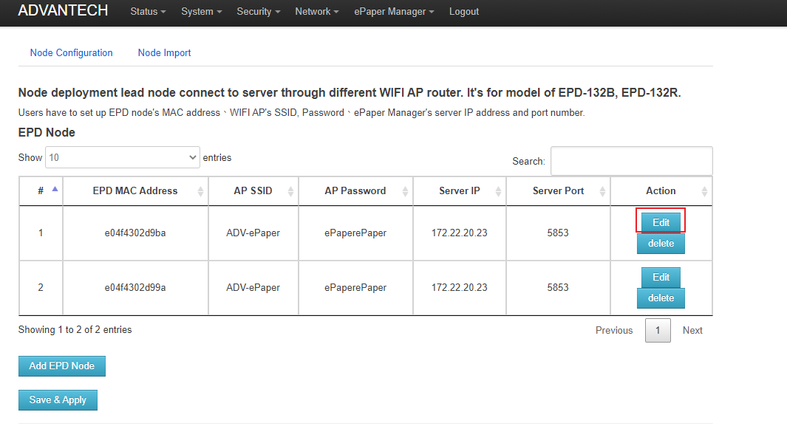

Step 3 : Modify AP SSID and AP Password to connect other WiFi AP. Then click “Save&Apply”

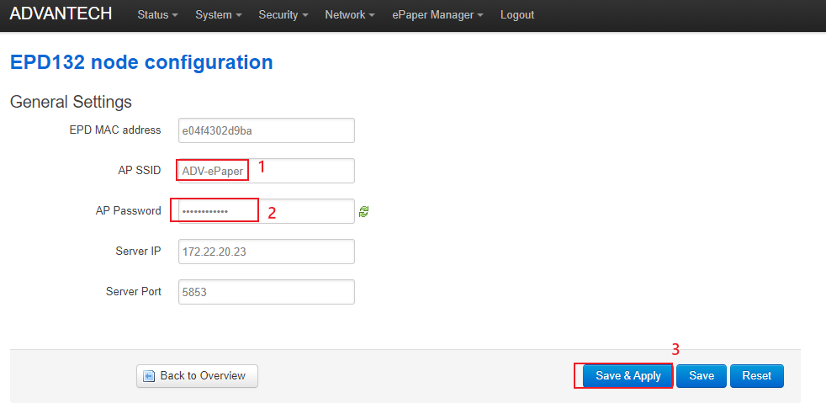

Step 4: Then click “Save&Apply”. The configuration will deploy to the EPD-662 and it will connect to other WiFi AP.

