**How to Setup Network with EWM-C403**

**Prerequisite**

* MIO-2364 and setup Windows 10 IoT Enterprise LTSC 21H2 on it
* EWM-C403 hardware revision “LE910C4-EU-H” M.2 Card

**Install Driver**

* Device driver

Please run the installer “TelitWHQLDriversxXX.msi” after extract the file “TC_Windows_10_WHQL_Drivers_Installer_2.20.0001.zip” and follow the prompt to install driver.

* AT command utility

Please run the installer “Setup_TATC_4.2.1_XFP_4.2.10.msi” after extract the file “Telit_AT_Controller_4.2.1_XFP_4.2.10.zip” and follow the prompt to install utility.

**Check Device**

After driver installed, you will see the snapshot as below.

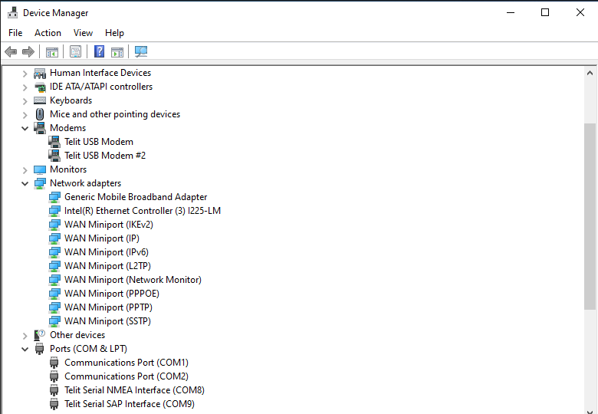

**Function Test**

* Speed test

This is only for reference.

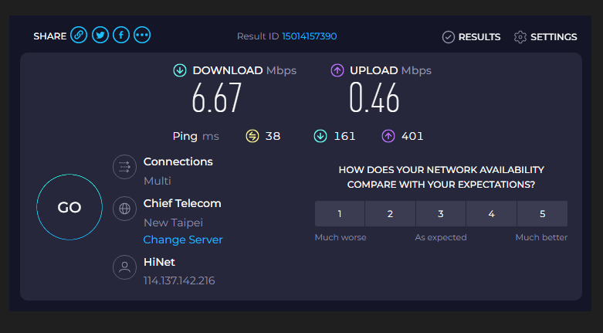

* Reliability

Observe the ping test at least 6 hours.

* AT command

Open the “Telit AT Controller” utility and setting as below, then input the AT command to test.

|  |
| --- |
| 1. Double click to open “Telit AT Controller” utility |
|  |

|  |
| --- |
| 1. Open the “Settings” to set serial port for AT command terminal |
|  |

|  |
| --- |
| 1. Open the “AT Terminal” to input AT command |
|  |

**GNSS Test**

Please follow the “AT command” above to open “AT terminal”, then refer to AT commands for testing with GNSS function.

* + Set to support active antenna

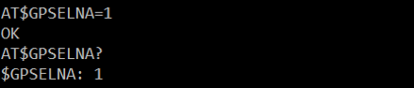

* + Set to GNSS_ALL (gps+glonass+galileo+beidou)

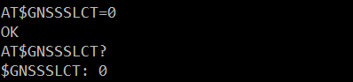

* + Set unsolicited NMEA Data Configuration

For GPS、Galileo and Beidou

AT$GPSNMUN=1,0,0,1,1,1,0

AT$GPSNMUNEX=1,1,0,1,1,1

For GLONASS

AT$GPSNMUN=1,0,0,1,1,1,0

AT$GPSNMUNEX=1,1,1,0,0,0

* + Start GNSS positioning session

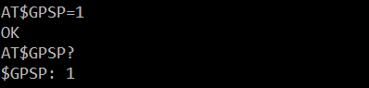

* + Get longitude and latitude

