EPD FAQ
Category | WISE-3240 | Date | 2022/4/11
Keyword | WISE-3240

- Question:
How to get other DHCP server IP from WISE-3240?

- Suggestion:

Step 1: Login WISE-3240 web page and select “Wifi->Edit”.
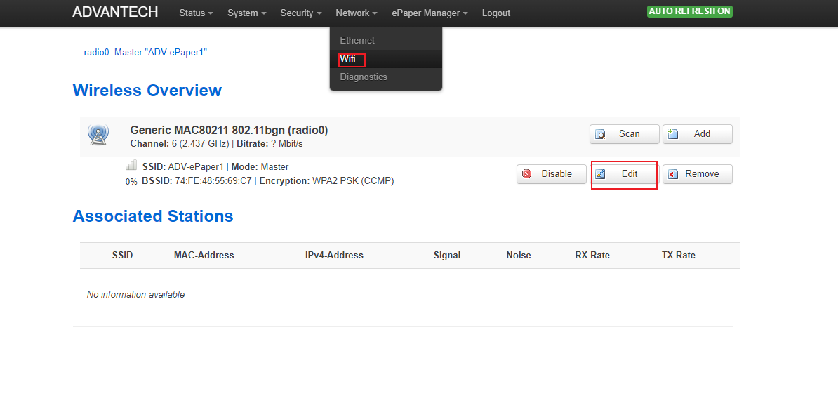

Step 2: Select “Access Point” Mode and change to mark “wan”.
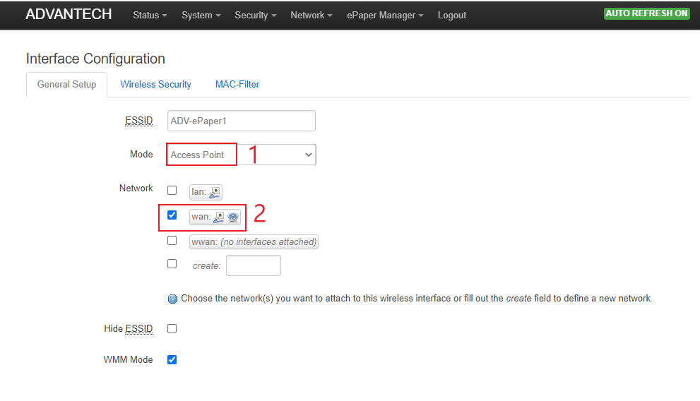

Step 3 : Using other device to connect WISE-3240. For this example, we use WISE-4060 to connect WISE-3240.
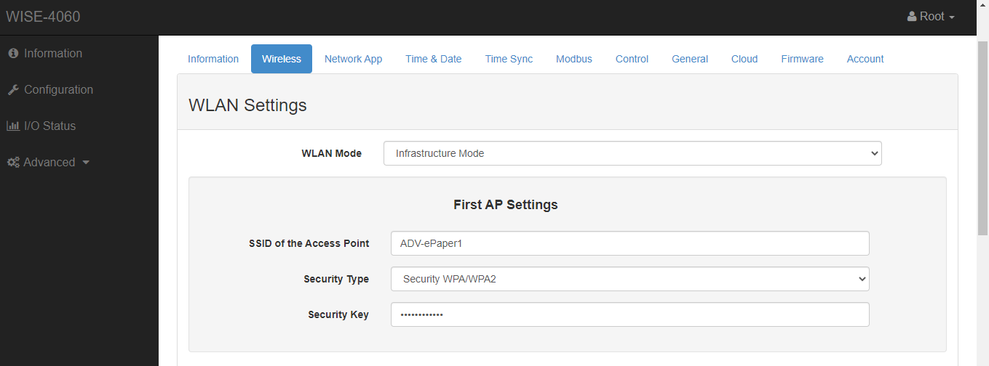

Step 4: Check the connection from WISE-3240.
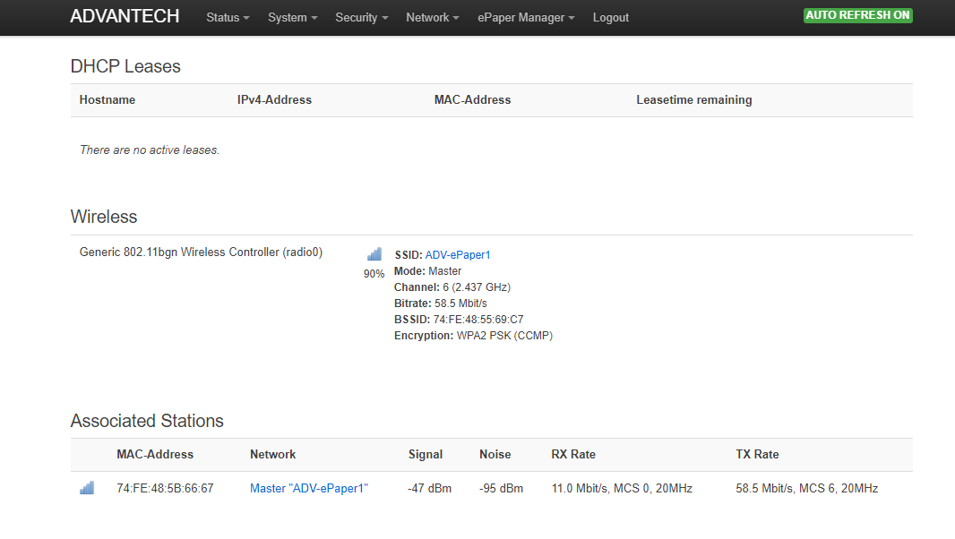
Step 5: Check device IP from WISE-Studio
