**AIW(EWM) FAQ**

|  |  |  |  |
| --- | --- | --- | --- |
| **Category** | AIW | **Date** | 2022/10/28 |
| **Keyword** | AIW-166, Intel AX210, SOM 6869, Windows 10 | | |

* **Question:**

How to solve AIW-166 Wi-Fi network interface disappears after system warm boot under some of Intel X86 platform?

* **Instructions :**

According to Intel official document, they suggest to modify BIOS setting to disable PCI De-emphasis option to allow Gen2 speed. Due to the PCIe Speed is configured as Auto(Gen2) in default setting, so we need to follow Intel document to disable PCI De-emphasis setting.

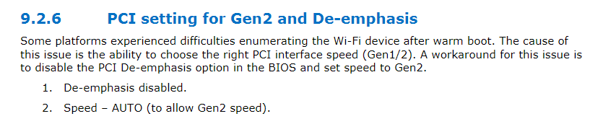

Basically, PCI De-emphasis setting is hidden in BIOS setting, so please modify the BIOS setting by specific tool, such as AMIBCP, then update the modified BIOS to the platform accordingly. (The default setting of PCI De-emphasis should be enabled, please disable it.)

