How to Setup WiFi/Bluetooth with AIW-163
Prerequisite
DS-085 and build-in Windows 10 on it.

Install Driver
Please run the installer “Setup.exe” after extract the file “RTLWlanE_WindowsDriver_6001.0.15.111_Drv_3.00.0039_Win11.L(61202).zip” and follow the prompt to install driver.

Check Device
- Before driver installed, the unknown device is displayed in “Device Manager”
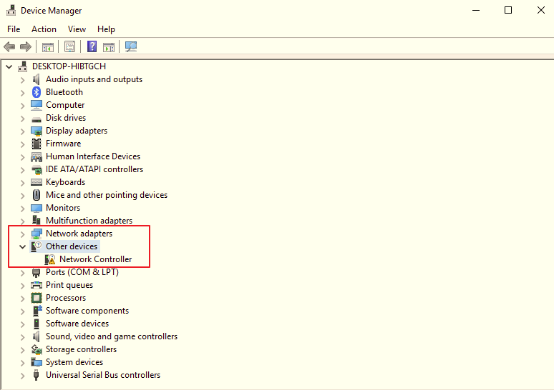

- After driver installed, you will see the snapshot as below
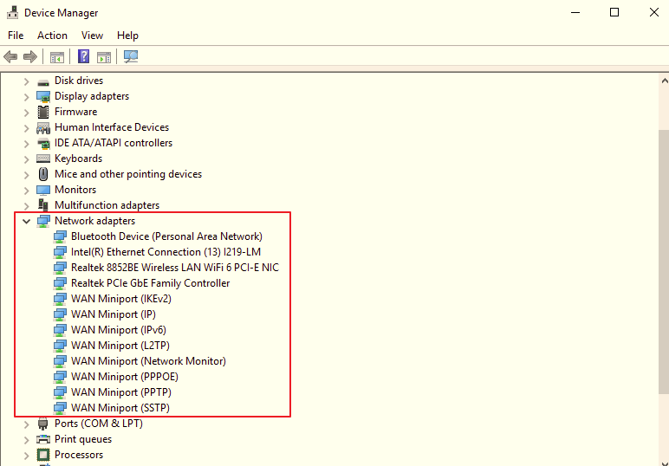

Function Test
- WiFi
Setup WiFi on Windows 10 and run the WiFi connection test with internet by Google Fiber Speed Test.
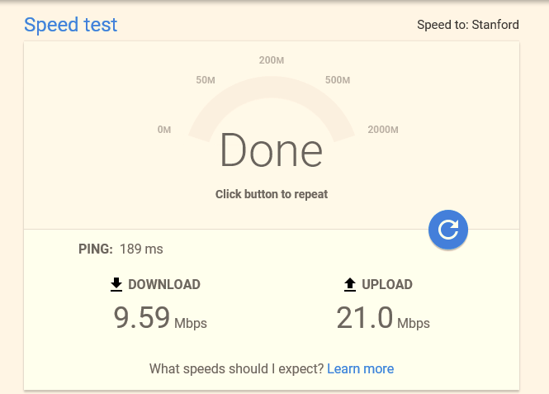

- Bluetooth
Scan devices by settings on Windows10.
Start menu button and select Settings -> Devices -> Add printers & scanners