EWM FAQ
Category | EWM | Date | 2020/09/21
Keyword | Build driver package, X86 platform,Ubuntu 18.04 LTS,Linux kernel 5.4.0-42

- Question:
How to build EWM-W172H01E’s wlan driver on Ubuntu 18.04 OS?

- Instructions :

Step 1
When inserting EWM-W172H01E module on your device, please ensure the module can be recognized on USB bus interface
- Enter “lsusb” command on terminal
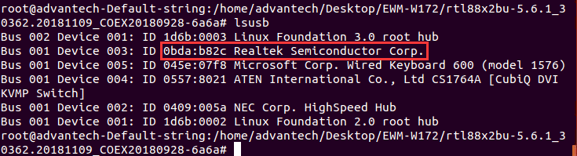
Step 2
Confirm if the WiFi function is workable or not
<Example>
The following capture image is unworkable
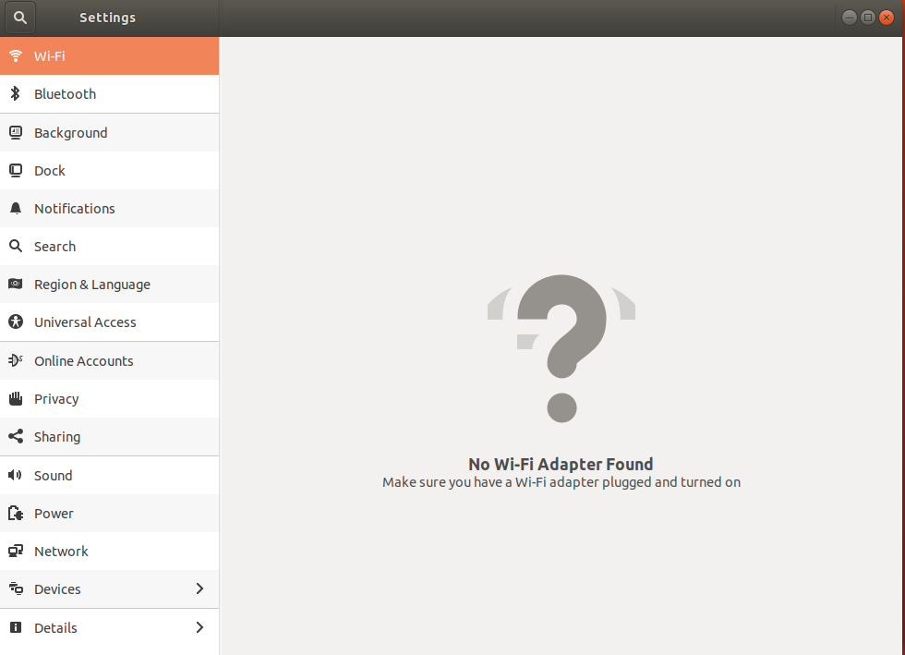
Step 3
Download driver package from following url
https://www.dropbox.com/sh/cdgxv4401otjk7l/AABj0MVZUqYlNZ8N8oR4sYnpa/WiFi%2BBT/W172/Driver/Linux/WiFi/EWM-W172H01E_rtl88x2bu-5.6.1_30362.20181109.zip?dl=0

Step 4
Decompress the driver package and enter to root directory
- sudo make clean
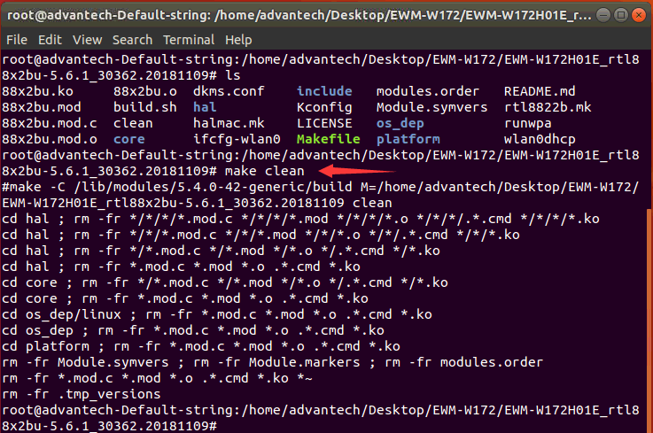
- sudo chmod 777 build.sh
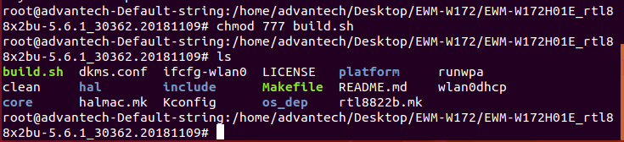
- sudo ./build.sh
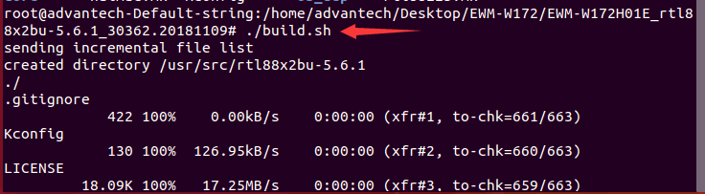
Step 5
After running a period of time, the installation process will be done and show “install completed”
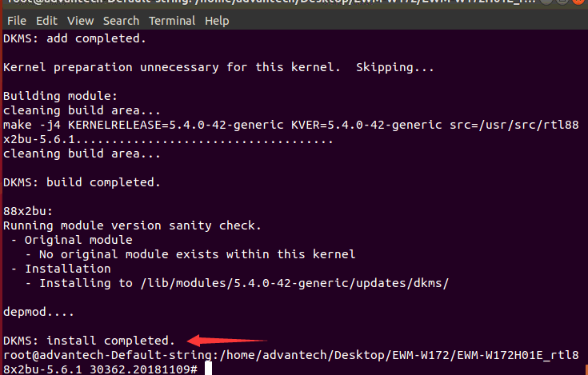
Step 6
If there is any compile error which appear during building driver as below, try to add extra CONFIG in “MakeFile”in specific directory
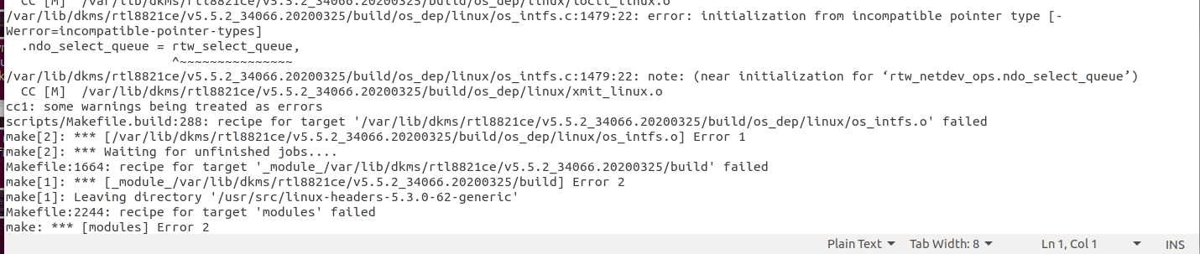
- add Extra Config “USER_EXTRA_CFLAGS=-Wno-error=incompatible-pointer-types” in the top of Makefile
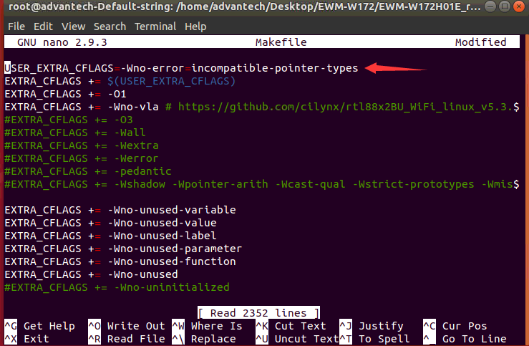
Step 7
Execute“./build.sh” command again on terminal and ensure the prompt of message “DKMS: install completed”

Step 8
After installing, reboot the system and you will see the wifi function is activated on wifi section
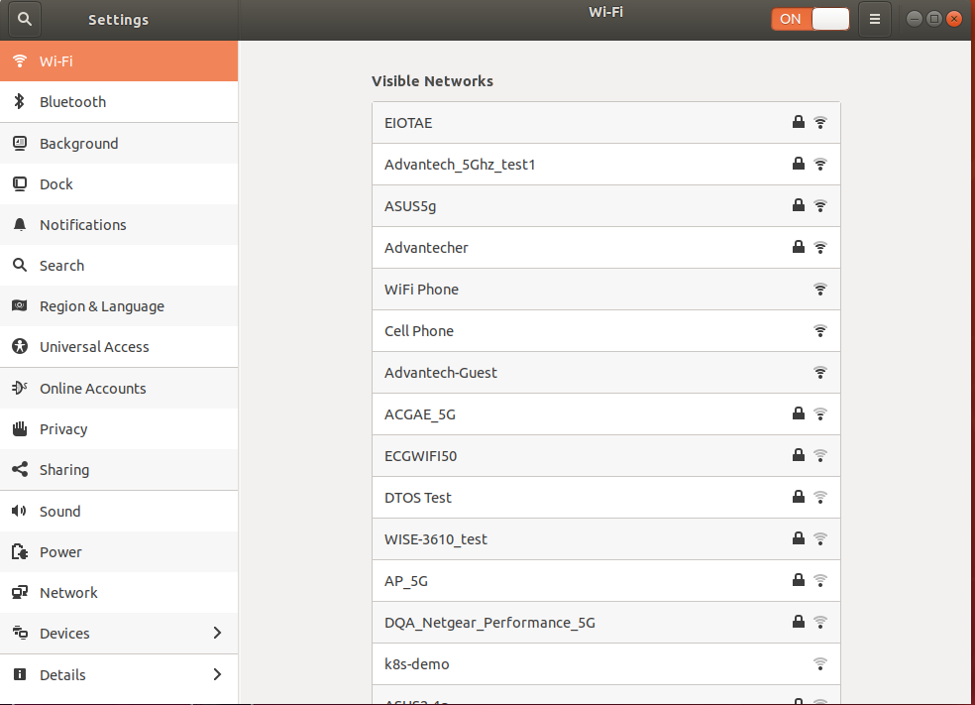

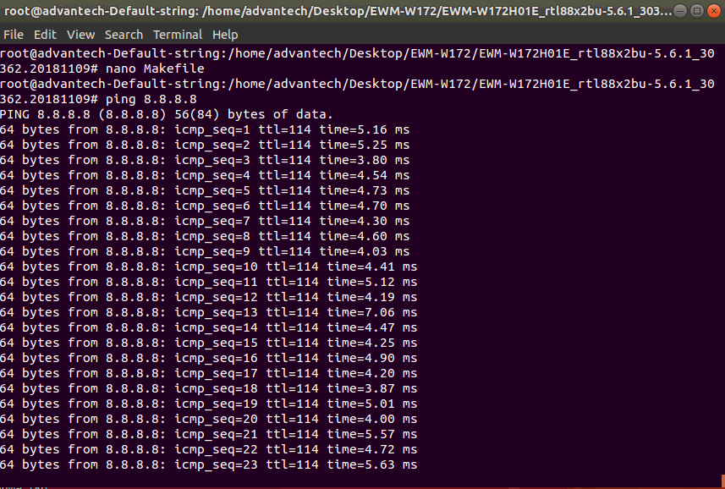

Step 9
If you would like to insert diver to activate by system when system boots up every time, please enter following instructions
- sudo make
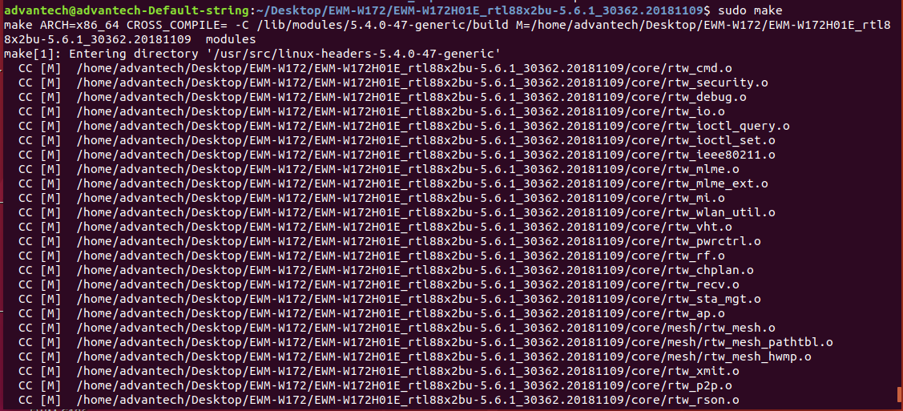
- sudo make install
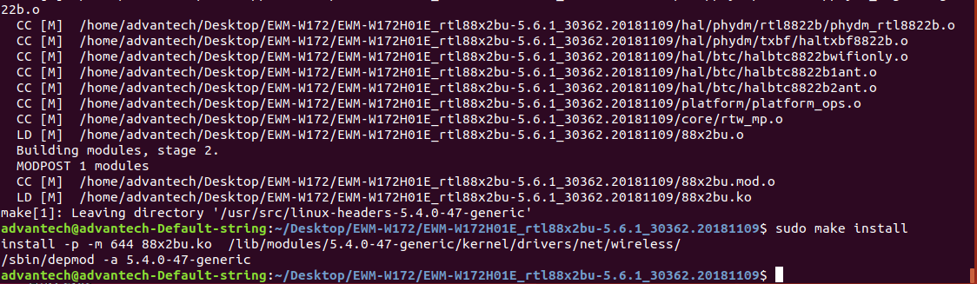
Step 10
Finally, the wifi function will appear in network manager when system boots up

Note: For more information, please check following github’s webpage.
https://github.com/jeremyb31/rtl8822bu

