How to enable WiFi/Bluetooth with EWM-W176H01E
Prerequisite
- MIC-713 and mSATA build-in Jetson Linux R35.1 (Ubuntu Ubuntu 20.04.5 LTS and Kernel 5.10.104-tegra)
- The tarball “EWM-W176H01E-MIC-713-Binary.tar.bz2” included driver and related files
- After boot up, please use ‘sudo’ with default username and password (mic-713/mic-713)
- AP router to support 6E. In our test envrionment, we have the ASUS GT AXE11000.

Check Hardware with Module
- Check PCIe interface for WiFi
# lspci
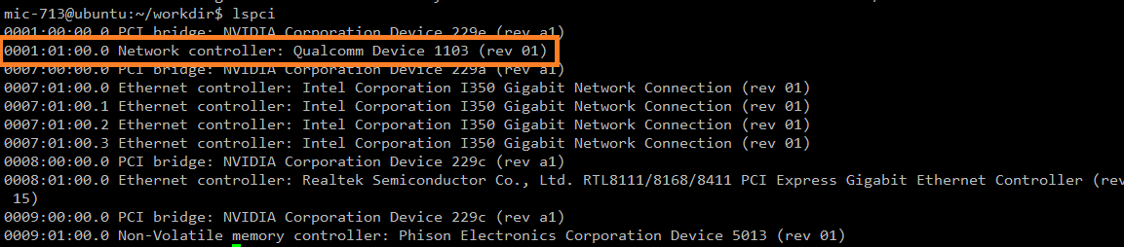

- Check USB interface for BT
# lsusb
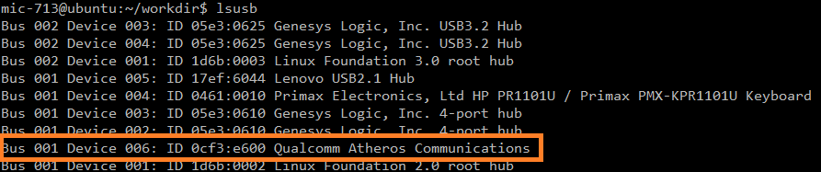

Setup WLAN
- Copy the firmware and related files to system
  - tar jxvf EWM-W176H01E-MIC-713-Binary.tar.bz2
  - cd ./EWM-W176H01E-Binary/wlan
  - sudo cp ./wlan_firmware/* /lib/firmware
  - sudo mkdir -p /lib/firmware/wlan
  - sudo cp ./wlan_host/qcom_cfg.ini /lib/firmware/wlan

- Load WLAN drivers
Step 1) sudo modprobe cfg80211
Step 2) sudo insmod ./driver/wlan_cnss_core_pcie.ko
Step 3) sudo insmod ./driver/wlan.ko

Setup Bluetooth
- Copy the firmware and related files to system
  - tar jxvf EWM-W176H01E-MIC-713-Binary.tar.bz2
  - cd ./EWM-W176H01E-Binary/bt
  - sudo mkdir -p /data/misc/bluetooth
  - sudo cp ./bt_firmware/ar3k/* /lib/firmware/ar3k/
  - sudo cp -f ./usr/lib/* /usr/lib/
  - sudo cp -f ./usr/bin/* /usr/bin/
  - sudo cp -f ./etc/bluetooth/* /etc/bluetooth/

- Load Bluetooth drivers
Step 1) sudo modprobe -r btusb
Step 2) sudo insmod ./driver/bt_usb_qcom.ko
Step 3) sudo rmmod bt_usb_qcom
Step 4) sudo modprobe btusb

Test

- Test by GUI

  - WiFi
- Select the option Wi-Fi

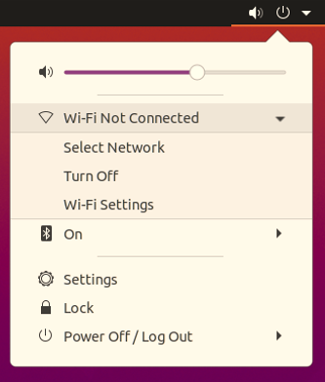

- Select the SSID of AP

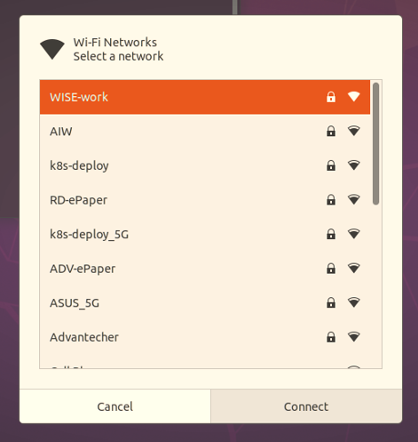

- Input your password of AP
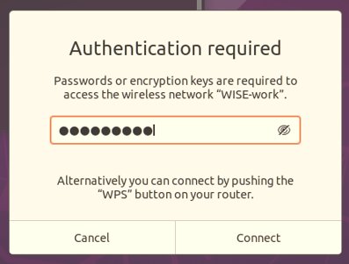

- Open the terminal to check interface and network connection
  - Check interface and you will see the interface as “wlanX”
# ifconfig
  - Check network connection after obtained IP address
# ping -c 3 8.8.8.8
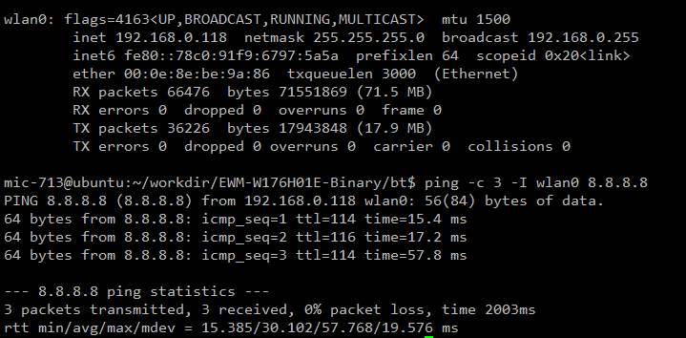

1.2 Bluetooth

- Select the option Bluetooth
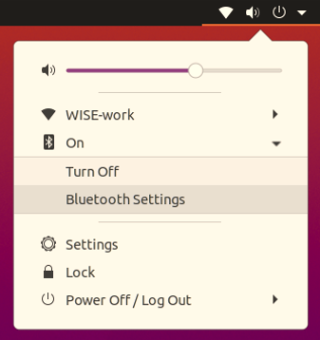

- You will see the result in scanning as below list
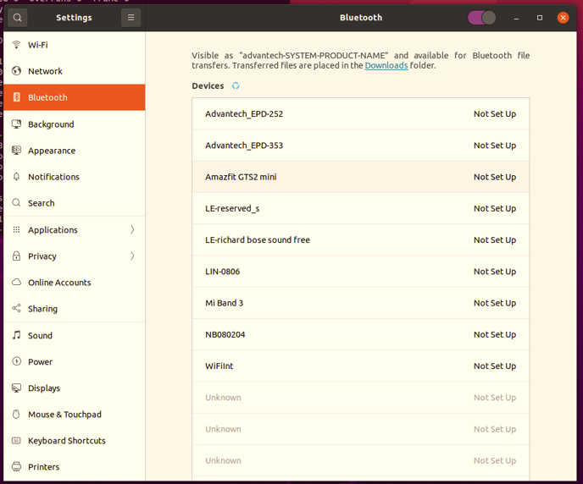

- Test WiFi with security “WPA3” by wpa_supplicant

- Stop wpa_supplicant service
# systemctl stop wpa_supplicant.service

- Create configuration and save it
Note that fill in your SSID and password depend on your AP router.

#vi /tmp/wpa.conf
  - Configuration with 6G
ap_scan=1
fast_reauth=1
pmf=1
sae_pwe=1
network={
scan_ssid=1
ssid="your_ssid"
proto=RSN
key_mgmt=SAE
pairwise=CCMP
group=CCMP
priority=10
ieee80211w=2
psk="your_ssid_password"
group_mgmt=AES-128-CMAC
}

  - Configuration with 2.4G or 5G
ap_scan=1
fast_reauth=1
pmf=1
network={
scan_ssid=1
ssid="your_ssid"
proto=RSN
key_mgmt=SAE
pairwise=CCMP
group=CCMP
priority=10
ieee80211w=2
psk="your_ssid_password"
group_mgmt=AES-128-CMAC
}

- Check WiFi interface
# sudo iwconfig
Note: you will see the interface like wlan0

- Running wpa_supplicant
# wpa_supplicant -Dnl80211 -i wlan0 -c /tmp/wpa.conf -B

- Get IP address by DHCP and check network connection
# dhclient wlan0
# ping -c 3 8.8.8.8

