**How to enable WiFi/Bluetooth with AIW-166**

**Prerequisite**

* Host PC and setup Ubuntu 20.04 on it
* SSD with a storage capacity of at least 32GB
* MIO-2375 or MIO-2361
* AIW-166 image “aiw-166-img.tar.gz”

**Programming image to SSD**

Please use dd command to program image to SSD storage on host PC.

* Get tarball of image and decompress it

# tar zxf aiw-166-img.tar.gz

* Use dd command for programming

# sudo dd if=./aiw-166.img of=/dev/sdb

Command usage as below:

dd if=/the/path/to/find/the/image of=/the/path/to/find/the/target_disk

**Test**

After boot up, please login or use ‘sudo’ with default username and password (advantech/advantech)

1. **Test by GUI**
   1. **WiFi**

* Select the option Wi-Fi

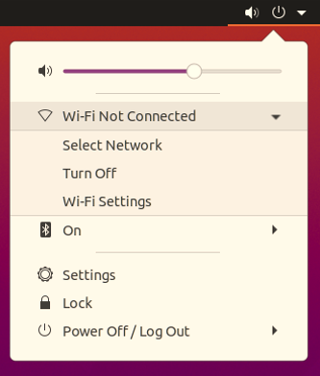

* Select the SSID of AP

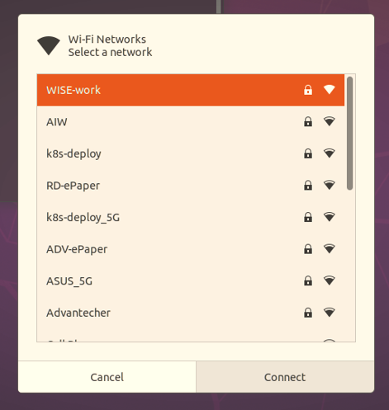

* Input your password of AP

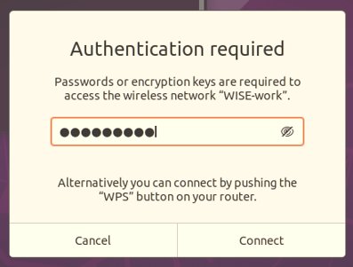

* Open the terminal to check interface and network connection
  + Check interface and you will see the interface as “wlp1sx”

# ifconfig

* + Check network connection after obtained IP address

# ping –c 3 8.8.8.8

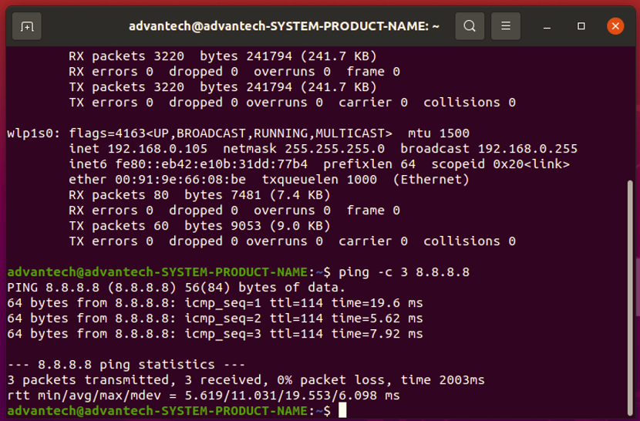

**1.2 Bluetooth**

* Select the option Bluetooth

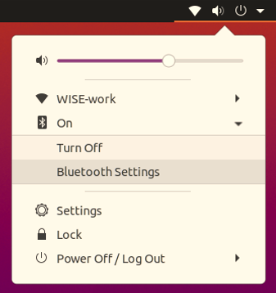

* You will see the result in scanning as below list

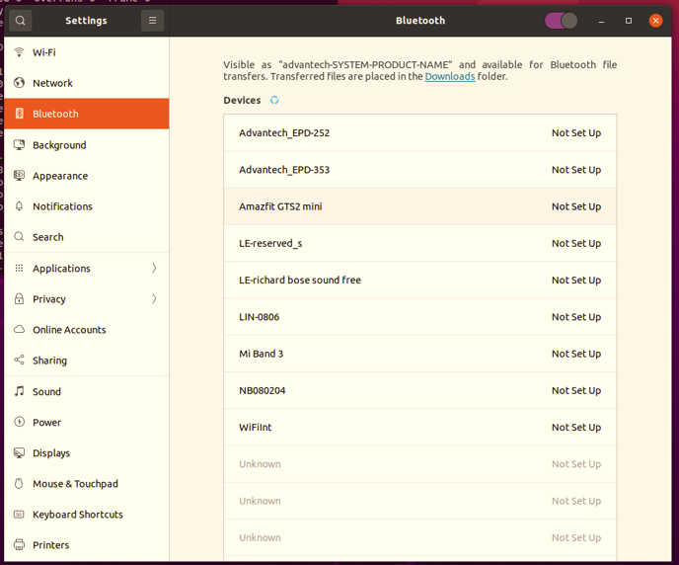

1. **Test by command line**
   1. **WiFi**

* Stop some services

# sudo nmcli radio wifi off

# sudo systemctl stop wpa_supplicant.service

# sudo systemctl mask wpa_supplicant.service

* Create configuration

# echo ‘ctrl_interface=/run/wpa_supplicant’ > /tmp/wpa.conf

# echo ‘update_config=1` >> /tmp/wpa.conf

# wpa_passphrase "XX" YY >> /tmp/wpa.conf

Note: XX: SSID, YY: Password

* Enable WiFi and check interface

# sudo rfkill unblock wifi

# sudo iwconfig

Note: you will see the interface like wlp1sX

* Running wpa_supplicant

# sudo wpa_supplicant -d -B -i wlp1sX -c /tmp/wpa.conf

* Get IP address by DHCP and check network connection

# sudo dhclient wlp1sX

# ping -c 3 8.8.8.8

* 1. **Bluetooth**
* Enable Bluetooth

# sudo rfkill unblock bluetooth

# sudo systemctl start bluetooth.service

* Check interface of bluetooth

# hciconfig -a

Note: you will see the interface like hciX

* Turn on/off scan

# sudo bluetoothctl scan on

# sudo bluetoothctl scan off