EWM FAQ
Category | EWM | Date | 2020/05/05
Keyword | LTE 4G network ,EWM-C163M201E,ppp mode,Linux OS, Cent OS 8

- Question:
How to establish 4G cellular network with EWM-C163M201E module on Cent OS?

- Instructions :

Step 1
Confirm your Cent OS version
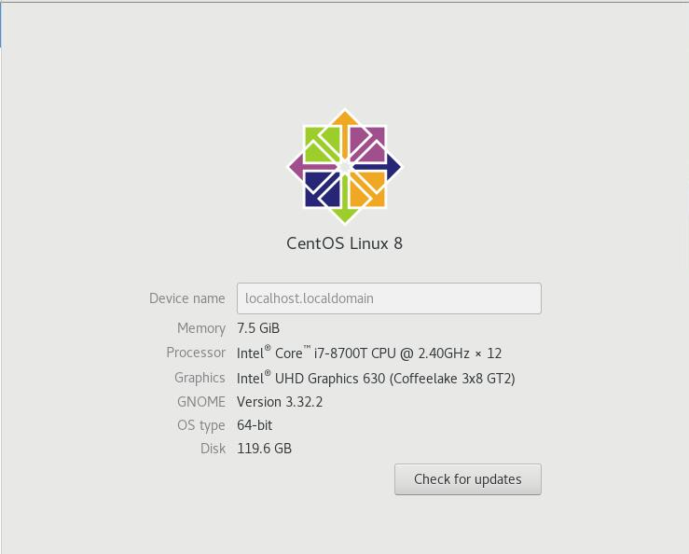

Step 2
List all of files under specific “dev” folder and ensure the ACM ports has generated as below
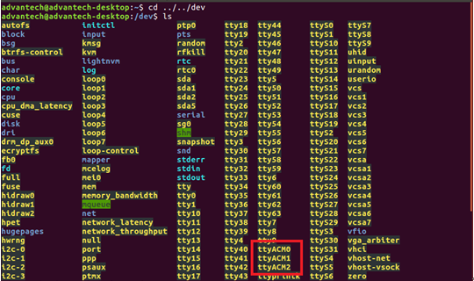
Step 3
Try to establish your cellular connection by “pppd” command and input specific username/password from sim card if needs
Command:
pppd connect 'chat -v -s -t 10 "" "AT" "" "ATDT*99#" "CONNECT" ""' user username password password /dev/ttyACM2 460800 nodetach crtscts debug usepeerdns defaultroute

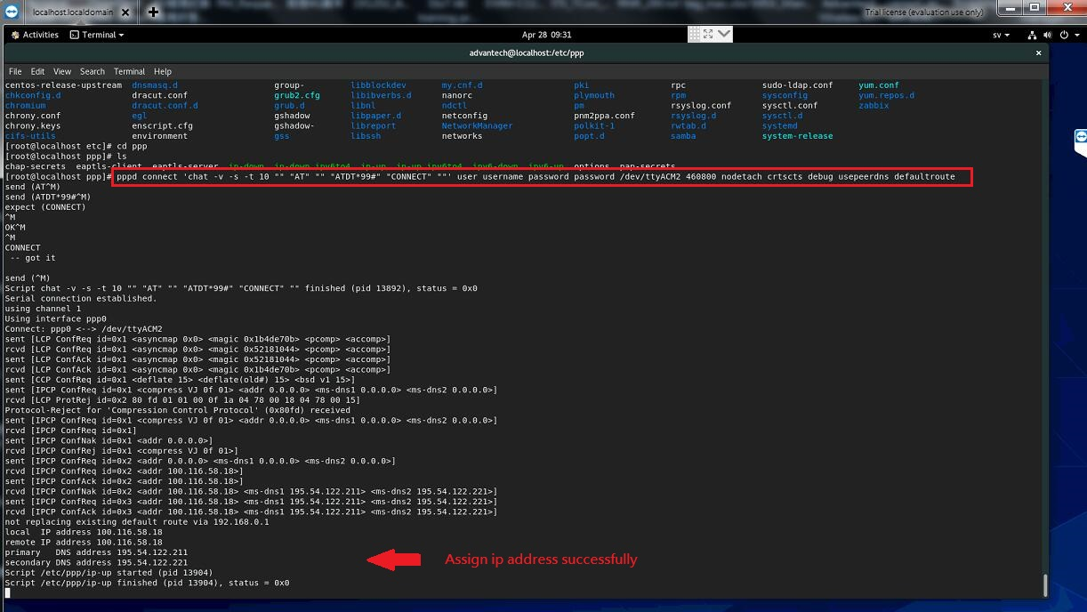
Note: if the ppp package is not installed on your system,please install it by following command.
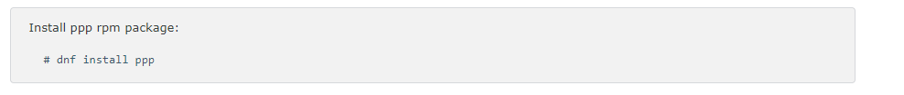
Step 4
Confirm the ppp0 interface has generated on network section and do ping test
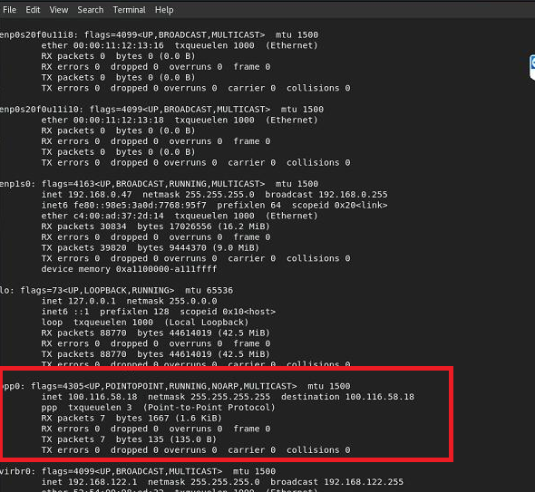
Step 5
Add pppd command to specific file path(etc/rc.d/rc.local) and save it
Command:
pppd connect 'chat -v -s -t 10 "" "AT" "" "ATDT*99#" "CONNECT" ""' user username password password /dev/ttyACM2 460800 nodetach crtscts debug usepeerdns defaultroute &

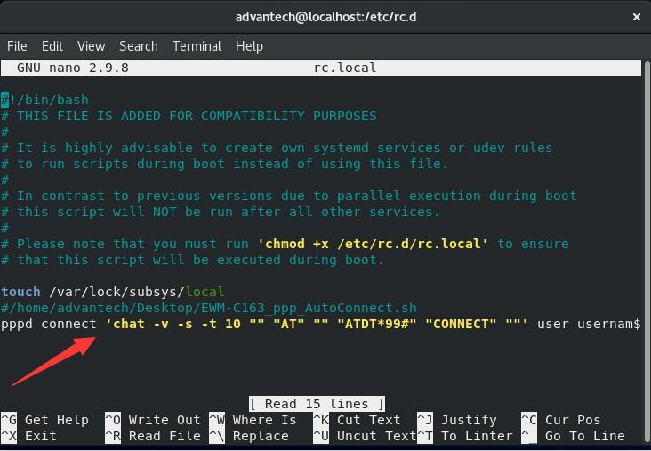
Step 6
Modify the access permission of file (chmod 777 rc.local) to ensure the file can be executed at starts up
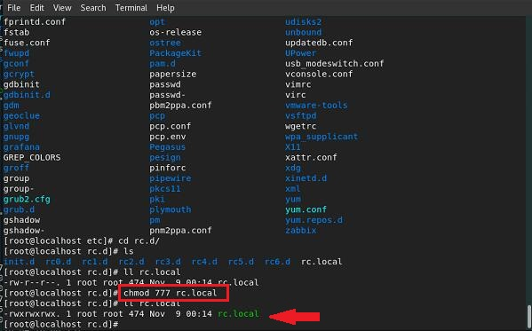
Step 7
Modify the “rc-local” service (usr/lib/system/system/rc-local.service) as below
- [Unit]
Requires=network-online.target
After=network-online.target
- [Install]
WantedBy=multi-user.target

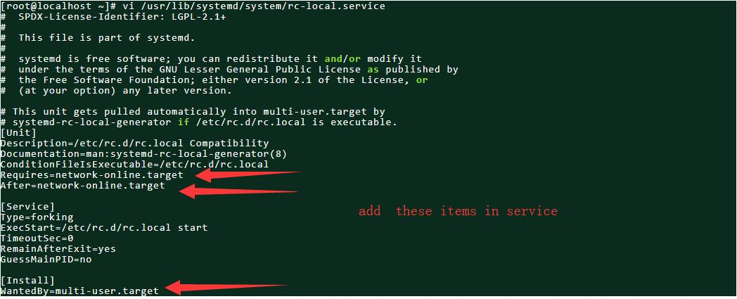
Step 8
Change high access permission of rc-local service
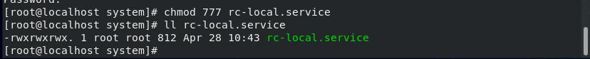
Step 9
Confirm rc-local service if it enables or not by following command
- systemctl status rc-local.service
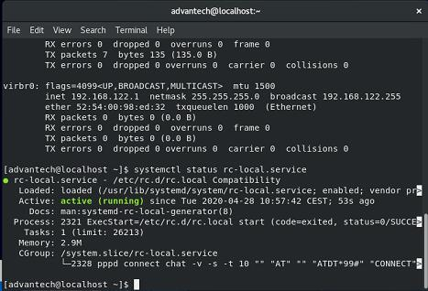
Note:if the status is not activated, please enter “systemctl enable rc-local.service” command and check again

Step 10
Reboot the system and confirm if the ppp0 interface can be established automatically or not
Note: if the connection cannot establish proper or unsuccessful, please cross check the status of “rc-local service” from STEP 9 or module status by AT commands below.
http://ess-wiki.advantech.com.tw/wiki/images/8/86/FAQ_EWM_How_to_do_troubleshooting_by_AT_commands_when_3G_4G_connection_is_not_workable_with_EWM-C109F601E_EWM-C117FL0XE_on_Linux_OS_4.docx

