AIW(EWM) FAQ
Category | AIW | Date | 2022/09/23
Keyword | AIW-163, driver, Ubuntu 20.04, kernel 5.4

- Question:
How to install AIW-163 driver on Ubuntu?

- Instructions :
- Download the driver package via below link.
RTL8852BE_WiFi_linux_v1.15.6.0.2-0-gac110bf5.20211029(55435).7z
- Unzip “RTL8852BE_WiFi_linux_v1.15.6.0.2-0-gac110bf5.20211029(55435).7z” using command
# 7z x RTL8852BE_WiFi_linux_v1.15.6.0.2-0-gac110bf5.20211029(55435).7z
- Access to “WiFi” folder.
- Decompress “RTL8852BE_WiFi_linux_v1.15.6.0.2-0-gac110bf5.20211029.tar.gz” using command
# tar zxvf RTL8852BE_WiFi_linux_v1.15.6.0.2-0-gac110bf5.20211029.tar.gz
- Access to “RTL8852BE_WiFi_linux_v1.15.6.0.2-0-gac110bf5.20211029” folder.
- Access to “driver” folder.
- Decompress “rtl8852BE_WiFi_linux_v1.15.6.0.2-0-gac110bf5.20211029.tar.gz”.
using command
# tar zxvf rtl8852BE_WiFi_linux_v1.15.6.0.2-0-gac110bf5.20211029.tar.gz
- Access to “rtl8852BE_WiFi_linux_v1.15.6.0.2-0-gac110bf5.20211029” folder.
- Input command “make” to compile driver package to generate ko files.
*If "make" error, try to use below command to fix:
# sudo apt install make
# sudo apt install build-essential
If still can’t make it work, try to copy the whole “rtl8852BE_WiFi_linux_v1.15.6.0.2-0-gac110bf5.20211029” folder to the other path, ex. desktop of PC then try to compile again.
After that, there’re a few files generated, including “8852be.ko”.
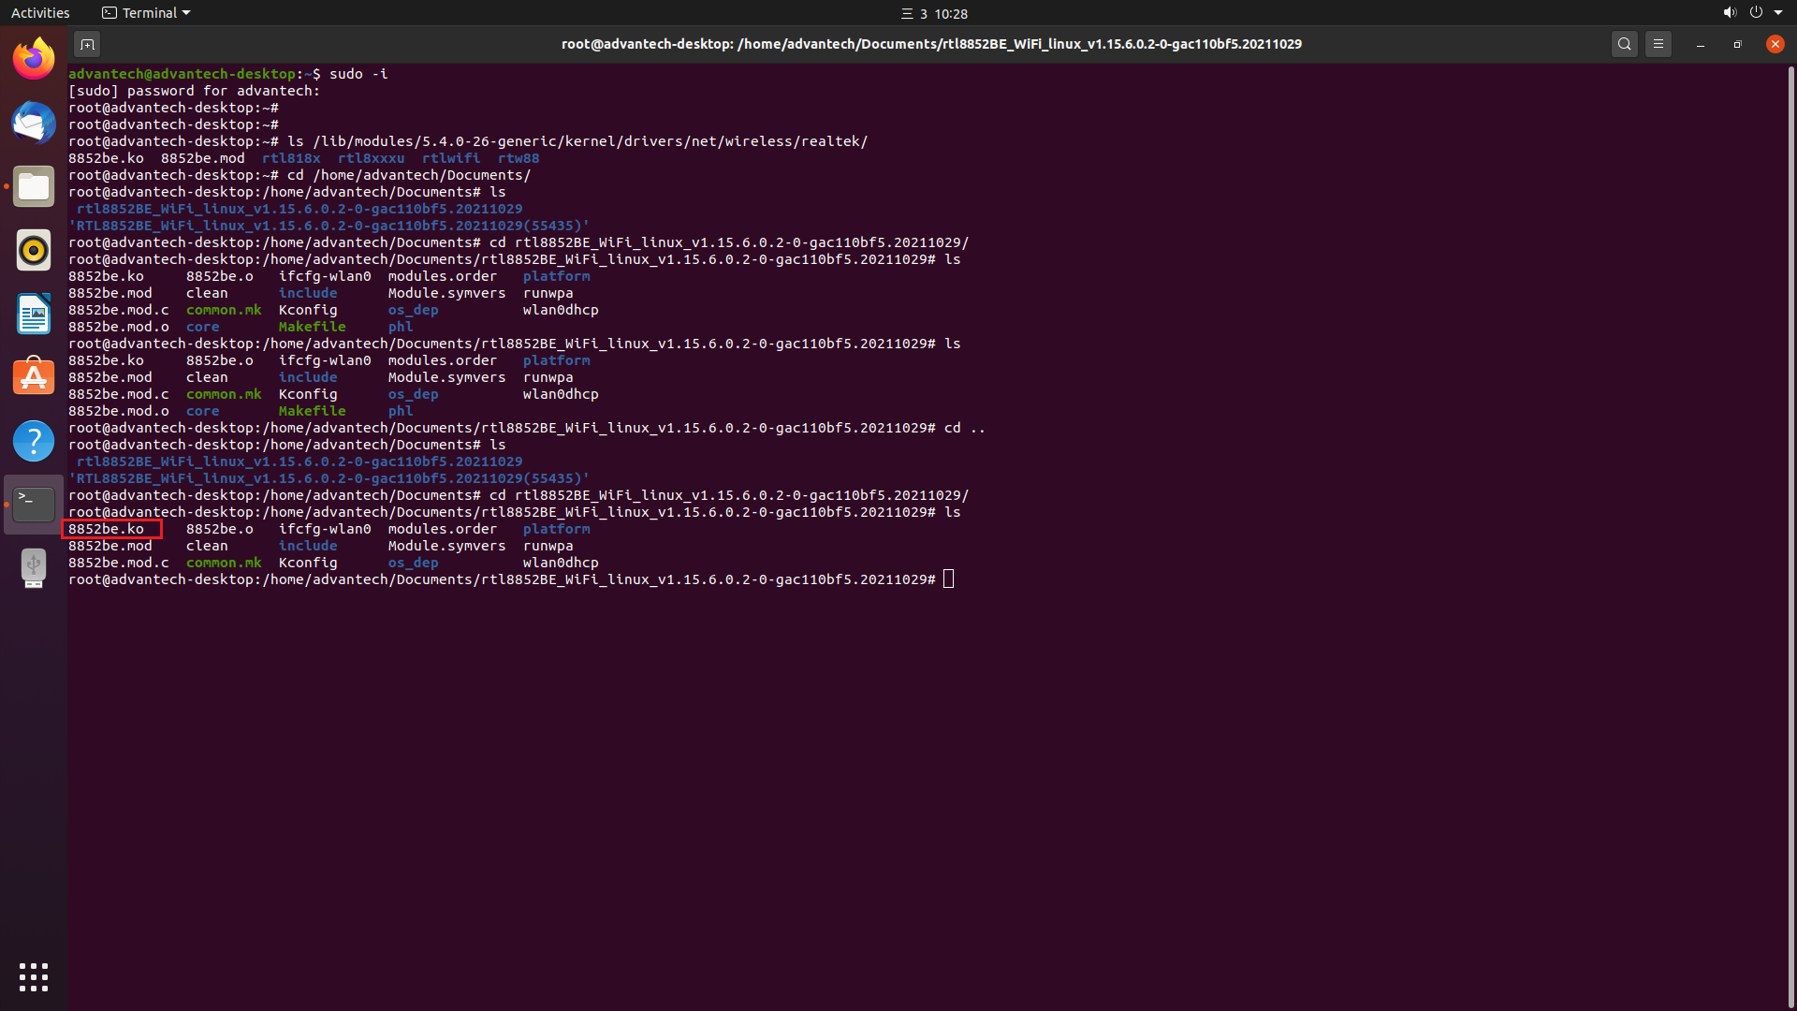
- Try to insert driver with below command.
# insmod 8852be.ko
*If error -2 issue(could not insert module XXX: Unknown symbol in module) happens while trying to insert driver, trying to use below command to fix:
# modprobe cfg80211
# insmod 8852be.ko again
- Finally, input below command to install the driver so that the driver will be loaded automatically in the future.
# make install

*Test environment:
