How to enable Wi-Fi/ Bluetooth with
EWM-W177M201E
Prerequisite
- MIO-5373 with Ubuntu Desktop 22.04.2 LTS Linux 5.17.15 installed.

Check Hardware Status
- Check the presence of Wi-Fi hardware
# lspci
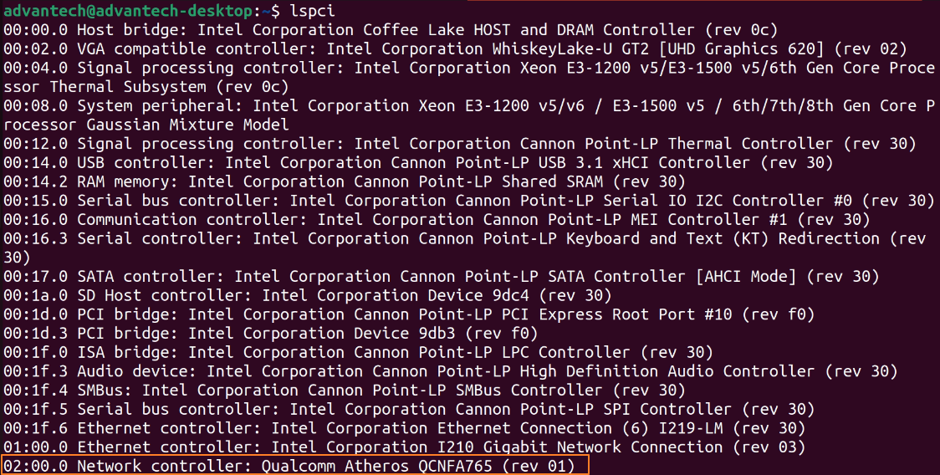

- Check the presence of Bluetooth hardware
# lsusb
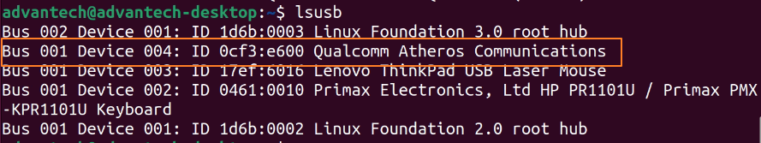

Test
After boot up, please login user account on Ubuntu, and refer following instructions to test module.

- Test by GUI

  - Wi-Fi
- Select the option Wi-Fi

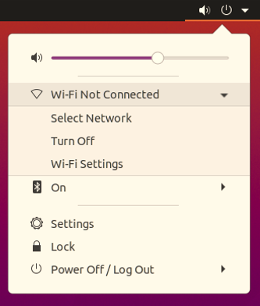

- Select the SSID of AP

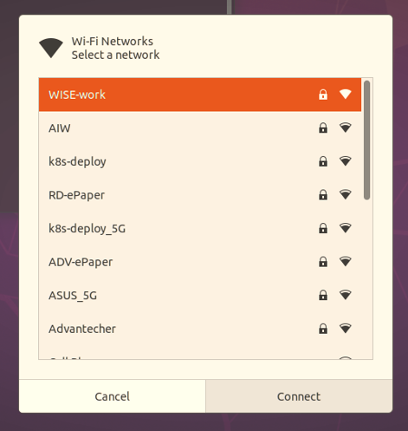

- Input your password of AP
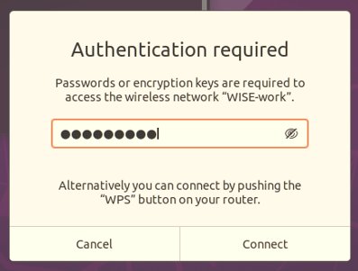

- Open the terminal to check interface and network connection
  - Check interface and you will see the interface as “wlp2sX”
# ifconfig
  - Check network connection after obtained IP address
# ping –c 3 8.8.8.8
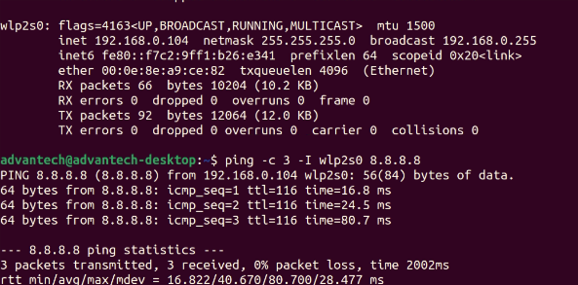

1.2 Bluetooth

- Select the option Bluetooth
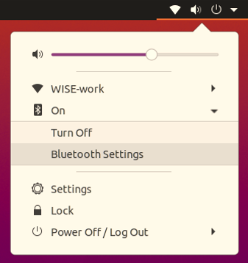

- You will see the result in scanning as below list
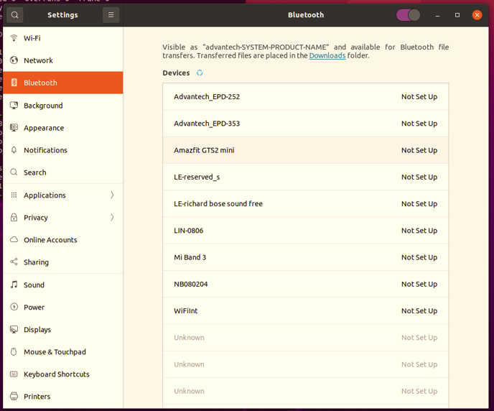

- Test by command line

  - Wi-Fi
- Stop some services
# sudo systemctl stop wpa_supplicant
# sudo systemctl stop NetworkManager

- Set Wi-Fi client configuration with /etc/wpa_supplicant.conf
E.g. Follows is set with AP with SSID as “TEST” and pre-shared key as
“123456789” to connect to Wi-Fi 4 (802.11n) or Wi-Fi 5 (802.11ac) AP

ctrl_interface=/var/run/wpa_supplicant
ctrl_interface_group=0
update_config=1
network={
ssid="TEST"
psk="123456789"
}

Or, refer to follows to connect to Wi-Fi 6 AP

ctrl_interface=/var/run/wpa_supplicant/
update_config=1
pmf=1
sae_pwe=1
network={
ssid="TEST"
proto=RSN
key_mgmt=SAE
ieee80211w=2
group_mgmt=AES-128-CMAC
psk="123456789"
}

- Enable Wi-Fi and check interface
# sudo rfkill unblock wifi
# sudo iwconfig
Note: you will see the interface like wlp2sX, e.g. wlp2s0

- Running wpa_supplicant
# sudo wpa_supplicant -s -B -i wlp2s0 -c /etc/wpa_supplicant.conf

- Get IP address by DHCP and check network connection
# sudo dhclient wlp2s0
# ping -c 3 8.8.8.8

  - Bluetooth
- Enable Bluetooth
# sudo rfkill unblock bluetooth

- Check Bluetooth interface
# hciconfig -a
Note: you will see the interface like hciX, e.g. hci0

- Turn on/off scan
# sudo bluetoothctl scan on

