EWM-C117 4G script auto run

Step 0 :
In /etc/systemd/system , create a 4G.service file
root@am335xepcr3220a1:/etc/systemd/system# vi 4G.service

4G.service:

[Unit]
Description=4G

[Service]
Type=oneshot
ExecStart=/mnt/4G_rndis.sh

[Install]
WantedBy=multi-user.target

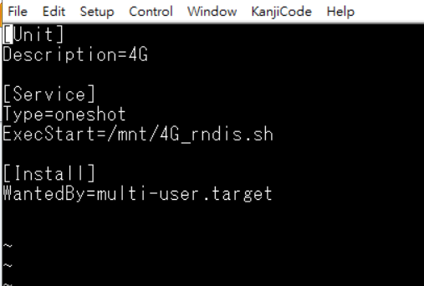

Step 1:
Copy 4G_rndis.sh into “mnt” folder

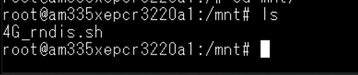

Step2:
root@am335xepcr3220a1:/# sudo systemctl enable 4G

Step3: reboot
Step 4: After reboot , check 4G.service
sudo systemctl status 4G

