WISE-EC FAQ
Category | WISE-EC | Date | 2018/01/19
Keyword | WISE-EC, WISE-1520,WISE-3610

- Question:
How to connect RMM server with WISE-1520?

- Instructions :

Step 1
Switch WISE-1520 to AP mode and connect to configuration page, then confirm the wifi profile already create.
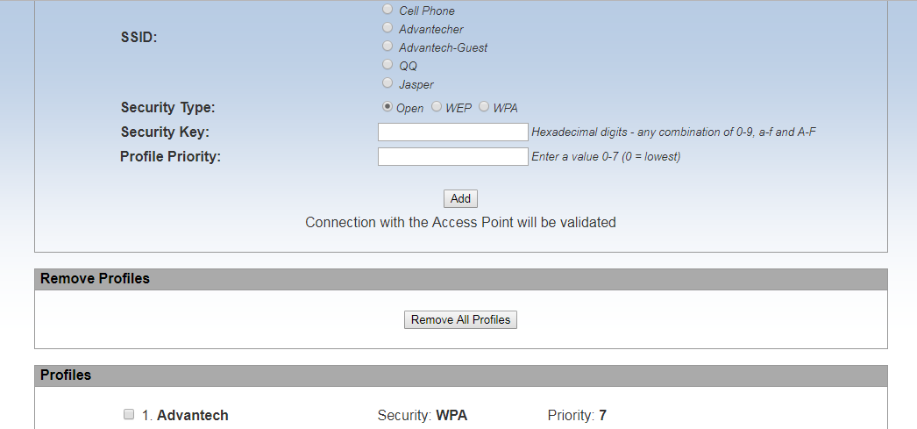
Step 2
Enter to “Device Config” section and input your RMM server (ex: 172.22.20.87) in the server name field
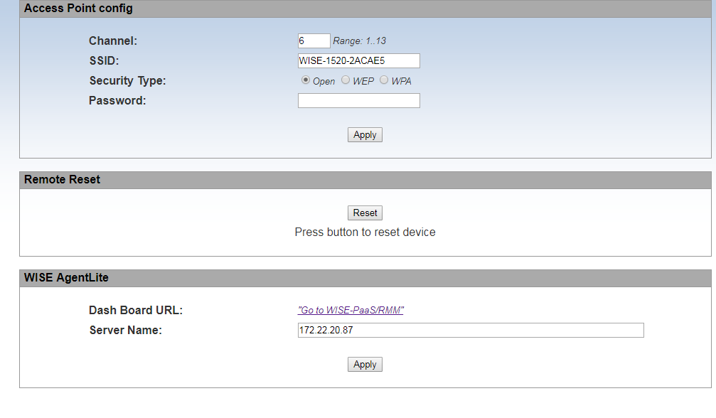
Step 3
Switch wise-1520 to station mode and press reset button to activate modify setting

Step 4
Make sure RMM server’s inbound port which already open at your server side (the port number is decided by the beginning of RMM server setup)
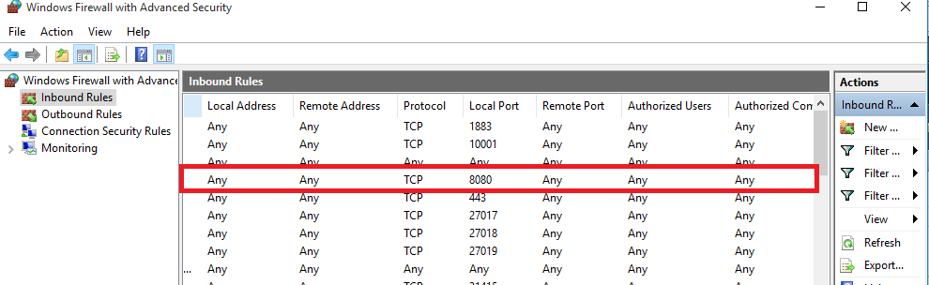

Step 5
Ensure your RMM server and wise-1520 are at same domain network
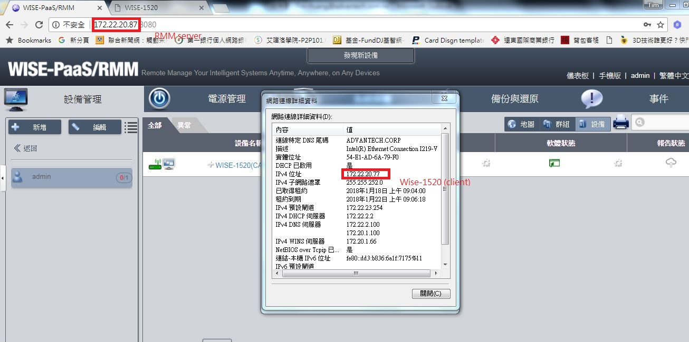

Step 6
After configuring above steps, try to login RMM server and add device by wise-1520’s mac address
