WISE-EC EPD FAQ
Category | EPD | Date | 20201111
Keyword | WISE-1810、EPD-023、EPD-053、WISE-3240

- Question:
Problem | Root cause
- Login failure | The server service has some problem
- Gateway is offline | Network or ePaper Manager IP setting are wrong
- Tag is disconnection or transmit image error | The signal is weak or the channel has interference or the power is not enough.
- Battery status is not correct | It is the battery character. When the battery does not supply the power, the power will recovery. You can see the power almost above 90%.
- Device name is error in the ePaper Manager | ePaper Manager will set the default value when the USB device doesn’t connect.

- Detail Solve Steps:
- Login Failure
After the ePaper Manager V1.5.1, you can check the service at the right bottom in the web page.
If the ePaper Manager version is below V1.3.6, you have to follow “EPD FAQ - How to reconnect all device in the ePaper Manager.docx” to restart all service.
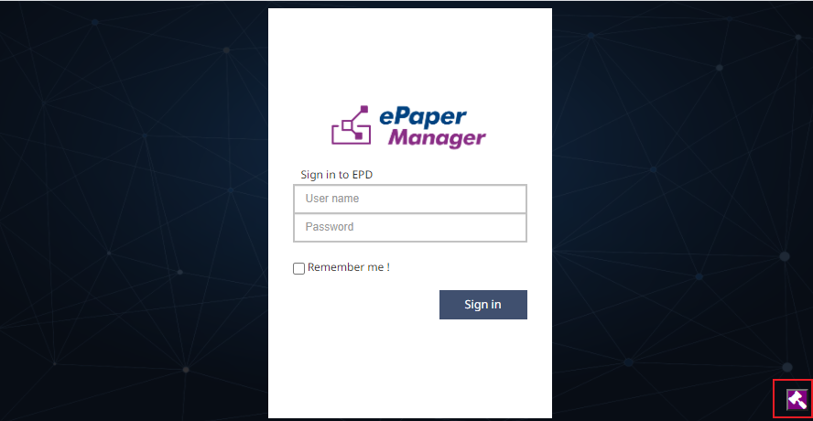

Click the “Start” to check all service
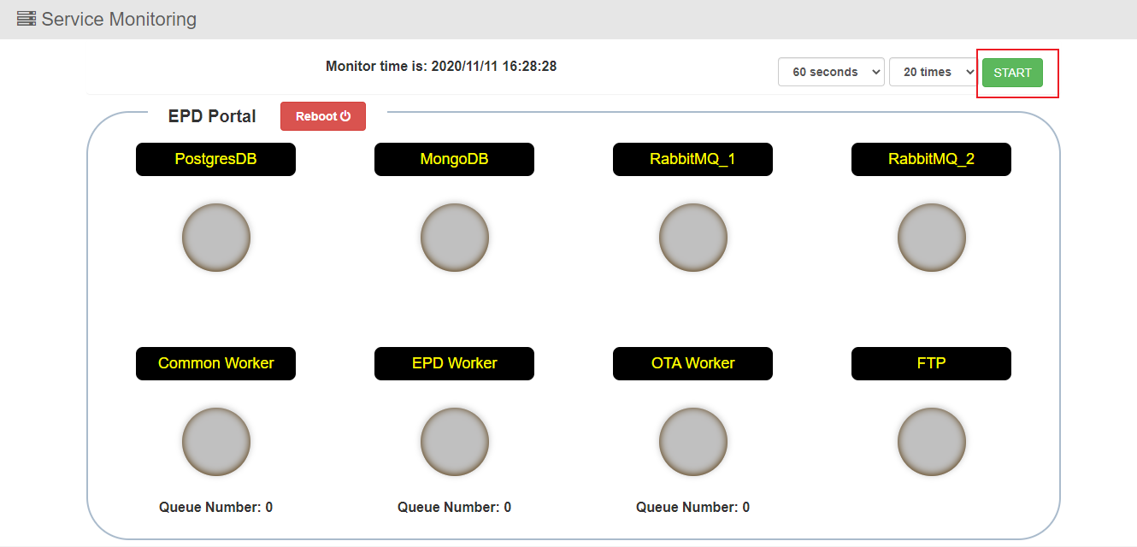

If one of the service is fail (red light), please click Reboot button to restart the system. If you still cannot login the system after reboot the system, please contact to product AE.
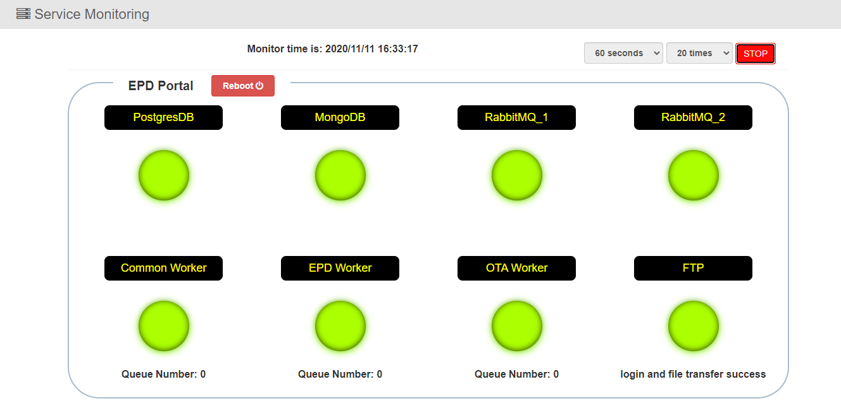

- Gateway is offline
Step1.
Please check the network status first. You can use “ping” command to check the WISE-32XX router is online or not.
Step2.
The ePaper Manager server IP is wrong in the WISE-32XX router. Please check the server IP address.
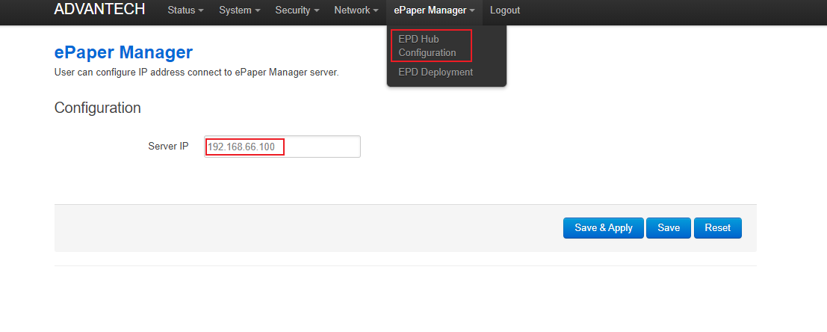

- Tag is disconnection or transmit image error
If the router is offline, the tag is also offline. Please check the router status first. When the router status is fine, the tag is still offline.
Maybe the tag is in the sleep mode. You have to press the any one of button on the tag. This action will wake tag up. If the tag is still offline, please change the tag battery.
- Battery status is not correct
The power will recovery is the battery characteristics. In the following photo, you can see the power less than 20% at beginning. After a while the battery recovery to more than 70%. In the ePaper Manager V1.6.0, it will keep the lowest power status. If your ePaper Manager version is less than V1.6.0 and you want to know the battery status. You have to check the battery status when the tag is flashing image.
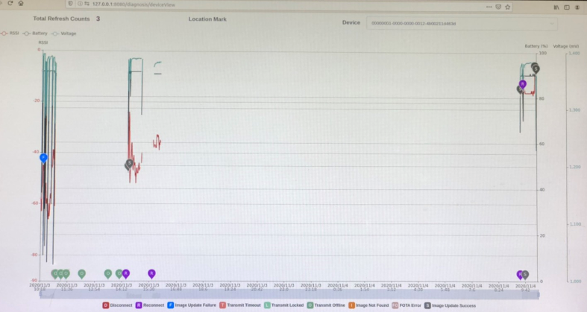

- Device name is error in the ePaper Manager
In some application, ePaper Manager will control tag by using USB. If you power on system first and plug in the USB. It will show the error device name in the ePaper Manager and you can not control the tag. Because the system will set the default device if the USB has no connection device. At that time, you change the USB device and the device name will not change in the ePaper Manager. Before you power on the system, the USB have been connected to the system. The system will update the device name in the ePaper Manager.

