How to Setup Network with AIW-357
on Ubuntu
Prerequisite
- PC and setup Ubuntu 20.04.3 LTS, 5.13.0-1008-intel on it
Please refer to the below picture for checking the jumper setting of M2_SEL1 pin1-2 to NC to support USB interface on ARK-1250.
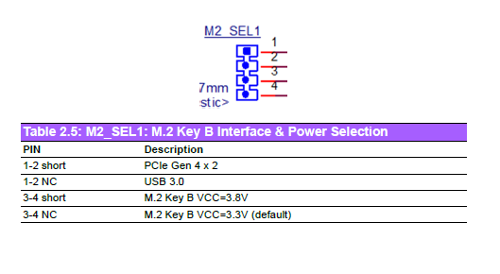

- Tarball file “aiw-357-mbim-set-ip.tar.bz2”

Network Test

- Stop modem manager
# sudo service ModemManager stop

- Prepare for MBIM
  - Install MBIM utility
# sudo apt-get install libmbim-utils
  - decompress the tarball aiw-357-mbim-set-ip.tar.bz2” and you will see the script “mbim-set-ip”
# tar jxvf “aiw-357-mbim-set-ip.tar.bz2”
  - Create the mbim configuration and copy it to /etc directory
# vi /etc/mbim-network.conf
Please fill your APN in the below orange rectangle

- Check SIM card information
# sudo mbimcli -d /dev/cdc-wdm0 -p --query-connection-state
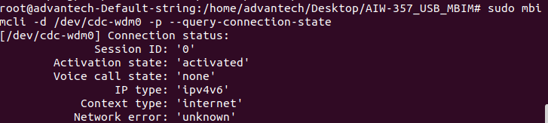

- Turn radio on
# sudo mbimcli -d /dev/cdc-wdm0 -p --set-radio-state=on
Note: please wait for 1-2 minutes to let module attaching to base station after running this command
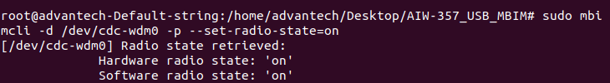

- Start network connection
# sudo mbim-network /dev/cdc-wdm0 start
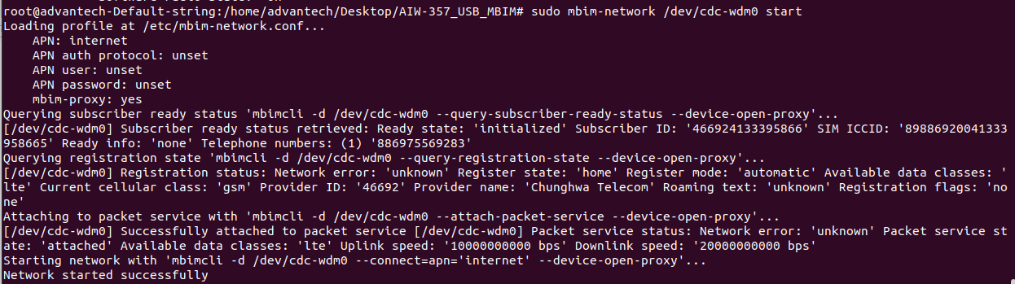

- Start network information with connection
# sudo ./mbim-set-ip /dev/cdc-wdm0 wwan0
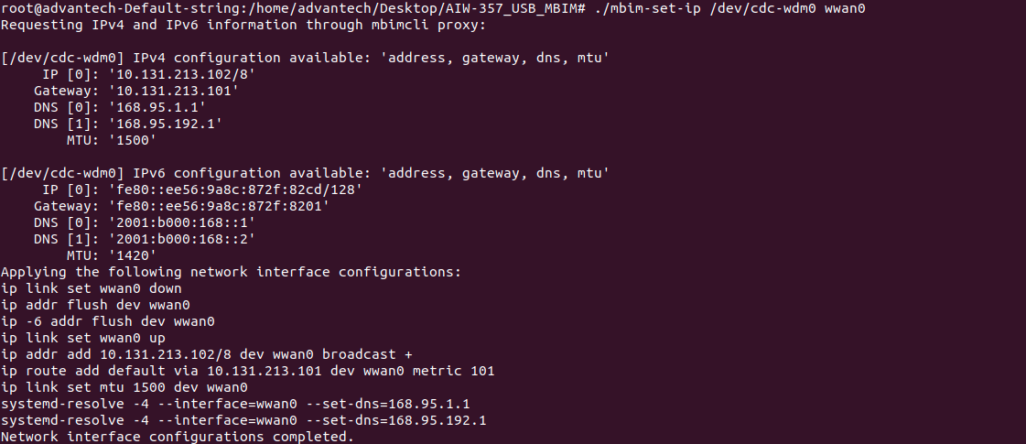
Note: change the access permission(sudo chmod 777 mbim-set-ip) if the“mbim-set-ip” cannot execute on terminal
- Ping test
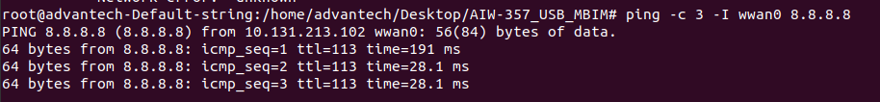
# ping -c 3 -I wwan0 8.8.8.8

GNSS Test

- Load driver to initialize COM ports with AIW-357
# sudo modprobe option
# sudo echo “0e8d 7129” > /sys/bus/usb-serial/drivers/generic/new_id
# ls /dev/ttyUSB*
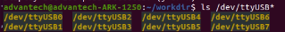
- Test with GNSS
Please use the passive antenna with GNSS.

- Start to run minicom and select the “Serial port setup”
# sudo minicom –s
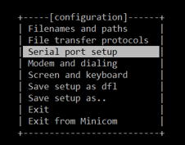

- Please set serial setting as below screenshot.
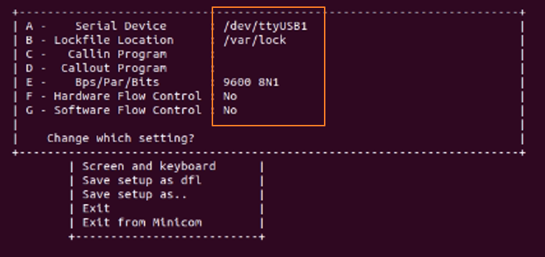

- Exit the setting and get into minicom console.
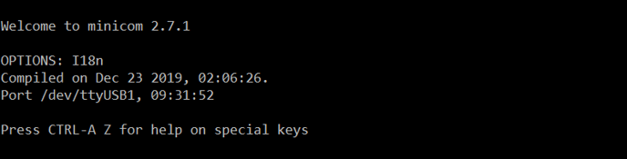

- Start to run GNSS by Linux command as below (choose either one)
# sudo sh -c "echo -n \"AT+ELCSSTART\r\n\" > /dev/ttyUSB1"
# sudo bash -c "echo -n -e '\x41\x54\x2b\x45\x4c\x43\x53\x53\x54\x41\x52\x54\x0d\x0a' > /dev/ttyUSB1"

  - Follow the below Linux command, you will see the longitude and latitude from module if start to run GNSS successful
# sudo cat /dev/ttyUSB1

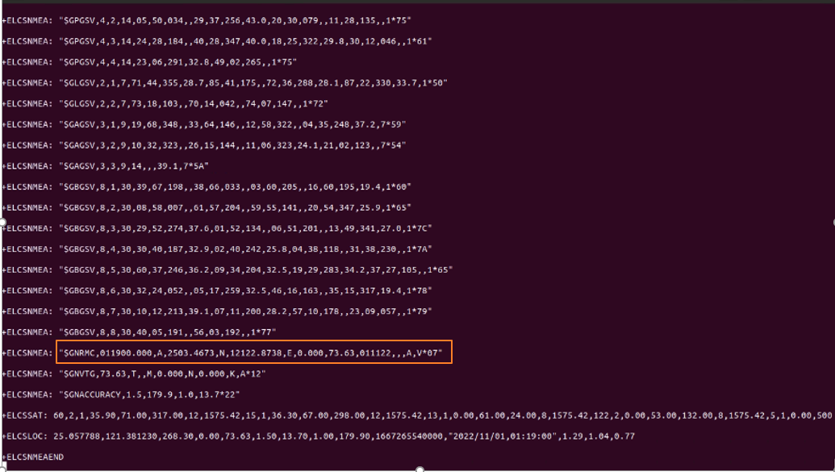

- Stop GNSS by Linux command as below (choose either one)
# sudo sh -c "echo -n \"AT+ELCSSTOP\r\n\" > /dev/ttyUSB1"
# sudo bash -c "echo -n -e '\x41\x54\x2b\x45\x4c\x43\x53\x53\x54\x4f\x50\x0d\x0a' > /dev/ttyUSB1"

