AIW(EWM) FAQ
Category | AIW/EWM | Date | 2022/09/21
Keyword | RTL8822CE, EWM-W159M201E, EWM-W193H01E, Ubuntu 20.04

- Question:
RTL8822CE driver installation guide on Ubuntu 20.04 with kernel 5.4.

- Instructions :
*Test with EWM-W193H01E*
- Download driver package via below link.
RTL8822CE_WiFi_linux_v5.12.1.8-2-g58609677a_COEX20210504-2323.20210923(52668).7z

2. Unzip “RTL8822CE_WiFi_linux_v5.12.1.8-2-g58609677a_COEX20210504-2323.20210923(52668).7z”.

- Access to “WiFi” folder, then decompress “RTL8822CE_WiFi_linux_v5.12.1.8-2-g58609677a_COEX20210504-2323.20210923.tar.gz”.

- Access to “RTL8822CE_WiFi_linux_v5.12.1.8-2-g58609677a_COEX20210504-2323.20210923” folder.

- Access to “driver” folder and decompress “rtl88x2CE_WiFi_linux_v5.12.1.8-2-g58609677a.20210923_COEX20210504-2323.tar.gz”.

- Access to “rtl88x2CE_WiFi_linux_v5.12.1.8-2-g58609677a.20210923_COEX20210504-2323” folder.

- Input command “make” with root permission to compile driver package to generate ko files.
*If "make" error, try to use below command to fix:
# apt install make
# apt install build-essential
If still can’t make it work, try to copy the whole “rtl88x2CE_WiFi_linux_v5.12.1.8-2-g58609677a.20210923_COEX20210504-2323” folder to other path, ex. desktop of PC then try to compile again.
After compiling successfully, there’re a few files generated, including “88x2ce.ko”.
- Try to insert driver with below command.
# insmod 88x2ce.ko
*If error -2 issue(could not insert module XXX: Unknown symbol in module) happens while trying to insert driver, trying to use below command to fix:
# modprobe cfg80211
# insmod 88x2ce.ko
Then driver should be able to be inserted successfully.
- Finally, input below command to install the driver so that the driver will be loaded automatically in the future.
# make install
Test result:
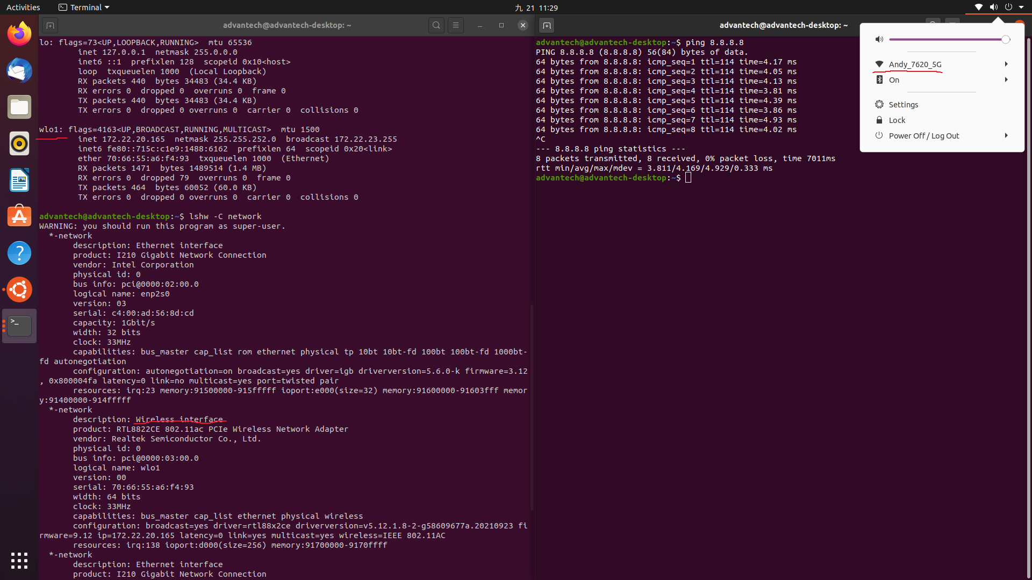

Platform information:
