AIW-154 Porting
AIW-154 Module is NXP (Marvell) PCIE-WLAN-UART-BT-8997 chip.

Support Yocto3.0 (Advantech RISC RSB-3710)

Get kernel source 5.4.70_2.3.0

#git clone https://github.com/ADVANTECH-Corp/linux-imx.git –b adv_5.4.70_2.3.0

Modify the kernel config (arch/arm64/configs/imx_v8_adv_defconfig)
-----------------------------------------------------------------------------------------------
Add CONFIG_MWIFI_PCIE_8997=m
Remove #CONFIG_MWIFI_PCIE_8997 is not set

Remove CONFIG_MWIFI_SDIO_8997=m
Remove CONFIG_MBT_SDIO_8997=m
Add # CONFIG_MWIFI_SDIO_8997 is not set
Add # CONFIG_MBT_SDIO_8997 is not set

Make kernel and dts
#cd linux-imx/
#source /opt/poky/3.0/environment-setup-aarch64-poky-linux
#make imx_v8_adv_defconfig
#make –j4 Image
#make -j4 freescale/imx8mp-rsb3720-a1.dtb

Make module and create module.tar.gz
#make -j4 modules
#mkdir ~/roofs
#make modules_install INSTALL_MOD_PATH=~/rootfs/
# cd ~/rootfs/lib/modules/
# tar zcvf 5.4.70-00015-g9ddadd71b1de-dirty.tar.gz 5.4.70-00015-g9ddadd71b1de-dirty/

Copy Image and dtb to SD
\linux-imx\arch\arm64\boot\Image
\linux-imx\arch\arm64\boot\dts\freescale\imx8mp-rsb3720-a1.dtb
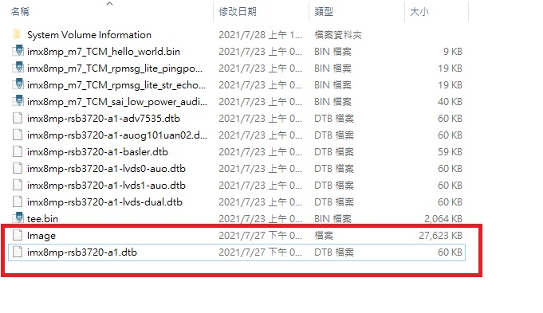
Copy rootfs.tar.gz to usb disk. Then copy to devices.
#mkdir /temp
#mount /dev/sda1 /temp
#cp -a /temp/0727/5.4.70-00015-g9ddadd71b1de-dirty.tar.gz /lib/modules/
#cd /lib/modules/
#tar zxvf 5.4.70-00015-g9ddadd71b1de-dirty.tar.gz

Modify the /etc/modprobe.d/advantech.conf
options pcie8xxx cfg80211_wext=0xf wfd_name=p2p cal_data_cfg=none drv_mode=7 fw_name=nxp/pcieuart8997_combo_v4.bin

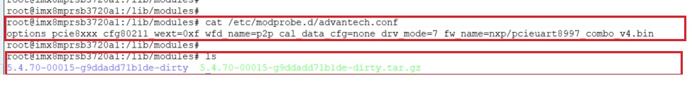

Then System Reboot.

(1)Command line to Connect
# ifconfig mlan0 up
# wpa_passphrase "XX" xx>/tmp/wpa.conf XX is WIFI ESSID , xx is password
# ifconfig eth0 down
# wpa_supplicant -d -B -i mlan0 -c /tmp/wpa.conf -Dnl80211
# udhcpc -i mlan0

(2)Shell script to Connect
#cd /
#/tools/wifi8997.sh XXXX xxxx XXXX is WIFI ESSID , xxxx is password

