WISE-1510、WISE-3610、WISE-1810 Debug method
Category | WISE-3610、WISE-1510、WISE-1810 | Date | 2018/07/23
Keyword | WISE-3610、WISE-1510、WISE-1810、Debug、Debug card

- Test Structure:
The detail of Wise-1510 debug structure is as below:
1. WISE-1510 model: The kernel of Lora model.
2. Antenna connector: Connect to the antenna.
3. WISE-DB1505: The platform of WISE-1510 provides many I/O port, and it could be replaced by WISE-DB1500-OIA1E.
4. USB port: Link the computer and the debug card.
5. WISE-ED20: By using the WISE-ED20 debug card, you can flash the WISE-1510 model firmware and check the log.
4
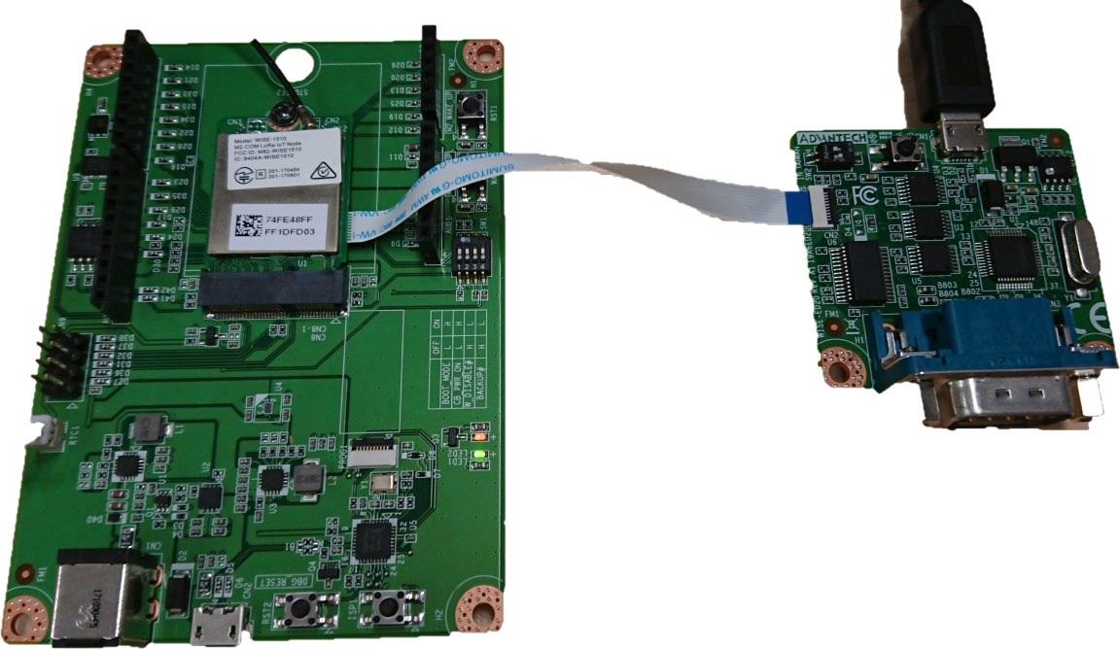
3
2

1
5

For setting the WISE-1510, you will need WISE-ED20 debug card, and you can connect it through serial port and node-cli.exe.

There are three ways to connect Wise-3610 debug structure. One is through the Wi-Fi, another is through the WAN port, and the other is through LAN port.
- Connecting the WISE-3610 with Wi-Fi port.
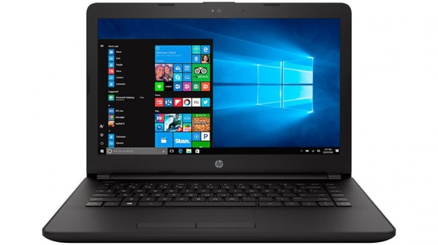
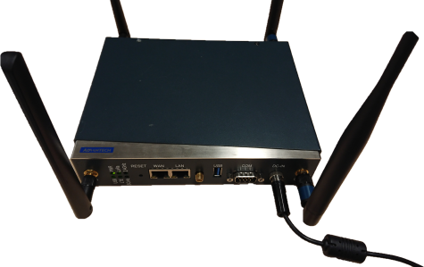

- Connecting the WISE-3610 with WAN port.
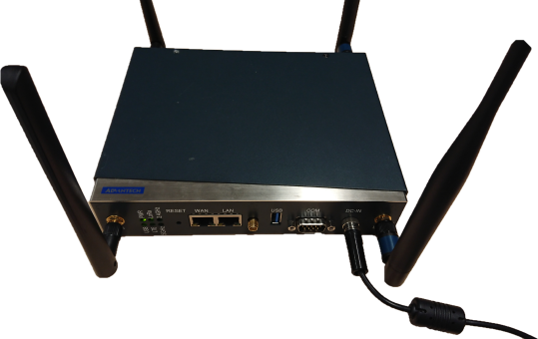

- Connecting the WISE-3610 with LAN port.
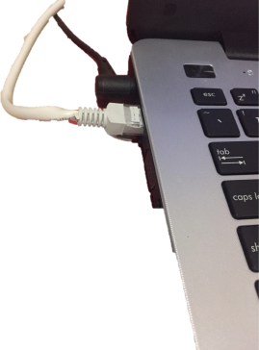

Check the WISE-1510 Lora node connects to the WISE-3610 Lora gateway.

- Debug method:
WISE-1510 Debug method:
You have to use “node_cli.exe” to log in the WISE-1510.
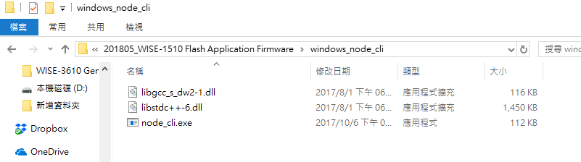

You will type “cmd” in the path and you will execute the “command prompt”.

In the command prompt, typing “node_cli.exe XXX” where XXX is the name of comport. In this example, the comport is com4 and you will see the information as below.
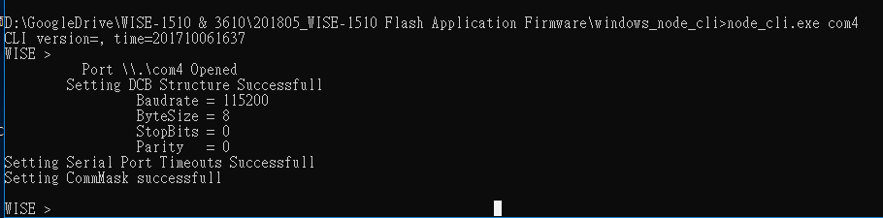

In the [V1.03 SDK], type “node lora debug 1” in the command line, and it will start to show debug message. Type “node lora debug 0” is turned off the debug message
In the [V1.04 SDK] or later, type “node lora debug 0xff” in the command line, and it will start to show debug message. Type “node lora debug 0” is turned off the debug message.

WISE-3610 Debug method:
- You can connect to the WISE-3610 by using ssh, and log in the WISE-3610 as root.
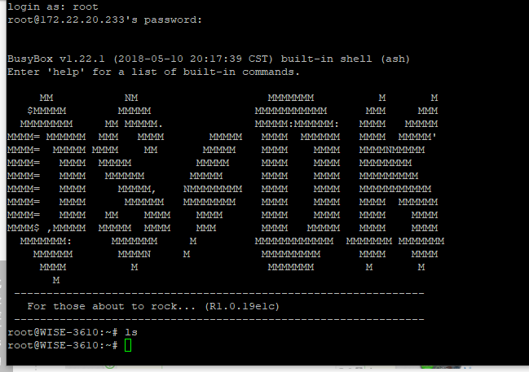

- Run "server_console" utility to check the validity of WISE-1810, and also turn on debug mask.

- When the WISE-1810 is running in the WISE-3610, you can use “server_console” command to get the WISE-1810 version information. (This step is to check WISE-1810 is still running. )
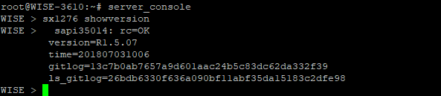

- Following, we enable debugging and redirect output to the WISE-3610 by using “sx1276 debug –mask 255 –port 1” command. If you want to disable debugging, using “sx1276 debug --mask 0 --port 0” command.

- When the debugging is enabling, the log will update in the “/var/log” folder. You can use “tail -f loraserver.log” to check final updated log.

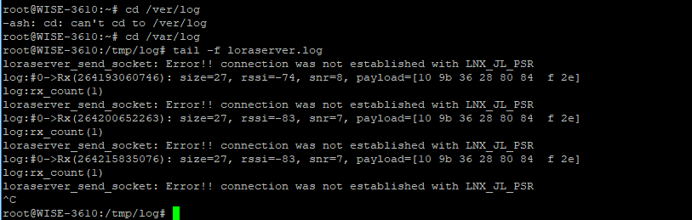

- Check if the following line keeps refreshing. This line means WISE-3610 still generates beacon.
ns_process_bcn_tmst: tmst(105691753), delta(2463535), time(1531120690283722), delt2456323)
or
log:#0->Tx(1017330951): freq=926900000, power=xx, 36 10 ...
This line means WISE-1810 transmits the beacon successfully.
7. Press "Ctrl+C" to terminate the output.
8. Upload the log to your PC using TFTP. (You've to run TFTP server on your PC in advance.)
# tftp -pl loraserver.log xxx.xxx.xxx.xxx
where xxx.xxx.xxx.xxx is IP address of your PC.
9. Send the log to RD for further analysis

WISE-3610 Log preserve
Due to WISE-3610 flash size limitation, loraserver.log is overwritten when its size reaches 2M bytes. If you want to keep all loraserver logs, you have to plug in a USB disk. And do following setting:
- Log in the WISE-3610
- Check if WISE-3610 has detected the USB drive by
#mount
…
/dev/sda1 on /mnt/usb type vfat (rw,relatime,fmask=0022,dmask=0022,codepage=437,iocharset=iso8859-1,shortname=mixed,errors=remount-ro)
- Create a loralog in /etc/config via vi editor to enable this feature.
- The loralog contain is like the following, you can just copy paste and then try again.
- config FTP 'FTP'
config TFTP 'TFTP'
config SD 'SD'
config USB 'USB'
option Enabled 'true'

Then you will observe whether loraserver_xxxxxx.log being tar and moved to the USB disk after 10 minutes.

Check WISE-1810 firmware version
If you want to check the WISE-1810 version, type “XXX.XXX.XXX.XXX/cgi-bin/luci/sysinfo ” in the URL where XXX.XXX.XXX.XXX is the WISE-3610 IP address.
