AIW-154 Porting
AIW-154 Module is NXP (Marvell) PCIE-WLAN-UART-BT-8997 chip.
Support Yocto3.0 (Example Device: Advantech RISC RSB-3710)

- Get kernel source 5.4.70_2.3.0
#git clone https://github.com/ADVANTECH-Corp/linux-imx.git –b adv_5.4.70_2.3.0

Modify the kernel config (arch/arm64/configs/imx_v8_adv_defconfig)
-----------------------------------------------------------------------------------------------
Remove
CONFIG_MWIFI_SDIO_8997=m
CONFIG_MBT_SDIO_8997=m
Add
CONFIG_MXMWIFIEX=m
# CONFIG_MWIFI_SDIO_8997 is not set
# CONFIG_MBT_SDIO_8997 is not set

**For 5.10.35
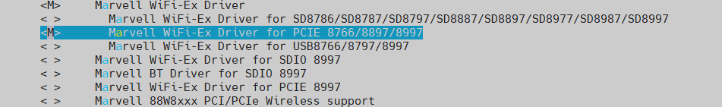

- Make kernel and dts
#cd linux-imx/
#source /opt/poky/3.0/environment-setup-aarch64-poky-linux
#make imx_v8_adv_defconfig
#make –j4 Image
#make -j4 freescale/imx8mp-rsb3720-a1.dtb

- Make module and create module.tar.gz
#make -j4 modules
#mkdir ~/roofs
#make modules_install INSTALL_MOD_PATH=~/rootfs/
# cd ~/rootfs/lib/modules/
# tar zcvf 5.4.70-00015-g9ddadd71b1de-dirty.tar.gz 5.4.70-00015-g9ddadd71b1de-dirty/

- Copy Image and dtb to SD (From Advantech Release Image )
\linux-imx\arch\arm64\boot\Image
\linux-imx\arch\arm64\boot\dts\freescale\imx8mp-rsb3720-a1.dtb
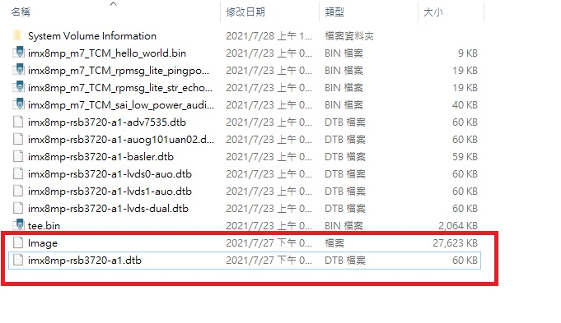
Copy rootfs.tar.gz to usb disk. Then copy to devices.
#mkdir /temp
#mount /dev/sda1 /temp
#cp -a /temp/0727/5.4.70-00015-g9ddadd71b1de-dirty.tar.gz /lib/modules/
#cd /lib/modules/
#tar zxvf 5.4.70-00015-g9ddadd71b1de-dirty.tar.gz

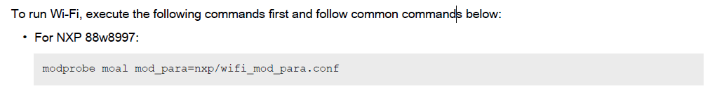
**For 5.10.35
Do not need modprobe moal.
Copy firmware to correct folder:
cp nxp/pcieuart8997_combo_v4.bin mrvl/

- WIFI
Command line to Connect
# ifconfig mlan0 up
# wpa_passphrase "XX" xx>/tmp/wpa.conf XX is WIFI ESSID , xx is password
# ifconfig eth0 down
# wpa_supplicant -d -B -i mlan0 -c /tmp/wpa.conf -Dnl80211
# udhcpc -i mlan0

- BT
$ hciattach /dev/ttymxc0 any 115200 flow
$ hciconfig hci0 up
$ hcitool -i hci0 cmd 0x3f 0x0009 0xc0 0xc6 0x2d 0x00
$ killall -9 hciattach
$ hciattach /dev/ttymxc0 any -s 3000000 3000000 flow
$ hciconfig hci0 up
$ bluetoothctl
discoverable on
pairable on
scan on
[NEW] FC:18:3C:8D:75:F4 myphone
scan off
pair FC:18:3C:8D:75:F4
connect FC:18:3C:8D:75:F4

