How to Setup WiFi/Bluetooth with AIW-169
Prerequisite
- MIO-5373 and build-in Windows 10 on it.
- Windows Driver.zip for AIW-169

Install Driver
- WiFi
Please install driver with “Setup.exe” as “Windows Driver\RTL8852CE\RTLWlanE_WindowsDriver_6001.16.119.0_Drv_3.00.0042.L(88302)\RTLWlanE_WindowsDriver_6001.16.119.0_Drv_3.00.0042.L\Setup.exe” after extract the file “Windows Driver\RTL8852CE\RTLWlanE_WindowsDriver_6001.16.119.0_Drv_3.00.0042.L(88302).zip” and follow the prompt to install driver.
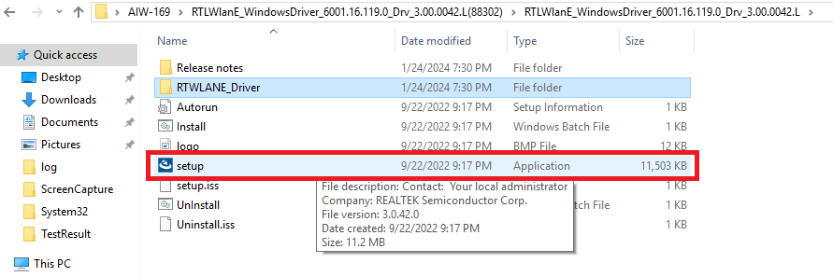
- Bluetooth
Window Device Manager will shows “Generic Bluetooth Adapter” under Bluetooth enumeration, so, you have to right click on the “Generic Bluetooth Adapter” and select “Update Driver” to install driver with “Windows Driver\RTL8852CE\RTBlueR_11ax_1.9.1051.3009_0907.2022_L(93023)\RTBlueR_11ax_1.9.1051.3009_0907.2022_L\x64\Rtkfilter.inf” after extract the file “Windows Driver\RTL8852CE\RTBlueR_11ax_1.9.1051.3009_0907.2022_L(93023).zip” and follow the prompt to install driver.
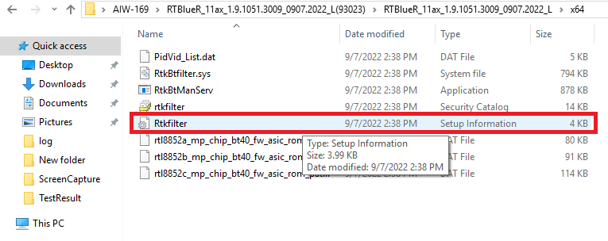

Check Device
- Before driver installed, the unknown device is displayed in “Device Manager”
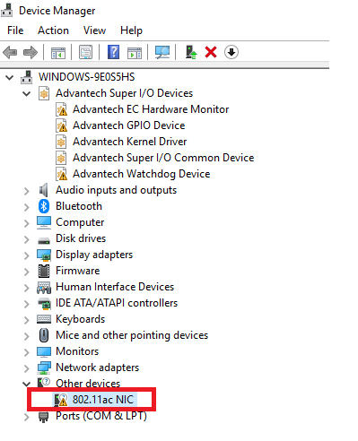

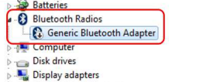

- After driver installed, you will see the snapshot as below

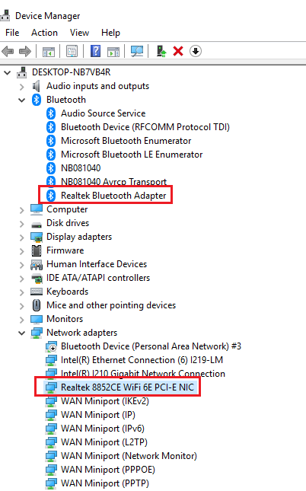
Function Test
- WiFi
Setup WiFi on Windows 10 and run the WiFi connection test with internet by Google Fiber Speed Test.
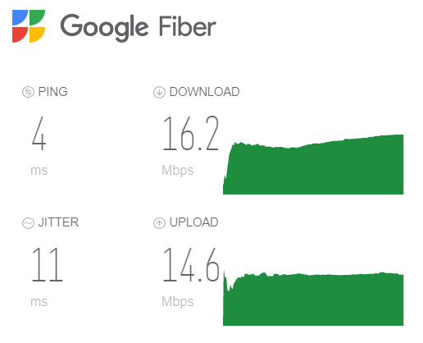

- Bluetooth
Scan devices by settings on Windows10.
Start menu button and select Settings -> Devices -> Bluetooth & other devices