**How to Setup Network with EWM-C359**

**Prerequisite**

* TREK-60 platform

Please refer to the below picture for finding SIM slot in SIM door and put the micro SIM card into it.

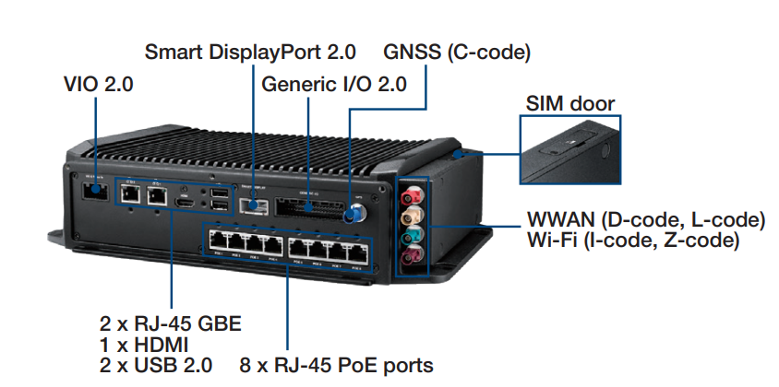

* Setup Windows 10

**Install Driver**

* Device driver

Please run the installer “SierraWireless_SDX55_Drivers_5154.exe” and follow the prompt to install driver.

**Check Device**

After driver installed, you will see the snapshot as below.

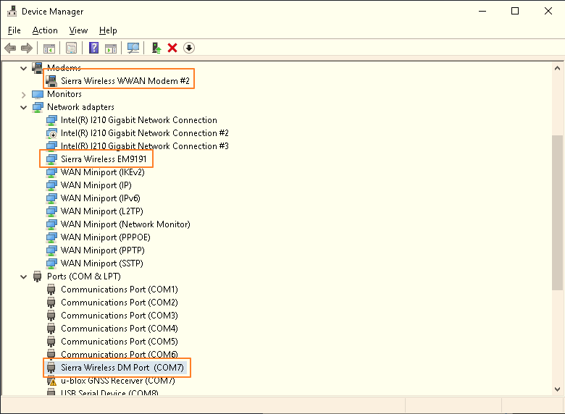

**Function Test**

1. Speed test

This is only for reference.

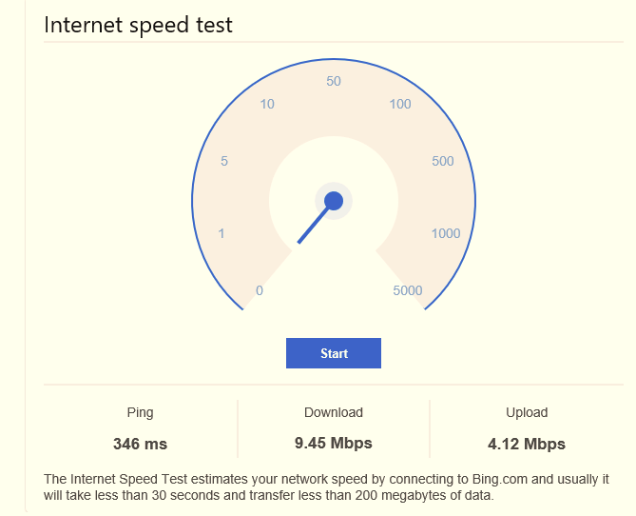

1. Reliability

Observe the ping test at least 6 hours.

1. AT command
2. Check the number of COM port with EM9191 in device manager.

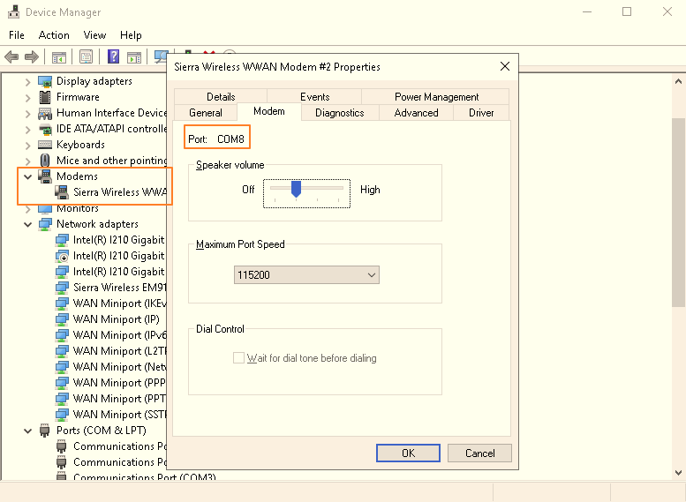

1. Access to AT command through terminal like putty.

Please make setting as below:

* + Baud Rate “9600”
  + Data bits "8"
  + Stop bits "1"
  + Parity "None"
  + Flow Control "None"

