**AIW/EWM FAQ**

|  |  |  |  |
| --- | --- | --- | --- |
| **Category** | AIW/EWM | **Date** | 2022/01/25 |
| **Keyword** | uAP (Software AP) ,AIW-154, Ubuntu 20.04 LTS,Linux kernel 5.8.0-53,X86,ARM platform support | | |

* **Question:**

How to setup software AP function when running AIW-154 on ubuntu linux OS?

* **Instructions :**

1. Download whole AIW-154 software package by attached file and decompress on your desktop

<https://advantecho365-my.sharepoint.com/:u:/g/personal/tim_huang_advantech_com/EWskDIWGfwhDoLXCNfGmQJYB12MQ_QLn_CqGU__l5cXgPw?e=piSDVo>

1. 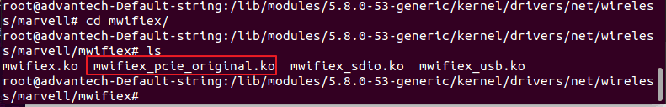Rename original inbox driver to avoid activating when system boots up

(/lib/modules/5.8.0-53-generic/kernel/drivers/net/wireless/marvell/mwifiex)

**Note:rename the filename from “mwifiex_pcie.ko” to “mwifiex_pcie_original.ko”**

1. Copy “nxp” whole folder under “/lib/firmware/”directory

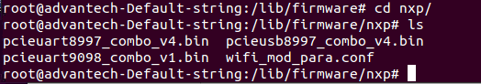

1. Compile driver package to generate ko files by “make”

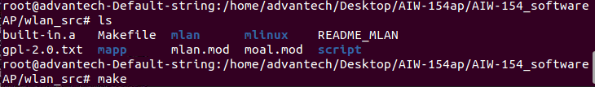  
NOTE: If your system is ARM base, please remember to modify the makefile before driver compiling

* Remark the x86 related configuration to switch for ARM base system

**ARCH ?= arm64**

**#ARCH ?= x86**

**#KERNELVERSION_X86 := $(shell uname -r)**

**#KERNELDIR ?= /lib/modules/$(KERNELVERSION_X86)/build**

<For X86 platform>

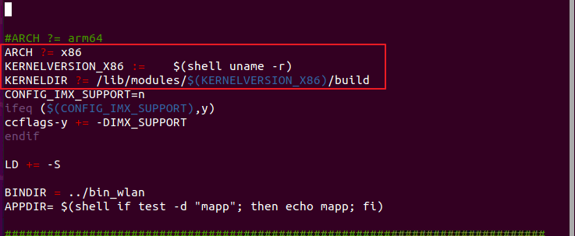

1. Make sure both of driver ko files generate success in your directory

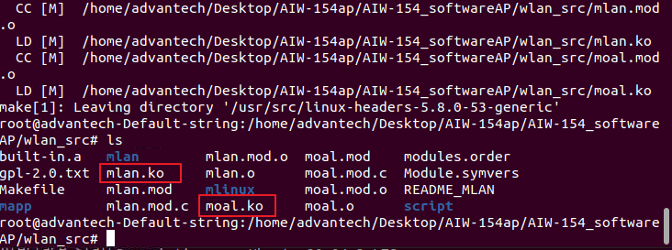

1. Insert driver and active software ap function by following command

* insmod mlan.ko
* insmod moal.ko mod_para=nxp/wifi_mod_para.conf drvdbg=0x7 cal_data_cfg=none
* Check these interfaces appear by “ifconfig”

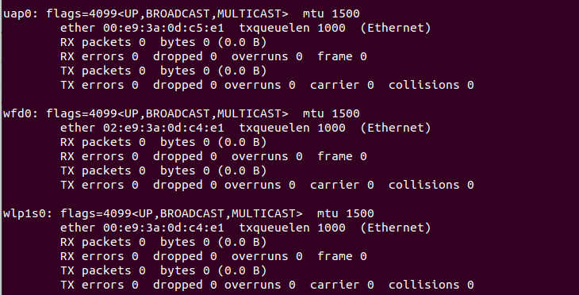

1. Create a new folder and fill in your ip table rules

* mkdir /etc/iptables/
* iptables -t nat -A POSTROUTING -o eth0 -j MASQUERADE
* iptables -A FORWARD -i eth0 -o uap0 -m state --state RELATED,ESTABLISHED -j ACCEPT
* iptables -A FORWARD -i uap0 -o eth0 -j ACCEPT
* iptables-save > /etc/iptables/iptables.rules

**Notice: the eth0 is my interface name of ethernet and ensure the name is correct before filling**

1. Create iptables service in specific directory (/lib/systemd/system/iptables.service) and enable the iptable process by commands

**<service_example>**

[Unit]

Description=IPv4 Packet Filtering Framework

Before=network-pre.target

Wants=network-pre.target

[Service]

Type=oneshot

ExecStart=/usr/sbin/iptables-restore /etc/iptables/iptables.rules

ExecReload=/usr/sbin/iptables-restore /etc/iptables/iptables.rules

RemainAfterExit=yes

[Install]

WantedBy=multi-user.target

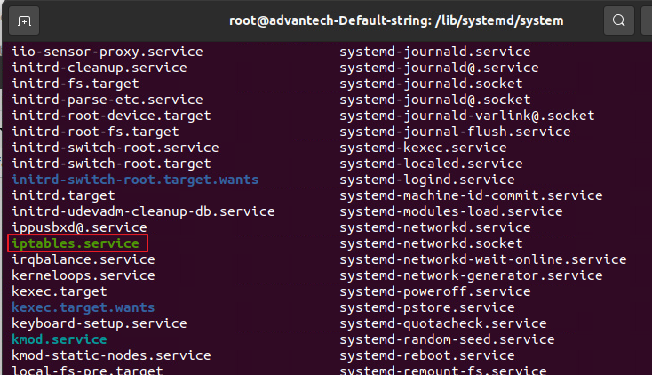

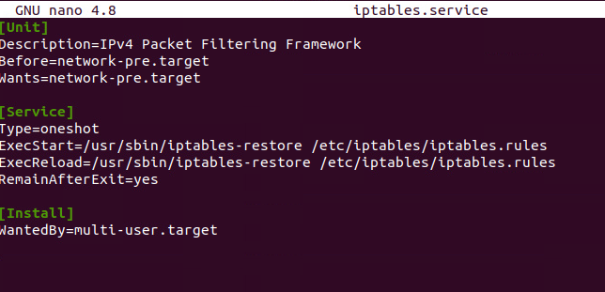

* systemctl –system daemon-reload
* systemctl enable iptables

1. Enable network packet forwarding setting on specific file (/etc/sysctl.conf) and save it

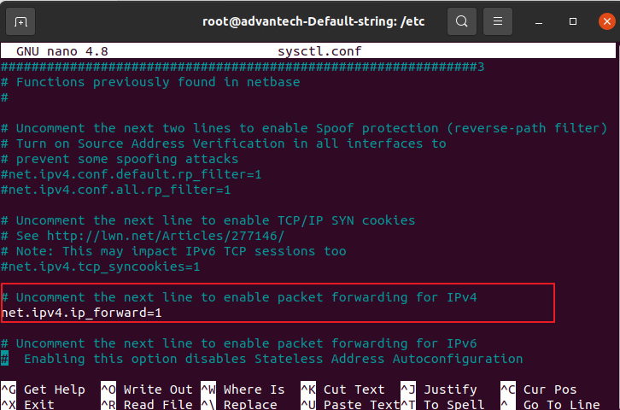

1. Install related software package(hostapd, udhcpc) and copy hostapd.conf & udhcpd.conf into “/etc/” directory

* sudo apt-get install hostpad
* sudo apt-get install udhcpd

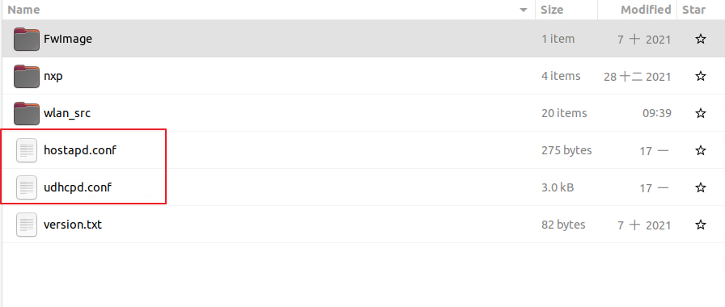

<Example_udhcpd.conf>

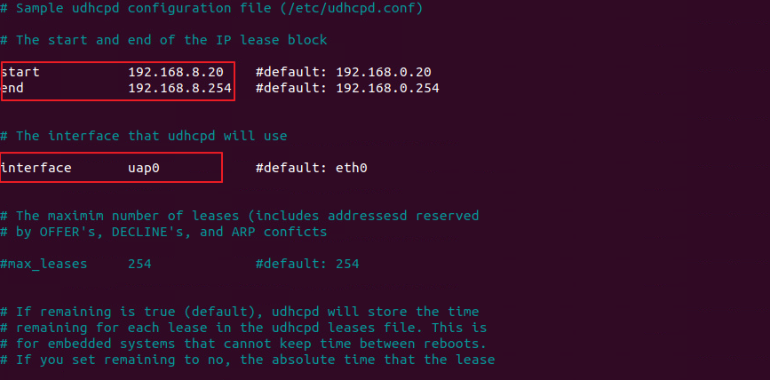

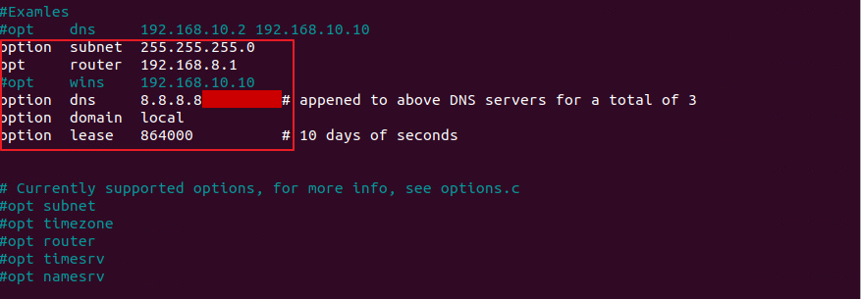

<Example:hostapd.conf>

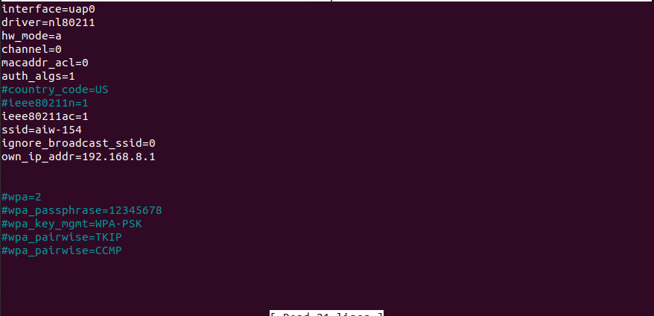

1. Activate udhcpd and check if the process is working under system background

* udhcpd /etc/udhcpd.conf &
* ps aux | grep udhcpd

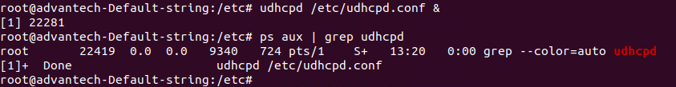

1. assign ip to your software ap (uap0)

* ifconfig uap0 192.168.8.1 netmask 255.255.255.0 up

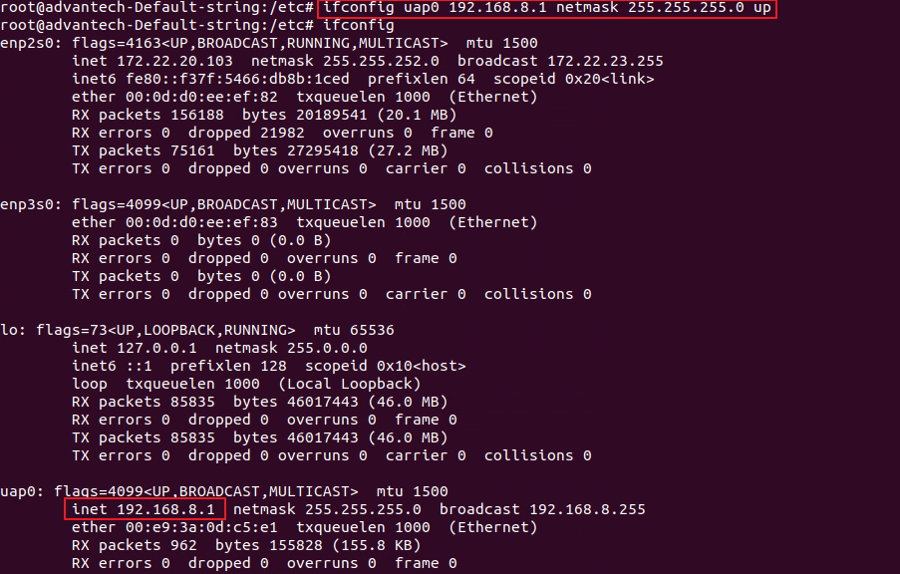

1. Active hostpad to start up your AP

* Hostapd hostapd.conf &

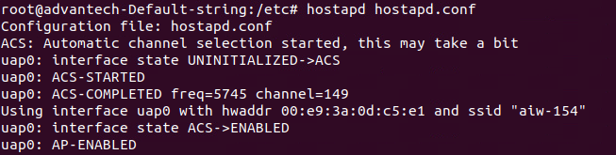

1. Try to connect your hotspot from other device and you will see the connection is established by following prompt message

