How to Setup WiFi/Bluetooth with EWM-W15UR
Prerequisite
MIO-5391 and build-in Windows 10 on it.

Install Driver
- WiFi
Please select install driver directory to “RTLWlanU_WindowsDriver_1030.42.0910.2020\” after extract the file “Windows\WiFi\RTLWlanU_WindowsDriver_1030.42.0910.2020.zip” and follow the prompt to install driver.
- Bluetooth
Window Device Manager will shows “Generic Bluetooth Adapter” under Bluetooth enumeration, so, you have to right click on the “Generic Bluetooth Adapter” and select “Update Driver” to install driver directory with “RTBlueR_Windows10_FilterDriver_1037.3003_0511.2021\RTBlueR_Windows10_FilterDriver_1037.3003_0511.2021_new_L” after extract the file “Windows\BT\RTBlueR_Windows10_FilterDriver_1037.3003_0511.2021.zip” and follow the prompt to install driver.

Check Device
- Before driver installed, the unknown device is displayed in “Device Manager”
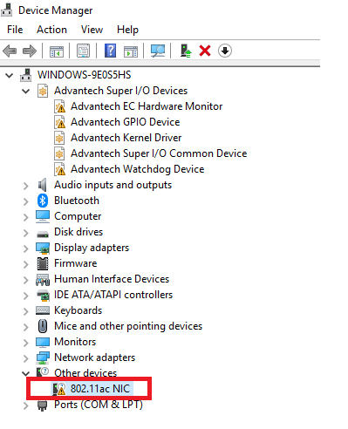

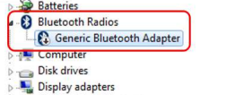

- After driver installed, you will see the snapshot as below

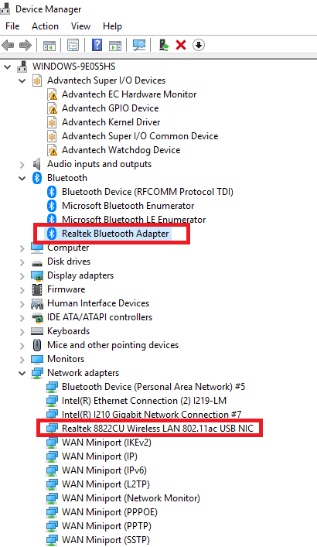
Function Test
- WiFi
Setup WiFi on Windows 10 and run the WiFi connection test with internet by Google Fiber Speed Test.
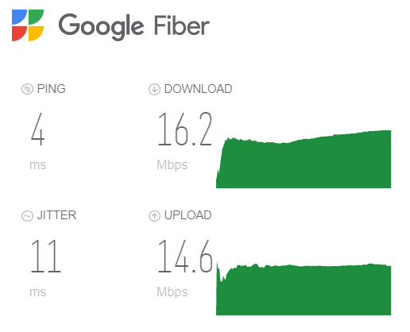

- Bluetooth
Scan devices by settings on Windows10.
Start menu button and select Settings -> Devices -> Bluetooth & other devices