How to Setup GNSS with AIW-213
Prerequisite
- TS-207 and mSATA storage build-in Windows 10 Pro (22H2)
- AIW-213 module
- GNSS active antenna
- ubox u-center utility

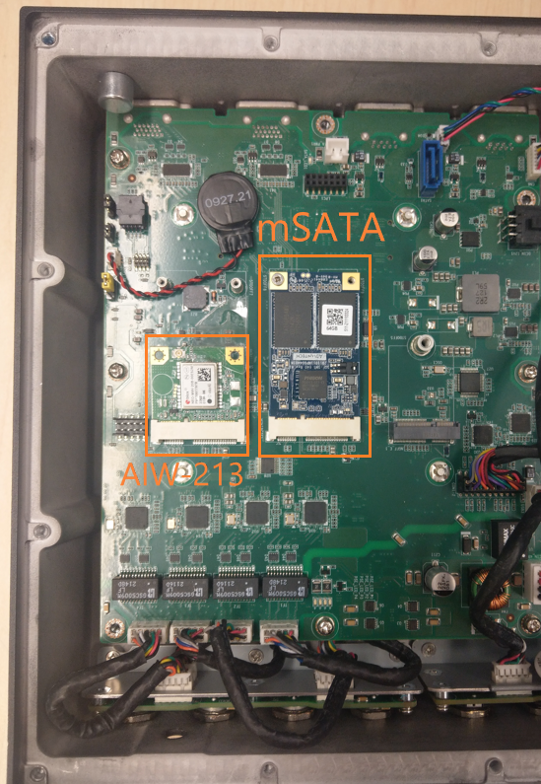

Install Utility
Please run the installer “u-center_v20.01.exe” and follow the prompt to install ubox u-center.

Check Serial Port
The serial port is present with driver free in “Device Manager”.
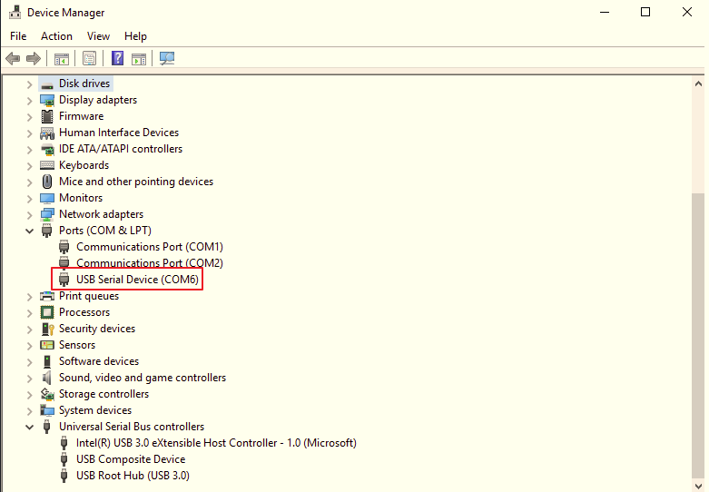

Get data by u-center
- Open u-center via “All Programs > u-blox > u-center > u-center” and you will see the snapshot like below.
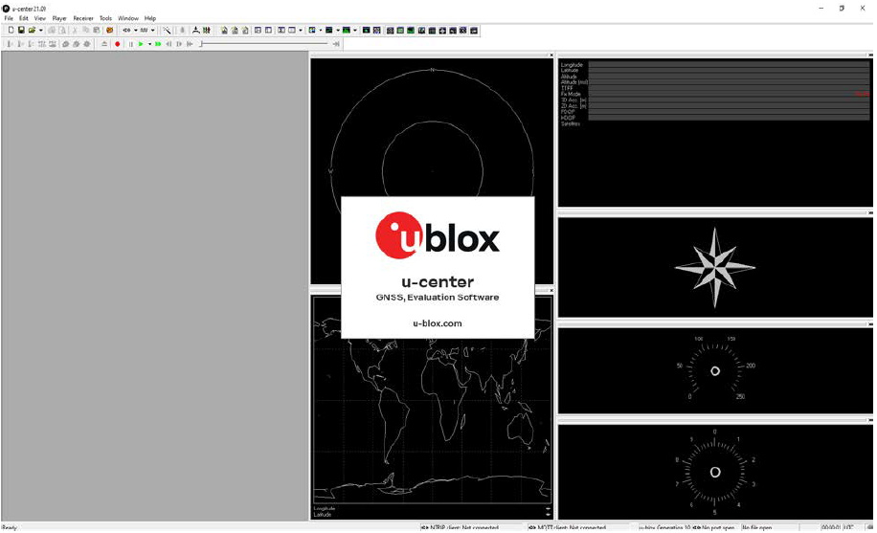

- Select the serial port
Locate the communication toolbar and click on the arrow as the below icon. This will show a list with all available COM ports. Select the corresponding COM port where the receiver is connected.

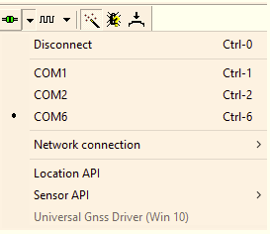

- Set baud rate with serial port
In the communication toolbar, click on the below icon. This will show a
list with all available baud rates. Select the baud rate to 38400 on which the receiver is communicating. If u-center is able to decode data from the receiver, the status bar begins to blink in green. This means that the connection is established successfully and the communication between the receiver and u-center is working. Now you are ready to use the receiver.

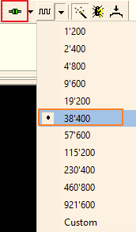

- Show message on text console
In standard menu bar, click on the “View” menu. This will show a
list with menu entries. Select “Text Console” entry like below.

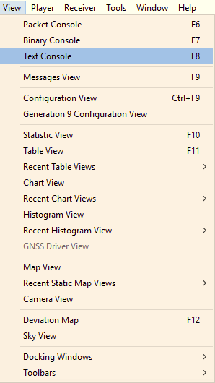

- Display message
Note that please setup attena in outdoor, it will show messages as below snapshoot.
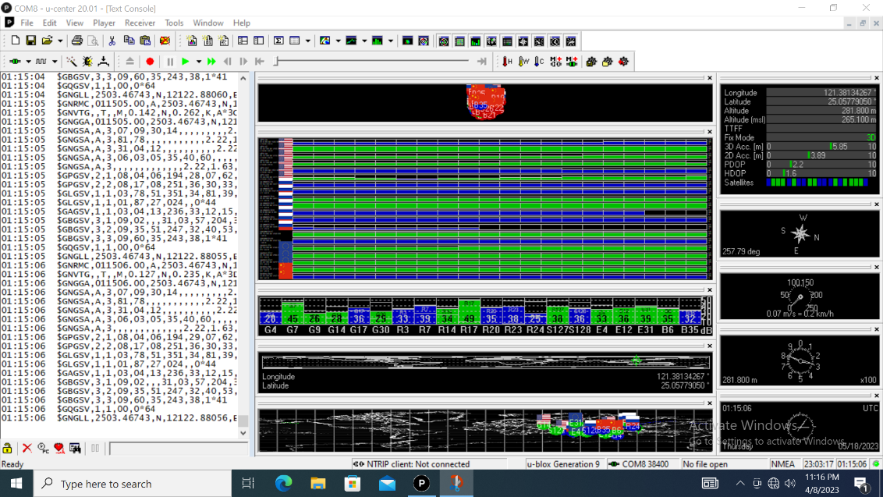

More Information
Please refer to u-center user guide for more information if needed. The user can find out the user guide via “All Programs > u-blox > User Guide” and you will see the snapshot like below.

