How to enable WiFi/Bluetooth with EWM-W180
Prerequisite
- MIO-5272 with Ubuntu 22.04 (Linux 5.17.15) on it
- Install WiFi driver with rtl88x2CU_WiFi_linux_v5.14.0-50-gce1b24864.20220218_COEX20210504-2323_sparklan_v4.tar.gz with following commands.
- tar xzvf rtl88x2CU_WiFi_linux_v5.14.0-50-gce1b24864.20220218_COEX20210504-2323_sparklan_v4.tar.gz
- cd rtl88x2CU_WiFi_linux_v5.14.0-50-gce1b24864.20220218_COEX20210504-2323
- modprobe cfg80211
- sudo insmod ./88x2cu.ko

Test
- Test by GUI

  - Wi-Fi
- Select the option Wi-Fi

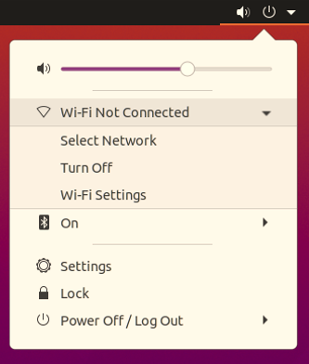

- Select the SSID of AP

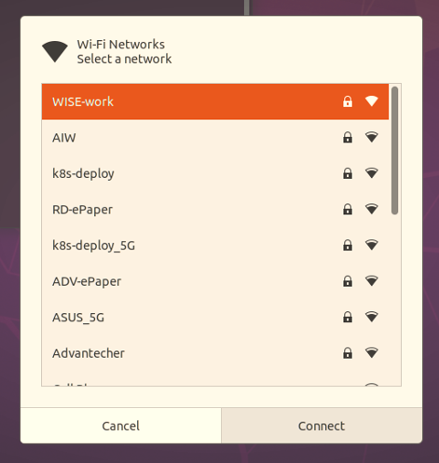

- Input your password of AP
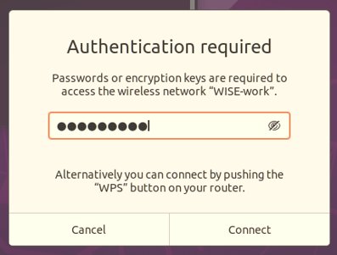

- Open the terminal to check interface and network connection
  - Check interface and you will see the interface as “wlx00XXXXXXXXXX”
# iwconfig
  - Check network connection after obtained IP address
# ping –c 3 8.8.8.8
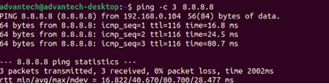
1.2 Bluetooth

- Select the option Bluetooth
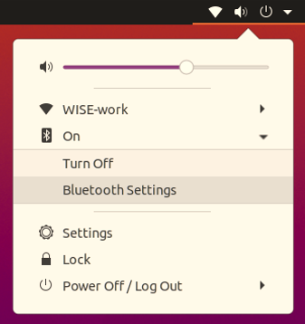

- You will see the result in scanning as below list
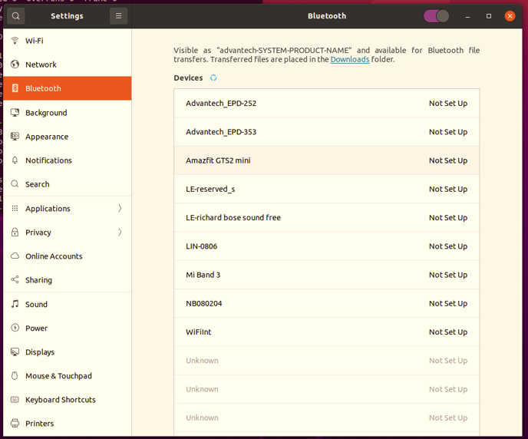

- Test by command line

  - Wi-Fi
- Stop some services
# sudo nmcli radio wifi off
# sudo systemctl stop wpa_supplicant.service
# sudo systemctl mask wpa_supplicant.service

- Create configuration
# echo ‘ctrl_interface=/run/wpa_supplicant’ > /tmp/wpa.conf
# echo ‘update_config=1` >> /tmp/wpa.conf
# wpa_passphrase "XX" YY >> /tmp/wpa.conf
Note: XX: SSID, YY: Password

- Enable WiFi and check interface
# sudo rfkill unblock wifi
# sudo iwconfig
Note: Wi-Fi interface’s information will be shown by iwconfig.

- Running wpa_supplicant
# sudo wpa_supplicant -d -B -i wlx00XXXXXXXXXX -c /tmp/wpa.conf
Note: wlx00XXXXXXXXXX is Wi-Fi interface name which can be known by iwconfig.

- Get IP address by DHCP and check network connection
# sudo dhclient wlx00XXXXXXXXXX
# ping -c 3 8.8.8.8

  - Bluetooth
- Enable Bluetooth
# sudo rfkill unblock bluetooth

- Check interface of bluetooth
# hciconfig -a
Note: you will see the interface like hciX

- Turn on/off scan
# sudo bluetoothctl scan on

