**AIW(EWM) FAQ**

|  |  |  |  |
| --- | --- | --- | --- |
| **Category** | AIW | **Date** | 2024/09/05 |
| **Keyword** | EWM-W179M201E, Windows 10/11, driver, Bluetooth | | |

* **Question:**

How to install Bluetooth driver for EWM-W179M201E on Windows 10/11?

* **Instructions :**

**Driver:**

[EWM-W179M201E Windows driver.zip](https://advantecho365-my.sharepoint.com/:u:/g/personal/tim_huang_advantech_com/Eaido5cFqUNIoB8AulXVCdYBfEtkC9Kz64n0p-ZNlBZoqA?e=h5yTvf)

-Download driver package and unzip it.

**Steps:**

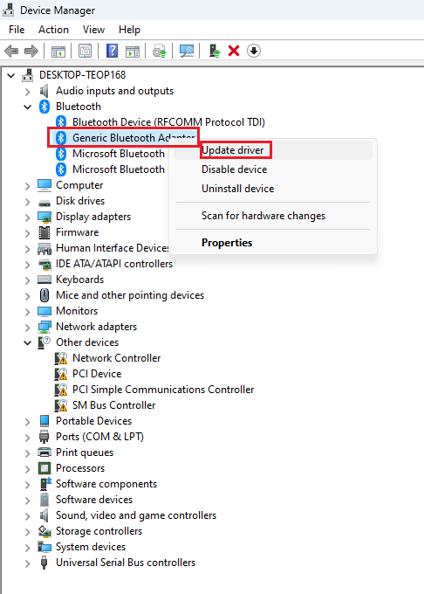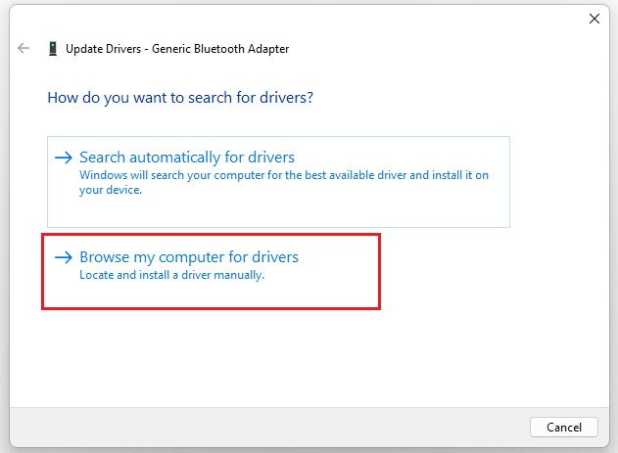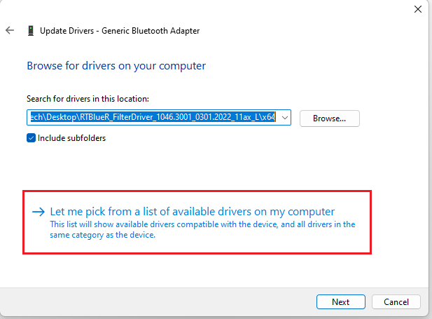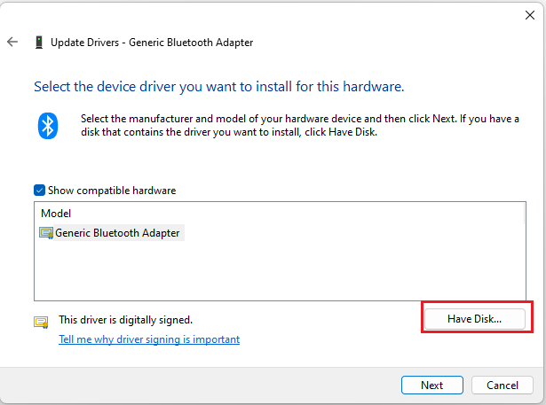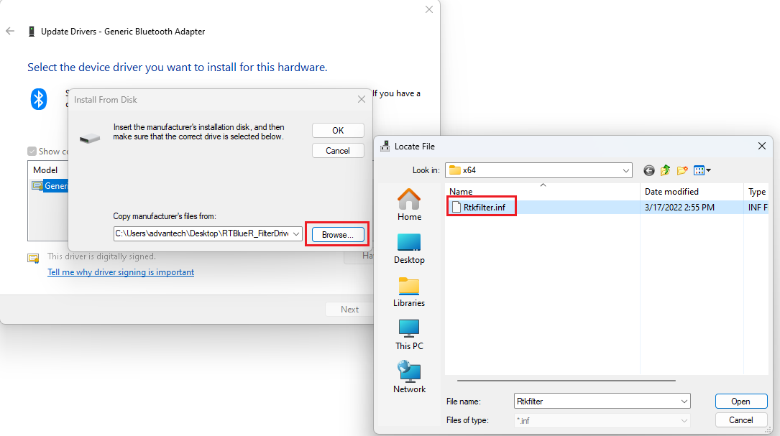

**\* Browse to the EWM-W179M201E BT driver package folder and select the .inf file.**

**/RTBlueR_FilterDriver_1046.3001_0301.2022_11ax_L/x64**

