How to enable WiFi/Bluetooth with EWM-W179
Prerequisite
- EPC-R7200 with Ubuntu 18.04.5 (kernel v4.9.201) or RSB-3720 with Linux kernel v5.4.70 on it

- Stop system background daemons by following commands with root user permission
#systemctl stop systemd-networkd
#systemctl stop NetworkManager
#rmmod rtk_btusb

- Copy WiFi driver (8852be.ko) and Bluetooth driver (including rtk_btusb.ko, rtl8852bu_fw and rtl8852bu_config) to one USB stick and plugged into one USB port of platform.

Test WiFi
- Bring up WiFi driver :
- Bring up WiFi driver with 8852be.ko if mount USB stick underlying “/media/ubuntu/USB_Disk”
# cp /media/ubuntu/USB_Disk/8852be.ko /tmp/
# sudo modprobe cfg80211
# insmod /tmp/8852be.ko
Note: you will see the interface wlan0 by “ifconfig –a” comman
# rfkill unblock wifi
# ifconfig wlan0 up

- Test with WiFi AP
- Set WiFi client configuration with /etc/wpa_supplicant.conf
(as follows as AP “TEST” with pre-shared key “123456789” as
example for your reference)

# cat /etc/wpa_supplicant.conf
ctrl_interface=/var/run/wpa_supplicant
ctrl_interface_group=0
update_config=1
network={
ssid="TEST"
psk="123456789"
}

# wpa_supplicant -i wlan0 -c /etc/wpa_supplicant.conf -B
# udhcpc -i wlan0 (for RSB-3720)
Or, #dhclient wlan0 (for EPC-R7200)

- If AP is configured with internet connection, user can use ping to check the internet availability as follows.
  - Check network connection after obtained IP address
# ping 8.8.8.8

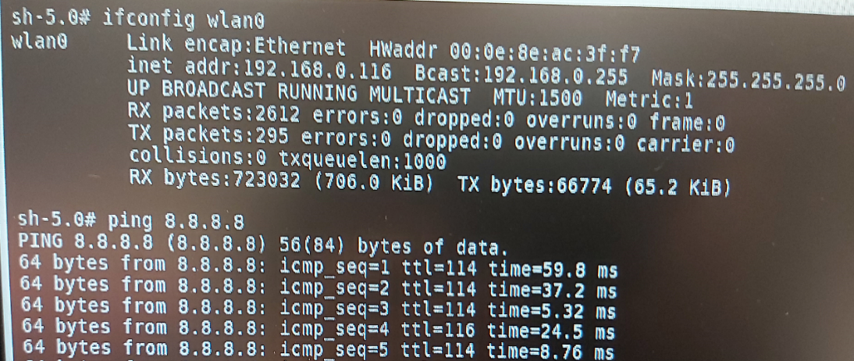

Test Bluetooth

- Bring up Bluetooth driver with follows if have mount USB stick underlying /media/ubuntu/USB_Disk

# cp /media/ubuntu/USB_Disk/rtk_btusb.ko /tmp/
# cp /media/ubuntu/USB_Disk/rtl8852bu* /lib/firmware/
# insmod /tmp/rtk_btusb.ko
Note: you will see the interface hci0 by “hciconfig –a” command

- Using Bluetooth with following commands
# hciconfig hci0 up
# bluetoothctl
[bluetooth]# scan on
[bluetooth]# scan off
If there are any Bluetooth devices nearby you will see some devices listed by “devices” command as follows.
[bluetooth]# devices

[ Notes ] EPC-R7200 has some compatibility issue on Bluetooth that cannot connect
with some Bluetooth gadget.

