How to enable WiFi/Bluetooth with AIW-162

Prerequisite
- ROM-5880 (SOM-DB2510) with Debian 10.13 (Linux kernel v4.19.232) on it
- Stop system background daemons by following commands with console utility.
#systemctl stop NetworkManager
#killall wpa_supplicant
- Extract “AIW-162_FW.zip” and copy files to one USB stick and plugged into any one USB port of SOM-DB251 platform and follows WiFi/ Bluetooth test steps next.
- AIW-162_FW.zip is including
- WiFi driver and firmware files:
bcmdhd.ko,
fw_bcm43752a2_pcie_ag.bin,
nvram_ap6275p_mp.txt,
clm_bcm43752a2_pcie_ag.blob

2) Bluetooth firmware: BCM4362A2_001.003.006.1059.1089.hcd

.

Test WiFi
- Bring up WiFi driver :
- Bring up WiFi driver with bcmdhd.ko if mount USB stick underlying /run/media/sda1
# cp /run/media/sda1/bcmdhd.ko /system/lib/modules/
# cp /run/media/sda1/fw_bcm43752a2_pcie_ag.bin
/vendor/etc/firmware/
# cp /run/media/sda1/nvram_ap6275p_mp.txt
/vendor/etc/firmware/nvram.txt
# cp /run/media/sda1/clm_bcm43752a2_pcie_ag.blob
/vendor/etc/firmware/

# insmod /system/lib/modules/ bcmdhd.ko
Note: you will see the interface wlan0 by “ifconfig –a” command
# ifconfig wlan0 up

- Test with WiFi AP
- Using editor (such as Vim) to create WiFi client configuration in /etc/wpa_supplicant.conf
(Following is one example as one AP named as “TEST” with pre-shared key
“123456789” for your reference)

# cat /etc/wpa_supplicant.conf
ctrl_interface=/var/run/wpa_supplicant
ctrl_interface_group=0
update_config=1
network={
ssid="TEST"
psk="123456789"
}

# wpa_supplicant -i wlan0 -c /etc/wpa_supplicant.conf -B
# dhclient wlan0

- If AP is configured with internet connection, user can use ping to check the internet availability as follows.
  - Check network connection after obtained IP address
# ping 8.8.8.8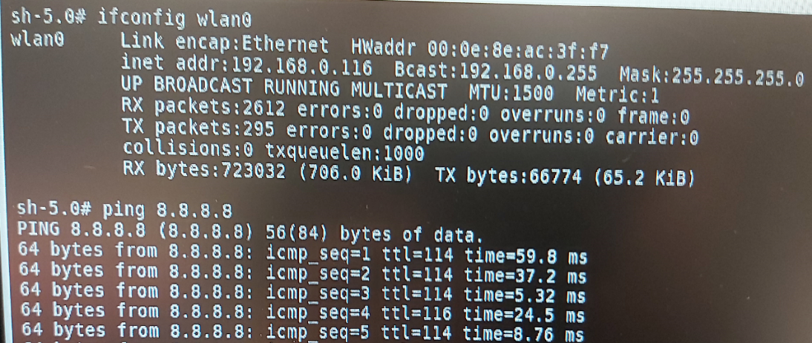

Test Bluetooth

- Bring up Bluetooth Interface
- Bring up Bluetooth driver with follows if have mount USB stick underlying /run/media/sda1

# cp /run/media/sda1/BCM4362A2_001.003.006.1059.1089.hcd
/vendor/etc/firmware/BCM4362A2.hcd

# brcm_patchram_plus1 -d --enable_hci --no2bytes --tosleep 200000 –
baudrate 1500000 --patchram /vendor/etc/firmware/BCM4362A2.hcd
/dev/ttyS4 &

[ Notes ]
- Please wait seconds for “brcm_patchram_plus1” commane to finish
- If you see following console snapshot which means the patch is done
successfully , and then the interface “hci0” is ready by
checking with “hciconfig –a” command.

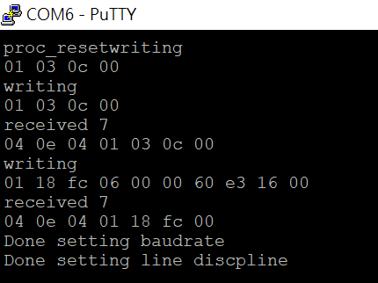

- Test Bluetooth Interface
- Using Bluetooth with following commands
# hciconfig hci0 up
# bluetoothctl
[bluetooth]# scan on
[bluetooth]# scan off
If there are any Bluetooth devices nearby you will see some devices listed by “devices” command as follows.
[bluetooth]# devices

