WISE-EC FAQ
Category | WISE-EC | Date | 2018/01/16
Keyword | WISE-EC, WISE-1520,WISE-3610

- Question:
How to verify the wifi profile is configured successfully when connecting wise-1520 in Station mode?

- Instructions :

Step 1
Ensure all of equipment already Set up at your side
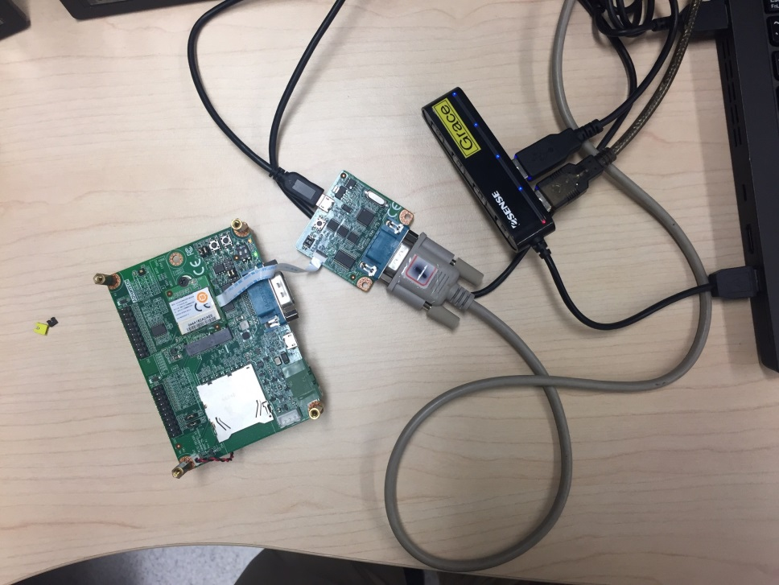
Step 2
Refer to our internal detail SOP to make sure all of steps configure proper
https://drive.google.com/open?id=1YvPKC3P9rDuzgJLeud_mQx3xlnKLztsL

Step 3
[mobile_Hotspot]
When you login to wise-1520 setting webpage, please ensure the profile can be created so that can connected proper in station mode

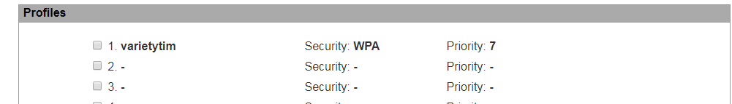

Step 4
Set into AP mode
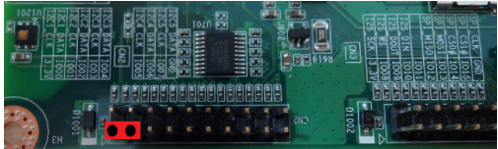

Step 5
Press reset button and check the output message on console and the connection can be established successfully
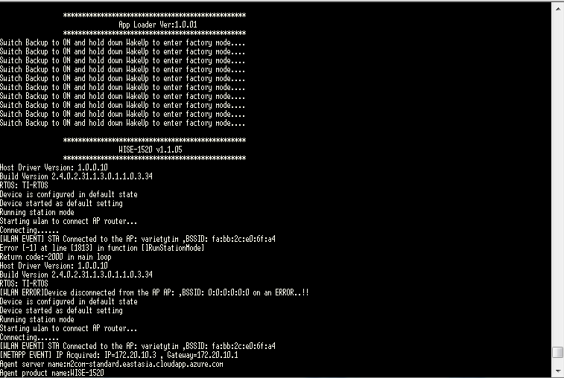

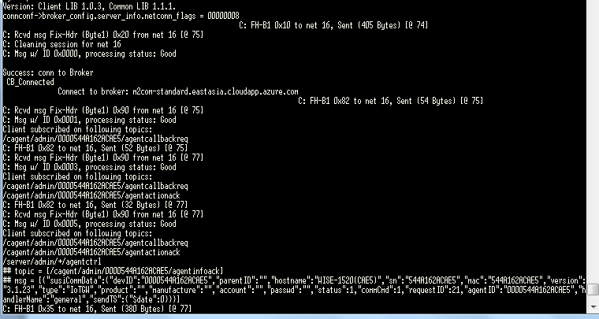

[Wise 3610]
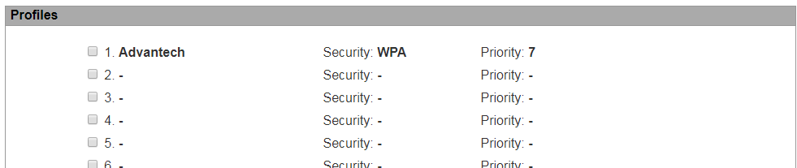

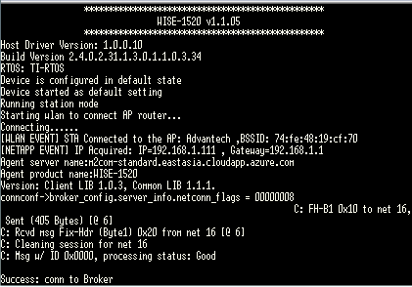

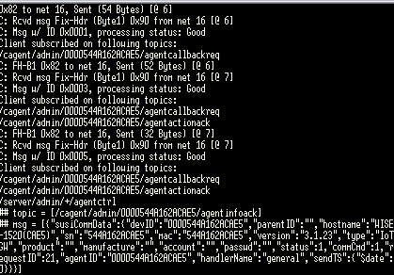
- Issue Clarification:
- We don’t have wise-3620 at our side that is the reason why I test on wise-3610.
the model is difference, but it may not the root cause of this problem on your testing. <the only different is with/without LoRa module between wise-3610 and wise-3620>
- If the connection still cannot connect after above instructions, please record a video during your testing for further investigation.

