**AIW(EWM) FAQ**

|  |  |  |  |
| --- | --- | --- | --- |
| **Category** | AIW(EWM) | **Date** | 2023/05/23 |
| **Keyword** | ARK-1250L, generic Ubuntu 20.04, Ubuntu 22.04, Intel platform, AIW-355, AIW-356, AIWTool | | |

* **Question:**

How to fix AIWTool(v0307) issue while trying to change to MBIM mode on generic Ubuntu 20.04 and 22.04(kernel 5.15) with AIW-355?

* **Issue Symptom:**

After execute ./setup.sh & ./dialout.sh, the dialout process can’t finish normally.

Open the other terminal and input “ifconfig”, it returns “Killed”. And system seems to be abnormal.

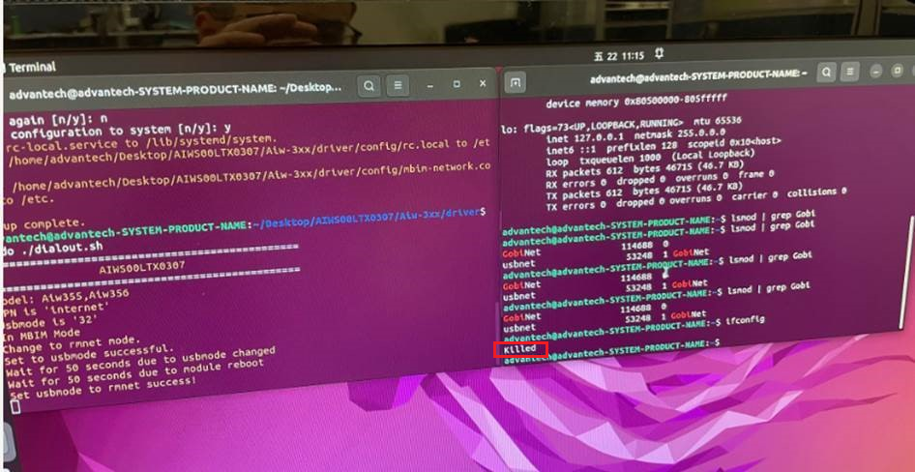

Sometimes, the system just crashed and hang after executed ./dialout.sh. Users have to reboot to make system recover.

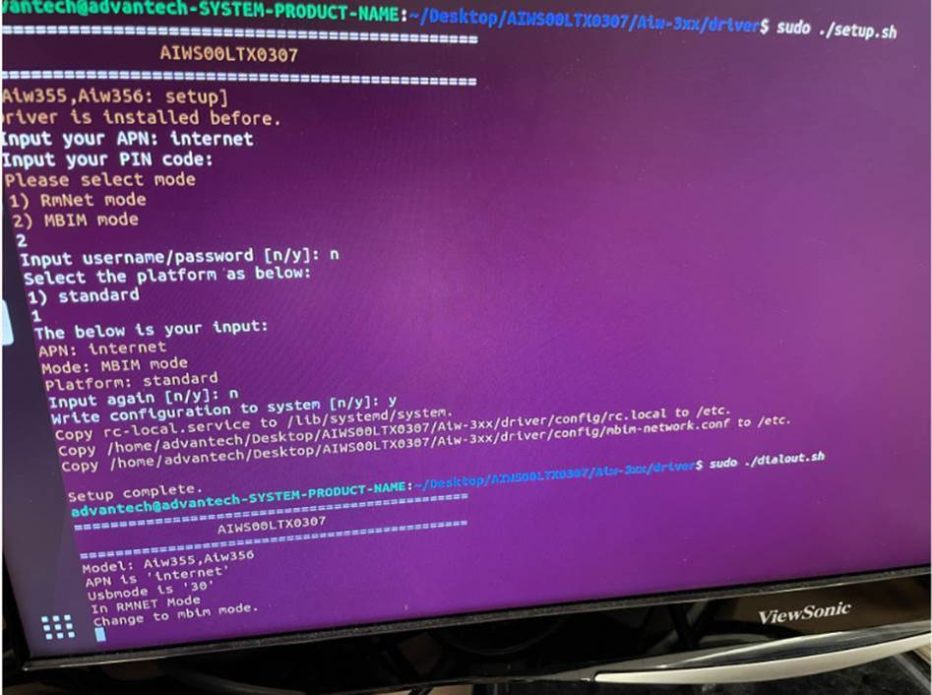

* **Analysis :**

If without AIWTool, issue still can be reproduced with following steps.

1. Make sure AIW-355 in Rmnet mode(at+gtusbmode=32)
2. Manually insert GobiNet.ko，$ sudo insmod GobiNet.ko

*GobiNet driver is version 2.01.00.06

1. Access the module com port via minicom to change mode，from Rmnet to MBIM mode(at+gtusbmode=30)

Even when I try to unload driver GobiNet.ko manually (module is in Rmnet mode), issue happens immediately after command “sudo rmmod GobiNet.ko”.

* **Conclusion :**

Issue can be reproduced without AIWTool which means that the issue is not related to AIWTool.

Instead, while unloading driver GobiNet.ko, then issue happens so the root is related to GobiNet.ko driver v2.01.00.06 and generic Ubuntu 20.04 or 22.04 with kernel 5.15.

To fix this issue, please download and install Intel IoT OS for Intel platform then check whether issue has been fixed or not.

<https://ubuntu.com/download/iot/intel-iot>

I’ve tested locally on ARK-1250L with Ubuntu 20.04(kernel 5.15.0-1016-intel-iotg) and issue doesn’t exist anymore.

