Technical Document
Category | WISE-PaaS/OTA | Date | 2018/01/03
Topic | How to remotely update BIOS with WISE-PaaS/OTA?
Keyword | WISE-PaaS/OTA 3.0.9, BIOS update/flash, AfuWin64, Windows

- Suggestion:
Instructions in this FAQ are intended to walk you through on how to remotely update BIOS under Windows utilizing Advantech’s WISE-PaaS/OTA software

Prerequisite:
- OTA server/agent v3.0.9 & OTAPackager 1.0.9
- FTP storage connected with OTA server (either on OTA server locally or other FTP site)
- A folder containing the following files
(If not, please contact Advantech for those files to proceed)
- AFUWINx64.EXE (version of AFUWINx64 may depend on the platform of agent devices)
- amifldrv64.sys
- OTA_message.exe
- Update.bat
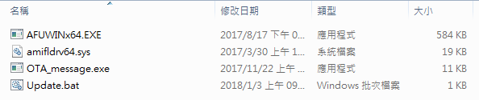

Step 1: Generate BIOS update package
Step 1-1: Open the folder and put BIOS to be updated in the same folder
(2250000U060V110.BIN here for example)
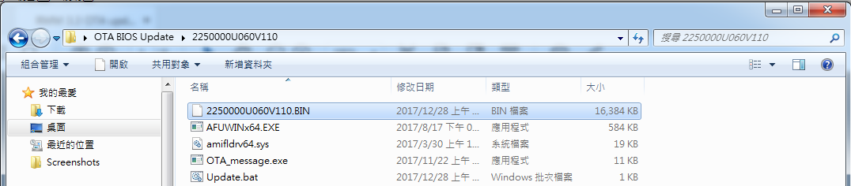
Step 1-2: Right-click “Update.bat” to edit the batch/script file
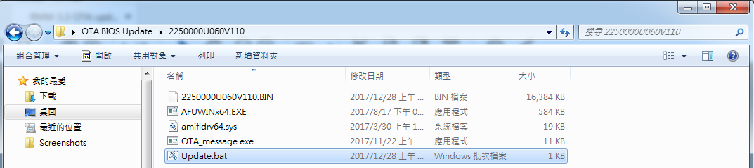
Step 1-3: Modify the highlighted area below to be the BIOS name you put in Step 1-1
(For example: 2250000U060V110.BIN)
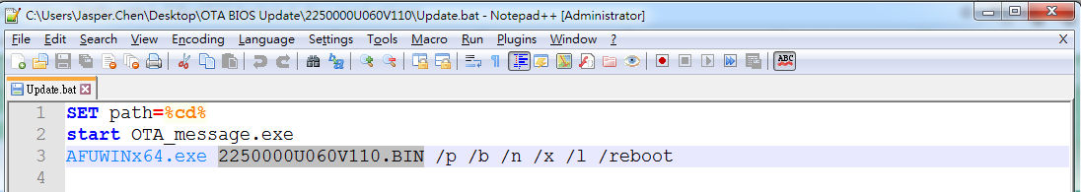

Step 1-4: Launch OTAPacker, fill in information required
- Package Type
- Packager Version
- Support Arch
- Supported OS

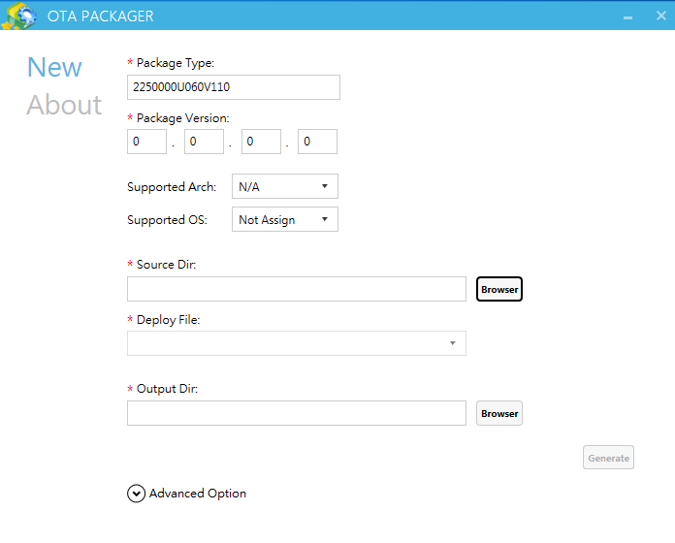

Step 1-5: Select source folder where you put all the files in Step 1-1
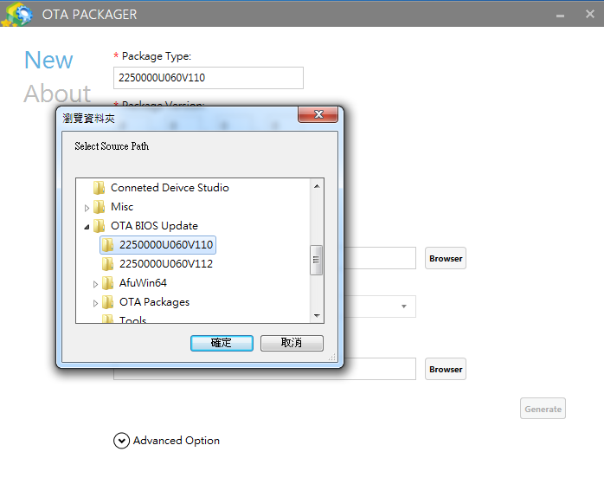

Step 1-6: Select “Update.bat” in drop-down list of “Deploy File” section
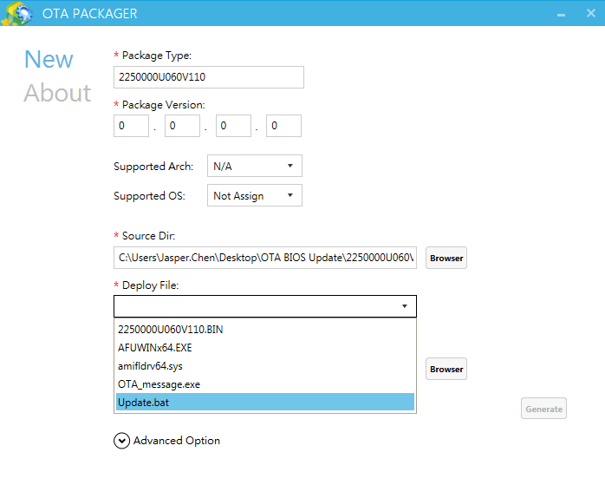

Step 1-7: Choose output directory then click “Generate”
Important Reminders: As mentioned in OTAPackager user manual:
- Output directory and input directory MUST BE DIFFERENT folders
- Output directory CAN’T be the sub-folder of input directory
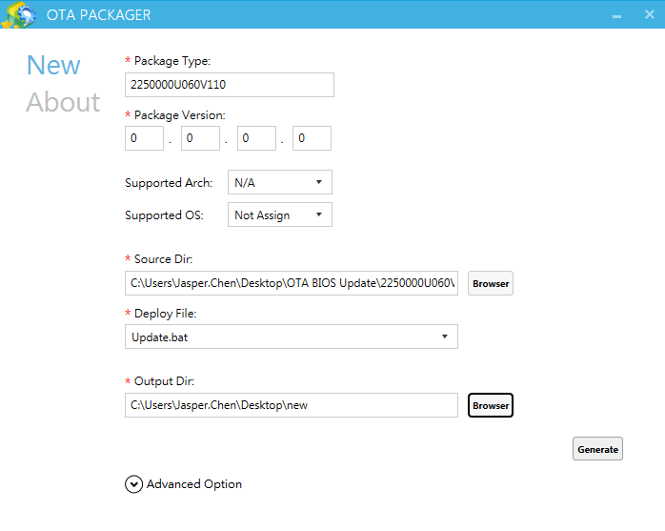

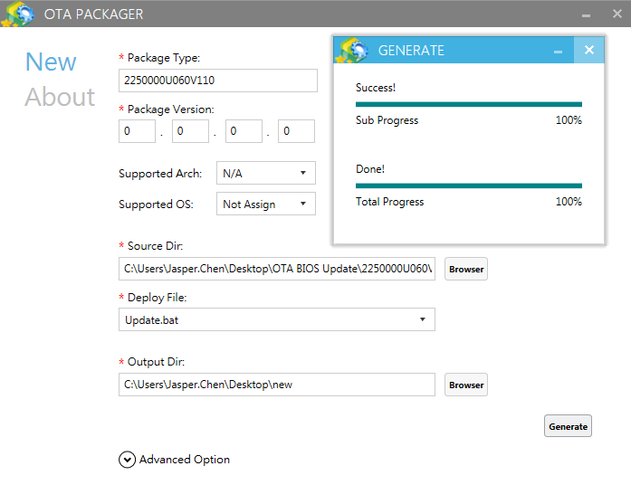

Step 2: Upload generated BIOS update package on OTA Server
Step 2-1: Login OTA server web console 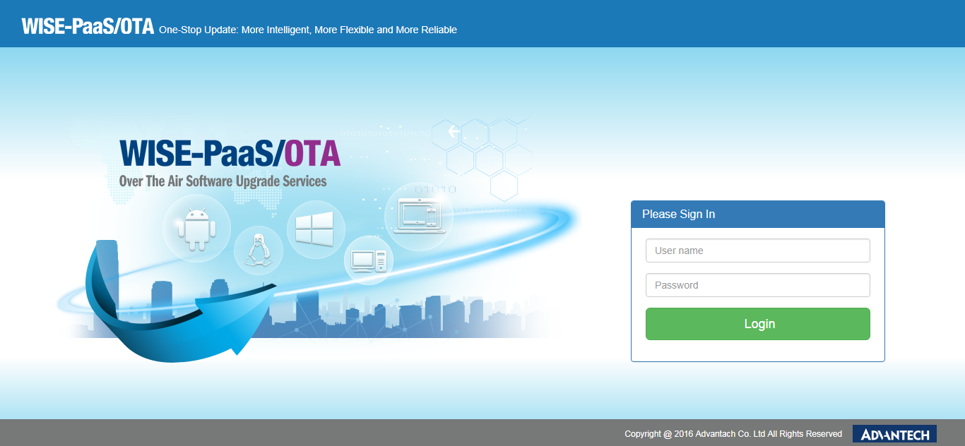

Step 2-2: Upload generated package from output directory selected in Step 1-7

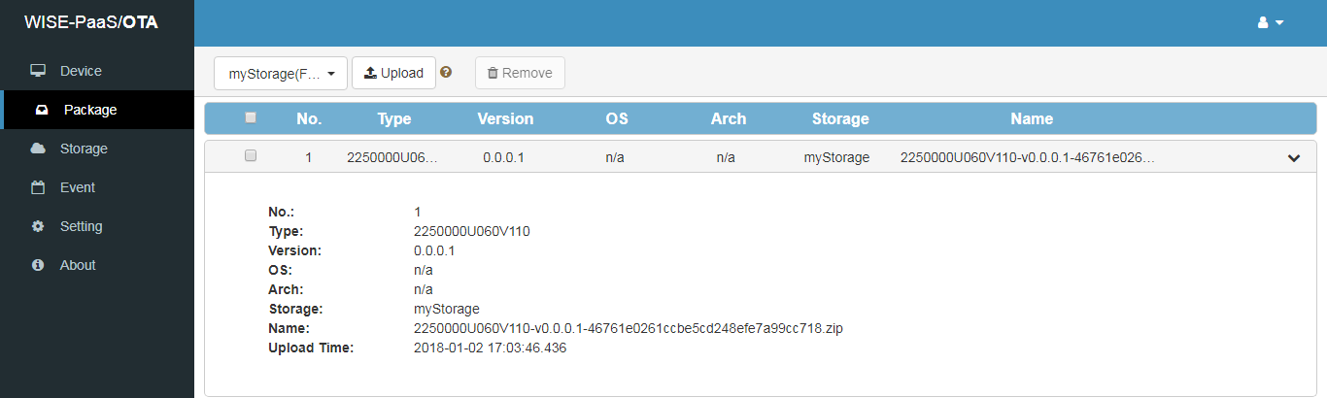

IMPORTANT REMINDER:
IF MASS OR LARGE SCALE DEPLOYMENT IS INTENDED, WE HIGHLY RECOMMEND PAUSING THE PROCESS AND TRYOUT ONE OR TWO AGENTS AT LOCAL END MANUALLY BEFORE DEPLOYING VIA WISE-PAAS/OTA SERVER TO MAKE SURE AFUWIN AND ALL FILES IN FOLDER IN STEP 1-1 WORKS PROPERLY, HERE’S HOW IN 5 STEPS:

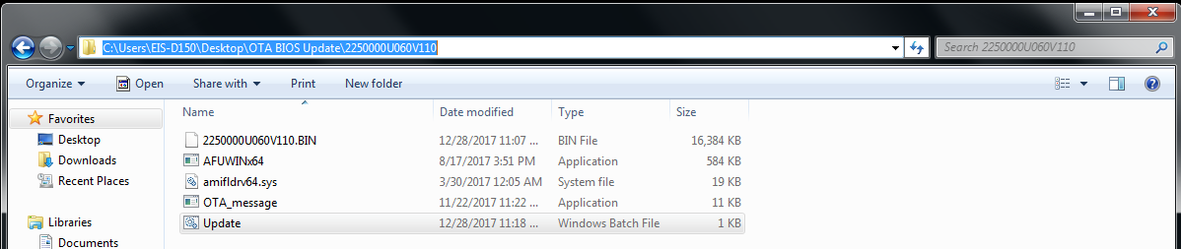
- Copy and paste the folder created in Step 1-1 on OTA agent device and click on the file path

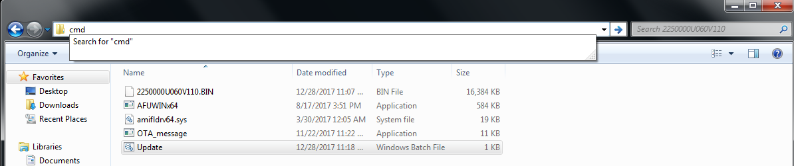
- Enter “cmd” and press “enter” to launch command prompt under this path

- Manually enter the last line of command in “Update.bat” file
(For example: AFUWINx64.exe 2250000U060V110.BIN /p /b /n /x /l /reboot)
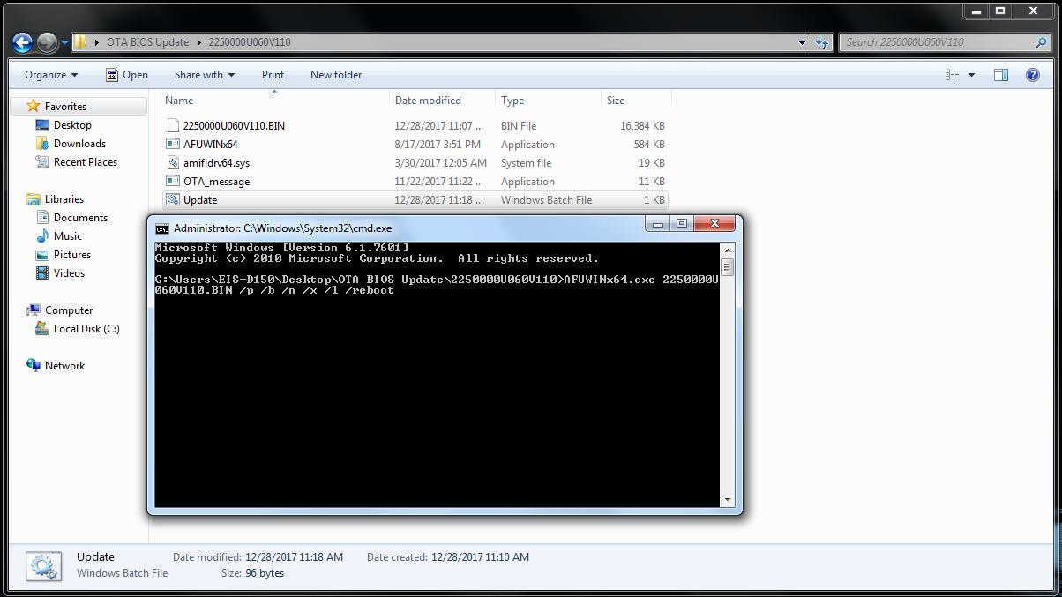

- Then you’ll see flashing process starts with mouse cursor locked, system will reboot after flash
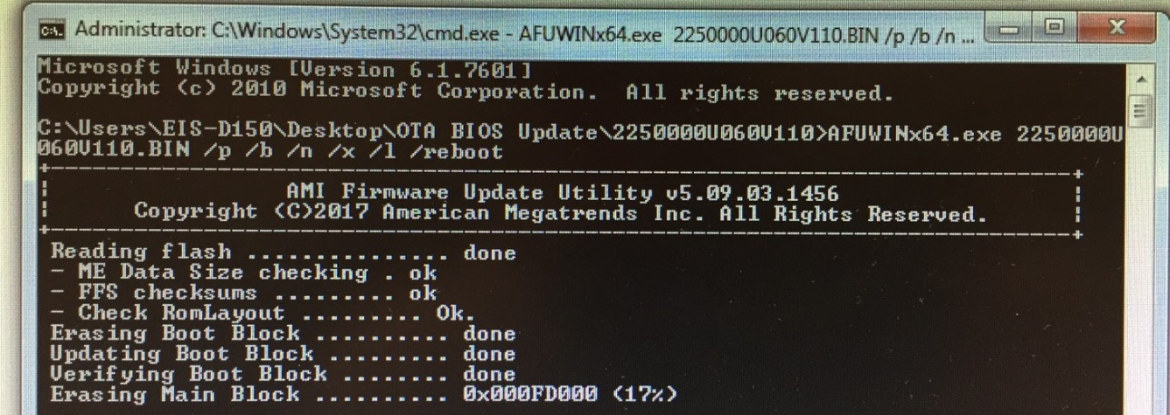

- Once we confirmed the files work normally locally with BIOS successfully updated (for example here we updated BIOS from V1.12 back to V1.10), and then we can go back and resume the process with OTA server for deployment with larger scale
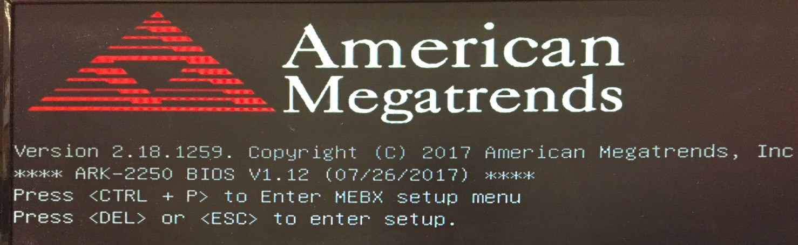
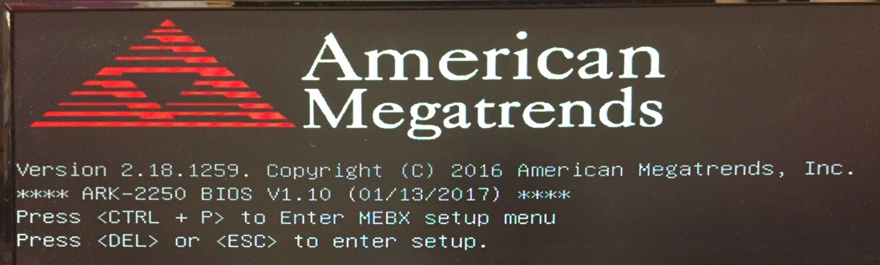
Now we get back to Step 2
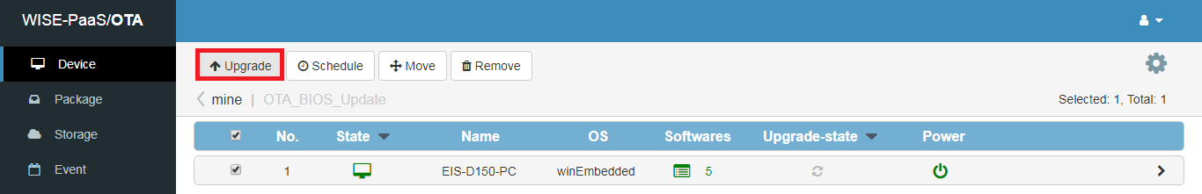
Step 2-3: Choose agent device(s) and click “Upgrade” button

Step 2-6: Select the BIOS you’d like to update/flash on agent devices
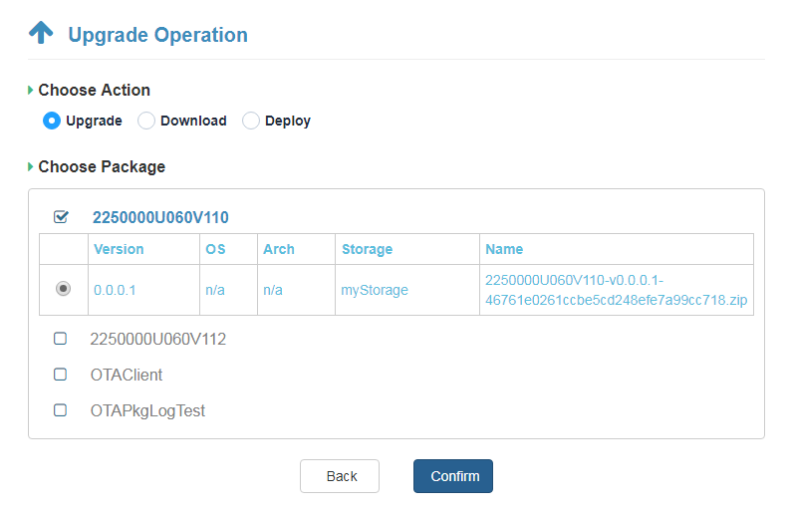

Step 2-7: In “Upgrade Info” tab under “Device” section, we can see update status and information
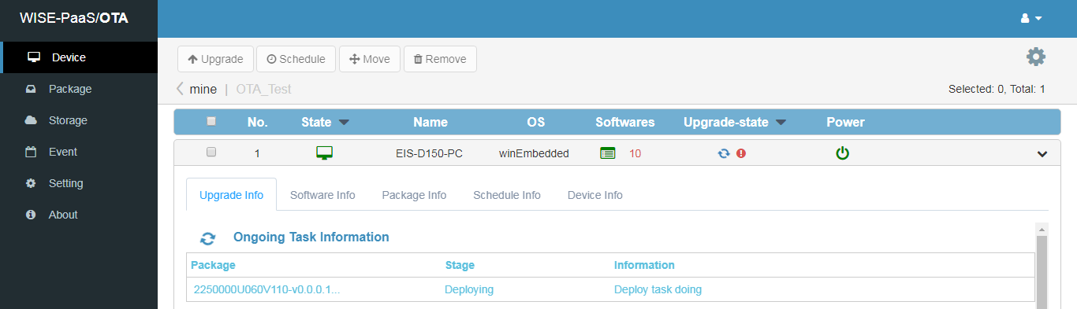

Step 2-8: During BIOS updating process, screen of agent devices will show an alert reminding the process is undergoing while keyboard/mouse cursor are locked. System will automatically reboot when finished
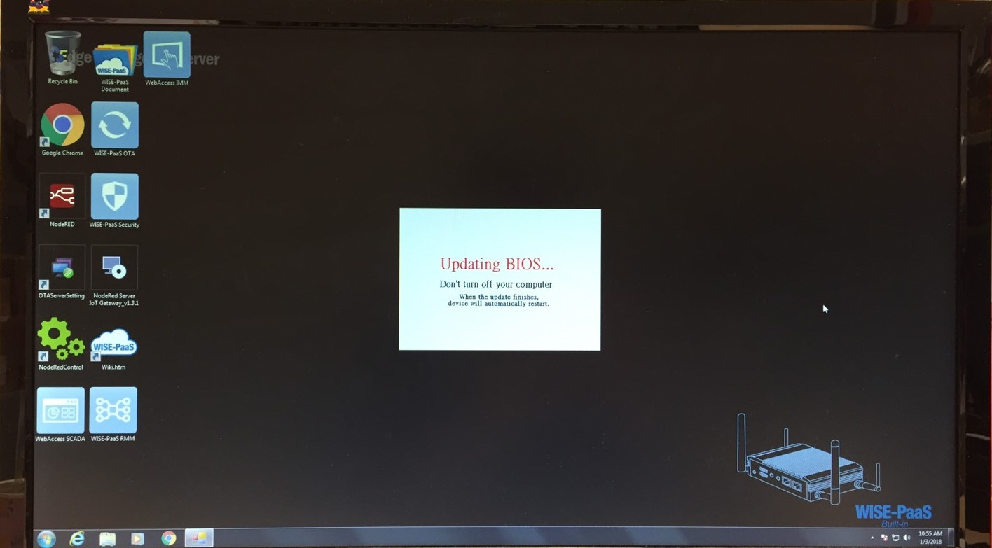

Step 2-9: Once completes, logs could be seen by user in “Event” session indicating deployment has successfully conducted
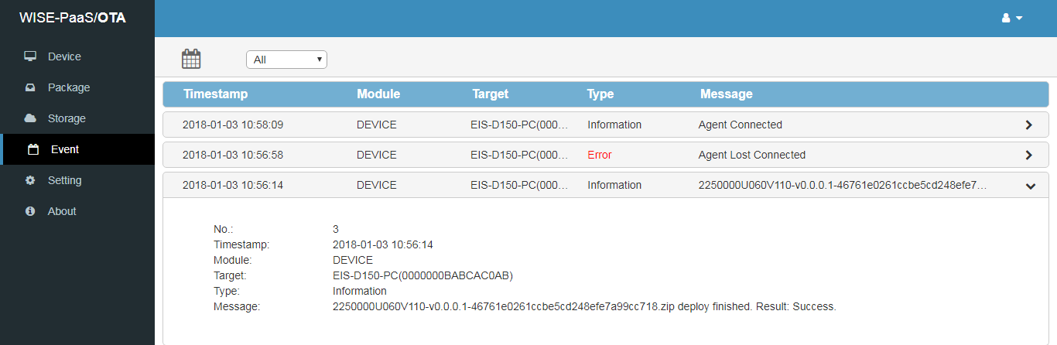
Step 3: Confirm BIOS version
Before BIOS update (for example: V1.12)

After BIOS update (for example: V1.10)

