WISE-PaaS FAQ
Category | EIS-D110 | Date | 2017/07/21
Keyword | EIS, WISE-PaaS, Document

- Question:
EIS-D110 image contents introduction

- Suggestion:
After unpacking the EIS OS image, we can see the desktop as below:
WISE-PaaS
Wiki
Node-RED
WISE-PaaS
Document
WISE-PaaS
Software Installer
WISE-PaaS Software Installer
Those shortcuts of five folders of Advantech’s embedded software “WISE-PaaS RMM”, “WebAccess SCADA”, “WebAccess IMM”, “WISE-PaaS OTA”, and “WISE-PaaS Security” are created on desktop for your quick access to experience and explore.
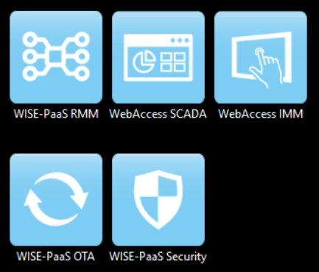
Each folder contains corresponding software installer package as shown below. In our EIS image, “RMM Agent”, “WebAccess SCADA”, “WebAccess IMM Agent” and “Node-RED” are already pre-installed (no need to install them again) on EIS-D110 to save you time and effort. You only have to install RMM server on another PC for Agent to upload data to the Server.
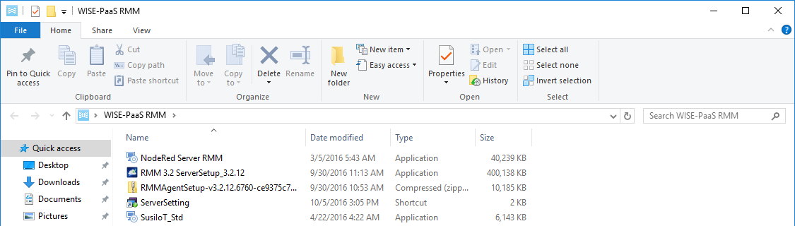
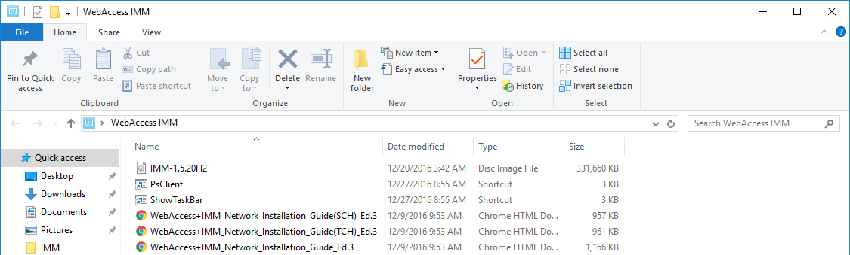

WISE-PaaS Document
Moreover, the folder “WISE-PaaS Document” on desktop contains four subfolders, which are “Node-RED”, “WebAccess IMM”, “WebAccess SCADA” and “WISE-PaaS RMM”. User manuals of Advantech’s software offerings bundled in EIS image are also included in each subfolder.
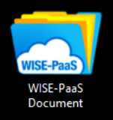
Additionally, there are also two shortcuts we would like you to pay special attention to: “Node-RED” and “Wiki.htm”.
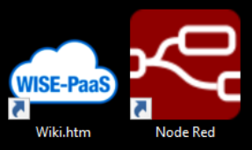
Node-RED
As you double click “Node Red” icon, browser will launch and direct to Node-RED page as shown below. Users can easily focus on developing their applications.
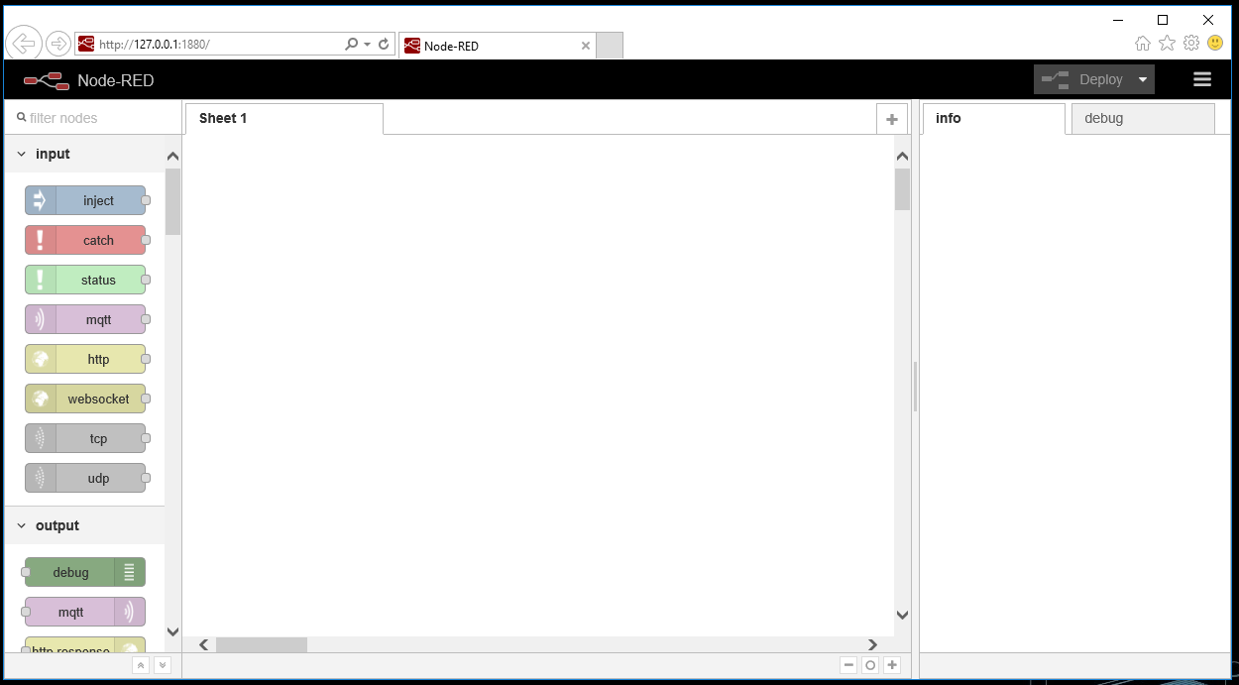

WISE-PaaS Wiki
If you’re interested and would like to take a deep dive in our WISE-PaaS, there is the perfect place for you to explore in every aspect. Just double click on “Wiki.htm” icon; it will take you to the Wiki web page created by Advantech Software Team that includes all kinds of detailed information (for example software architecture) on Advantech’s WISE-PaaS software offerings.
