Software Specification

Alleantia Co-Creation Program

Revision History

Revision | Date | Notes | Owner
1.0 | 2018/08/3 | First version | Hank.Peng
- Customer’s requirement
Project (*) | Alleantia Co-Creation Program | Apply Date (*) |  | 2018/07/24
Customer (*) | Alleantia | Business (*) |  | IoT co-creation program
PM (*) | Kurt.Ou | AE (*) |  | Kalvin.Yang
Platform | UTX-3117 | OS (*) |  | Windows10
Peripheral | Name | Purpose
User /  Functional Requirements | Description |  | Evaluate Solution |  | Version
 | Alleantia SRP development
 | Custom plugin which is able to communicate with Alleantia ISC based on MQTT protocol.
 | Defining a suitable IPSO data format which is capable to cover different industry data model from Alleantia.
 | SRP dashboard development
Others
Integration plan and Architecture
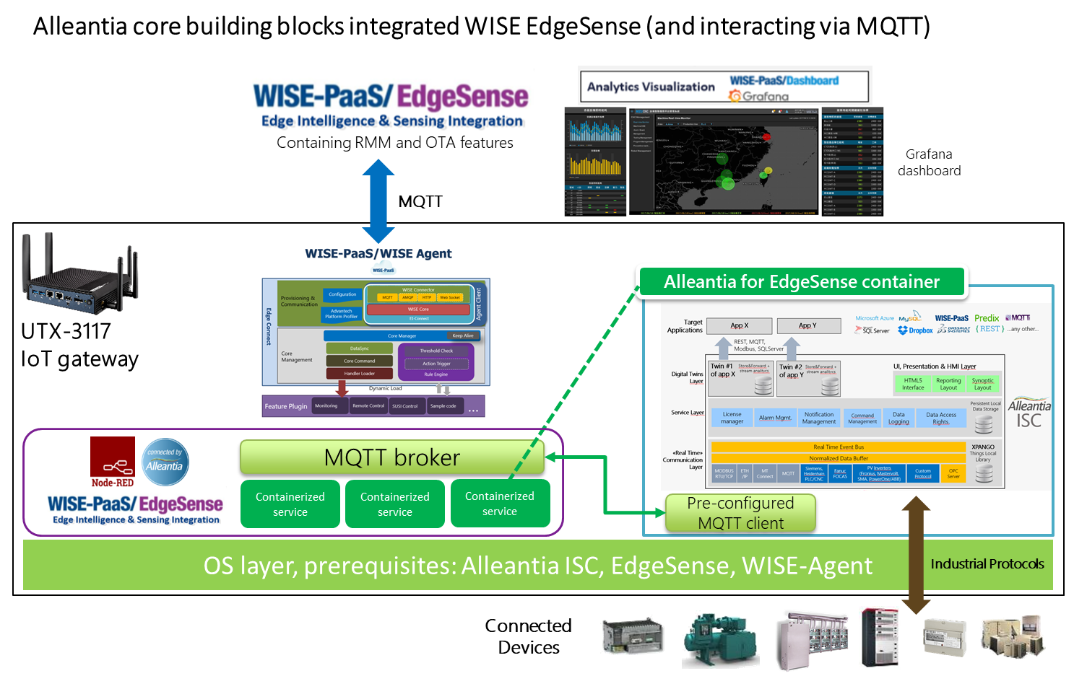

(*): Must

- Software Specification

We will provide a software service for the function of subscribing Alleantia MQTT data and transform the data into WISE-PaaS/EdgeSense data format for EI-Agent to upload the data to WISE-PaaS/EdgeSense cloud, the detail function include below items:

Item | Description | Remark
1. | Transfer Alleantia sensor data format to Advantech IPSO-like format
2. | Upload real-time Alleantia sensor data to WISE-PaaS/EdgeSense
3. | Get real-time Alleantia sensor data to WISE-PaaS/EdgeSense
4. | Set real-time Alleantia sensor data from WISE-PaaS/EdgeSense
5. | Transfer Alleantia Alarm message to WISE-PaaS/EdgeSense
6. | Transfer Alleantia Event message to WISE-PaaS/EdgeSense
7. | Register system to runs as a Windows service
8. | Pack installer by AdvanceInstaller

The system architecture is defined as below:

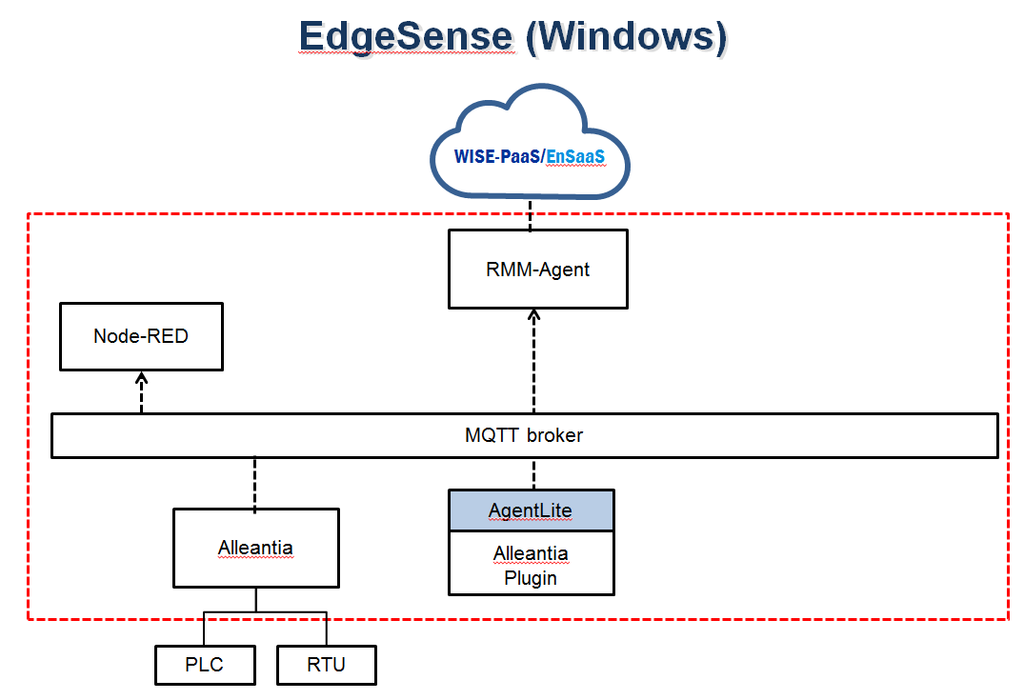

Note:
- The system doesn’t support Alleantia configuration from WISEPaaS/EdgeSense.
- Alleantia configuration can be set by Alleantia Web Portal

- Efforts of Software Development/Customization

Tasks | Comment | Man-days
Feasibility Evaluation | Technique study + Confirm SW specification + Demo kit setup | 3
Architecture Design | Software architecture design | 2
Data Simulator | Define data format and provide a Node-Red flow to generate simulate data | 5
SW Service Development | Implement | 15
Integration | Integration with WISEPaaS/EdgeSense | 5
Functional verification | RD function verification, debug and define test plan | 3
Documentation | Release Note & User Guide | 2
Total |  | 35

- Signature

Customer:  Company: ______________________  By (Signature): __________________  Name (Print): ___________________  Title:__________________________  Address:______________________  Anticipated Annual Quantities: _____ | Approve by: | Advantech Co., Ltd.  Name(Print):  Title:  Address:  2F., No.27, Wende Rd., Guishan Dist., Taoyuan City 333, Taiwan, R.O.C  Tel: 886-2-2792-7818
 | Comments:

