**WISE-PaaS FAQ**

|  |  |  |  |
| --- | --- | --- | --- |
| **Category** | WISE-3610、Arm Pelion | **Date** | 2019/7/4 |
| **Keyword** | WISE-3610、WISE-1510、Arm Pelion | | |

* **Question:**

How to do OTA for WISE-3610 which can support Arm Pelion?

* **Configuration:**

Step 1: Log in the Arm Pelion website. URL: <https://portal.mbedcloud.com/login>

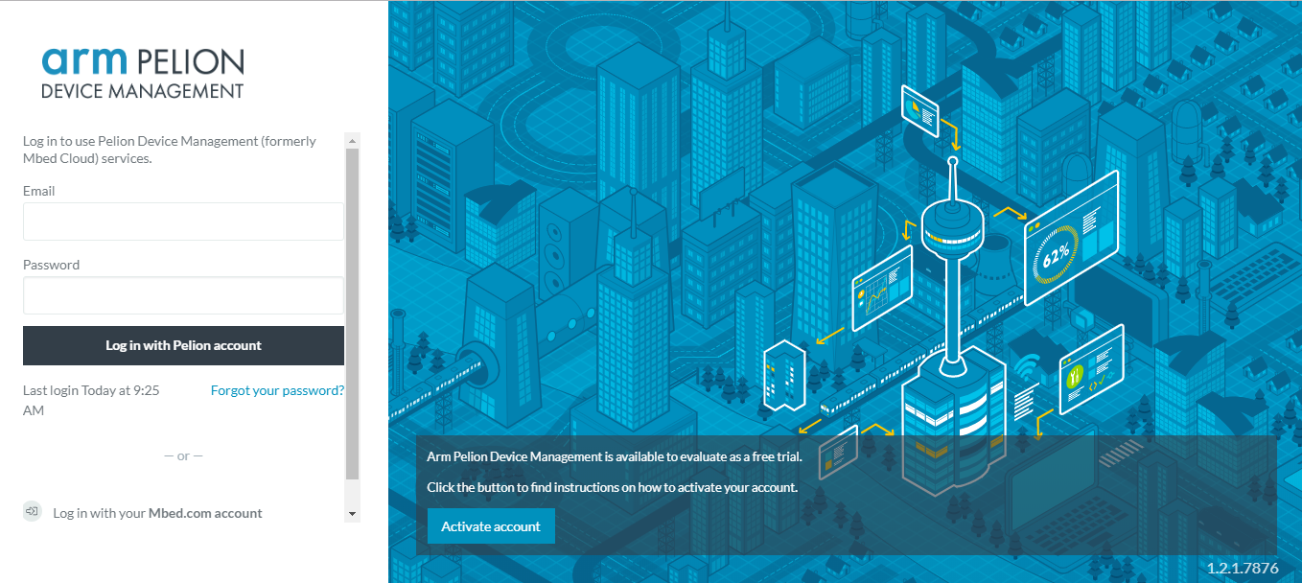

Step 2: Click the button. It will show all online devices.

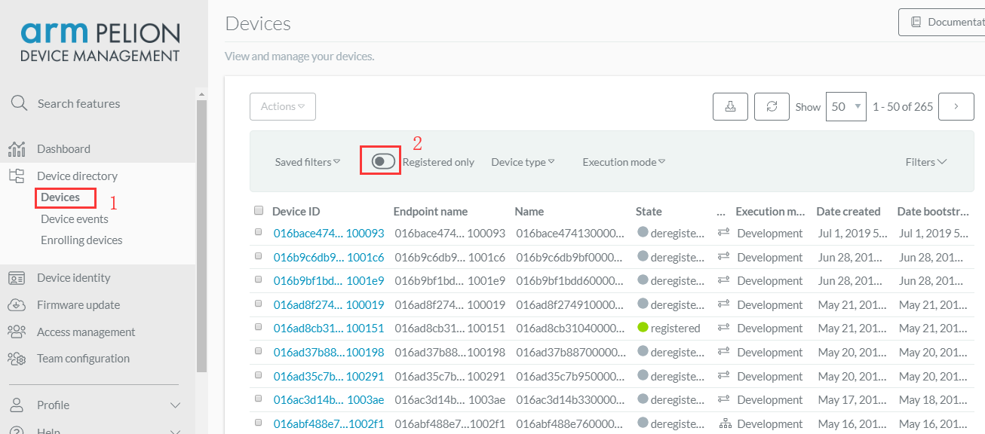

Step 3: Now, we have to setup the Filter. It will help us easy to find the device. Click “Devices directory”, “Device” and then click “Filters”.

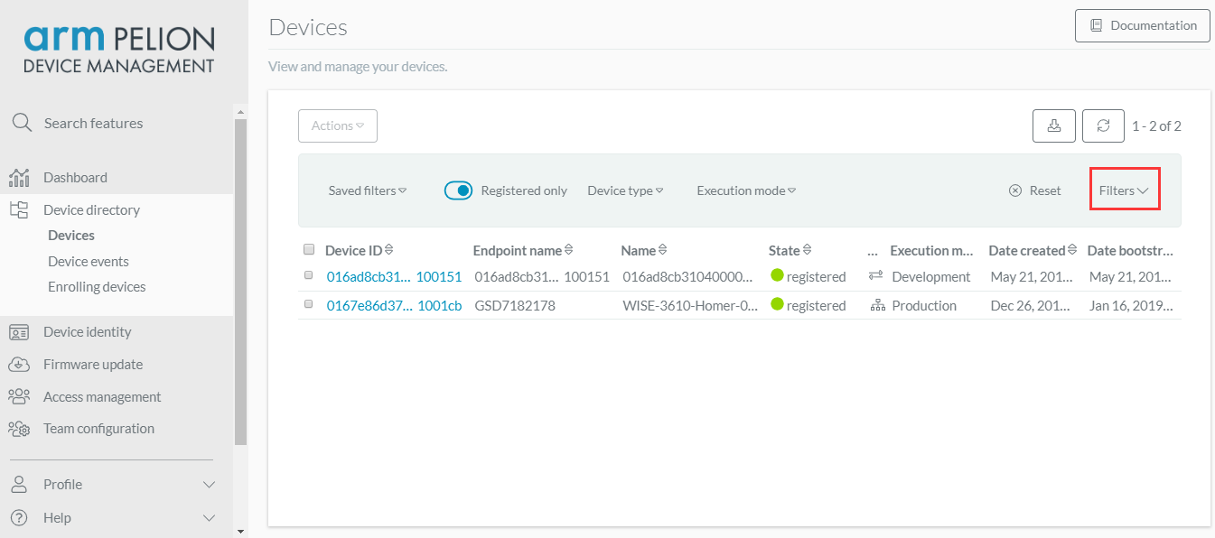

Step 4: Fill in your Device ID and the device will show as below. Then save the setting.

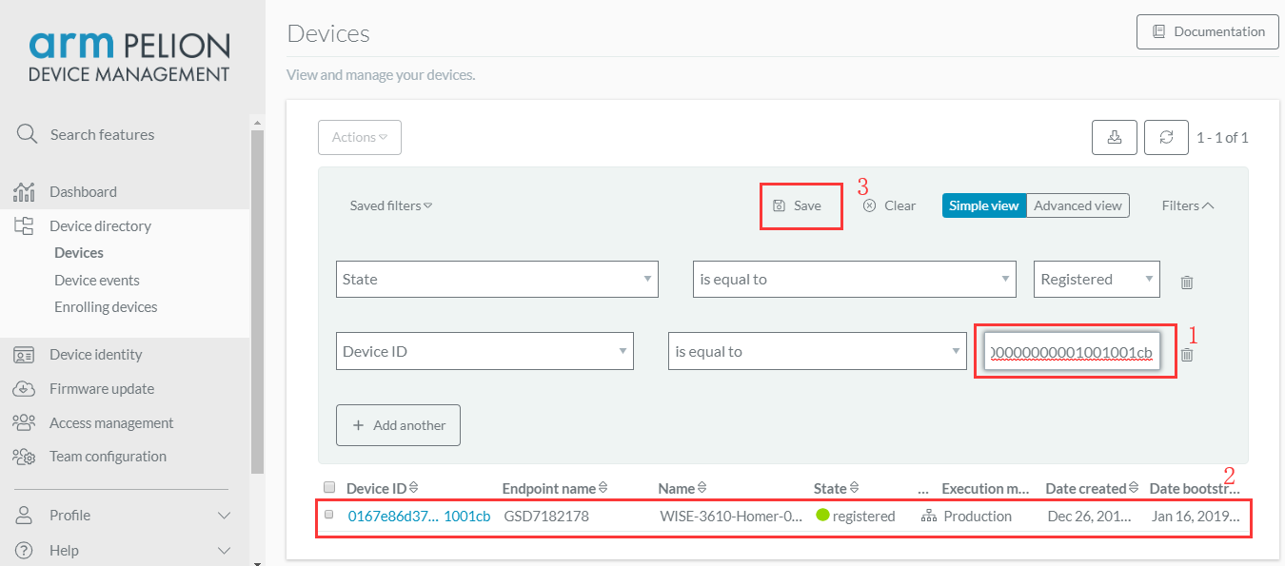

Step 5: Full the Save filter name.

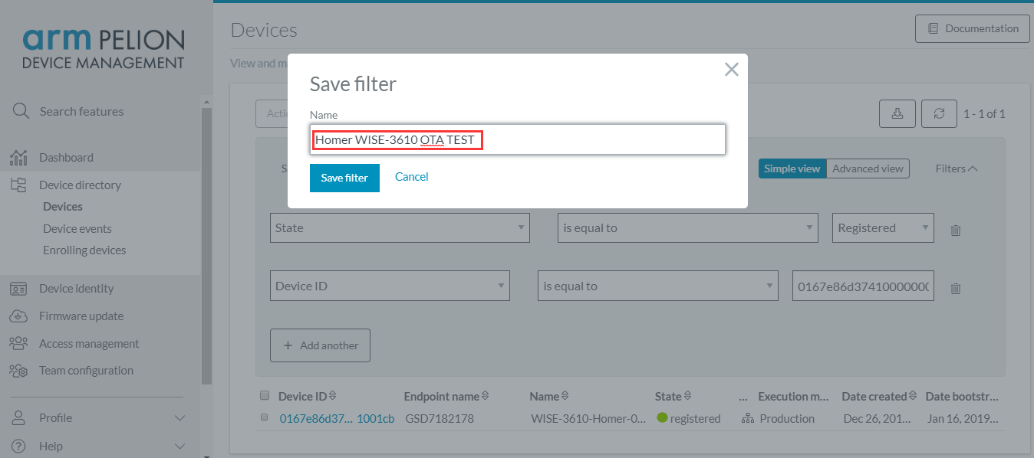

Step 6: We have to check the new firmware on the website. In this example, we have been uploaded the firmware on the Arm Pelion.

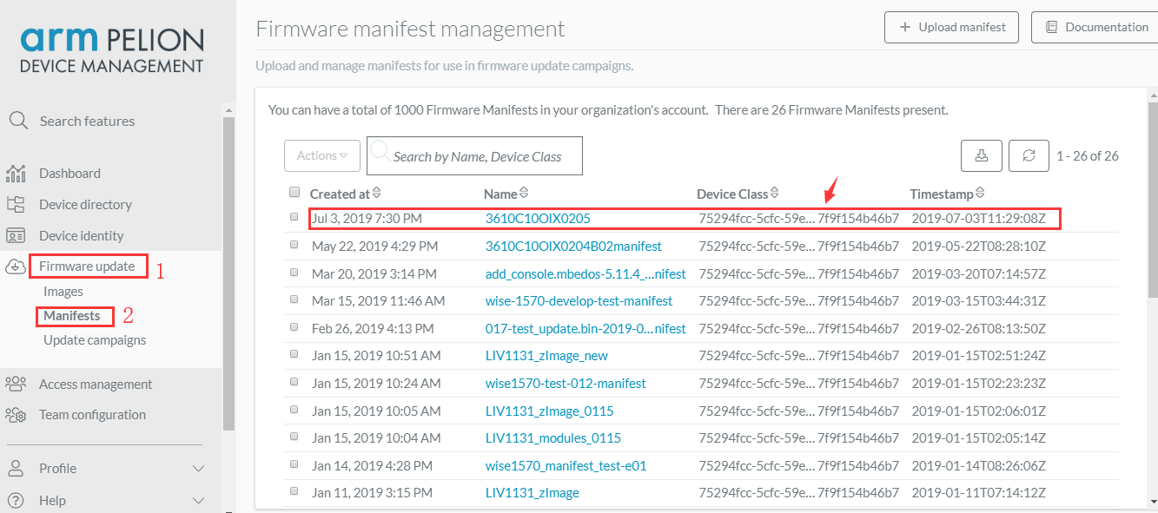

Step 7: Click “Firmware update”, “Update campaigns” and “New campaign”. You will add a new OTA process.

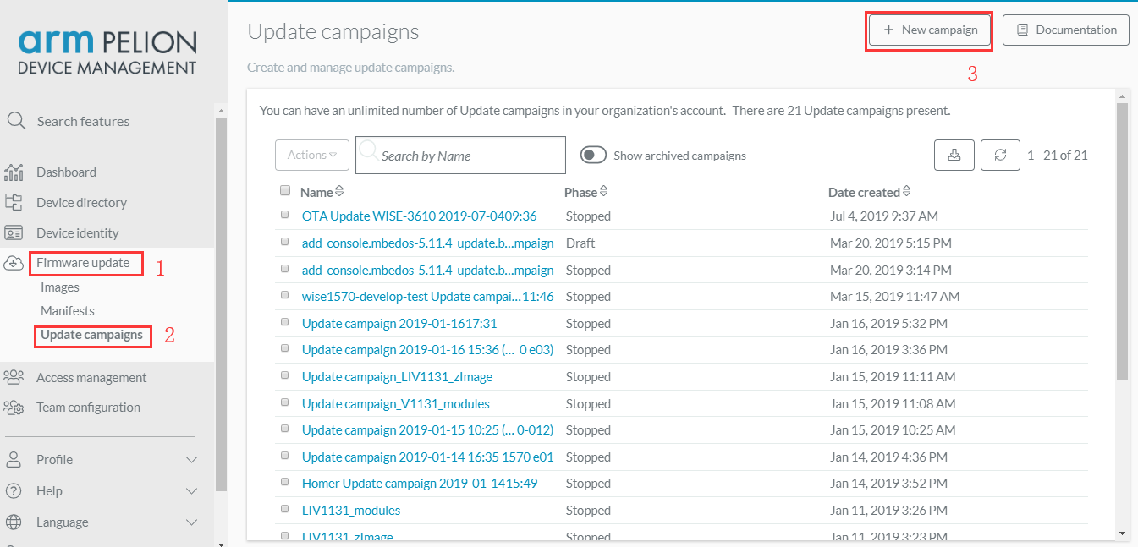

Step 8: Following you can modify the campaign name and description. The Manifest file and the filter have to the same as before setting. After fill in all columns, click “Finish”.

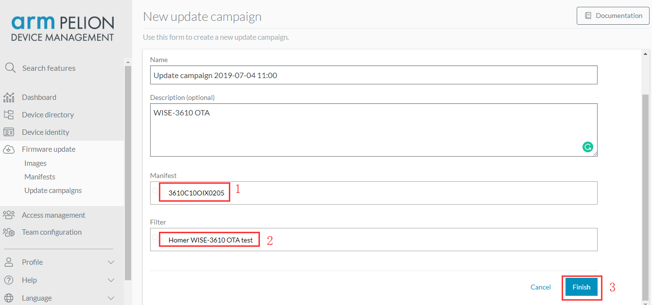

Step 9: Click Start to start the process.

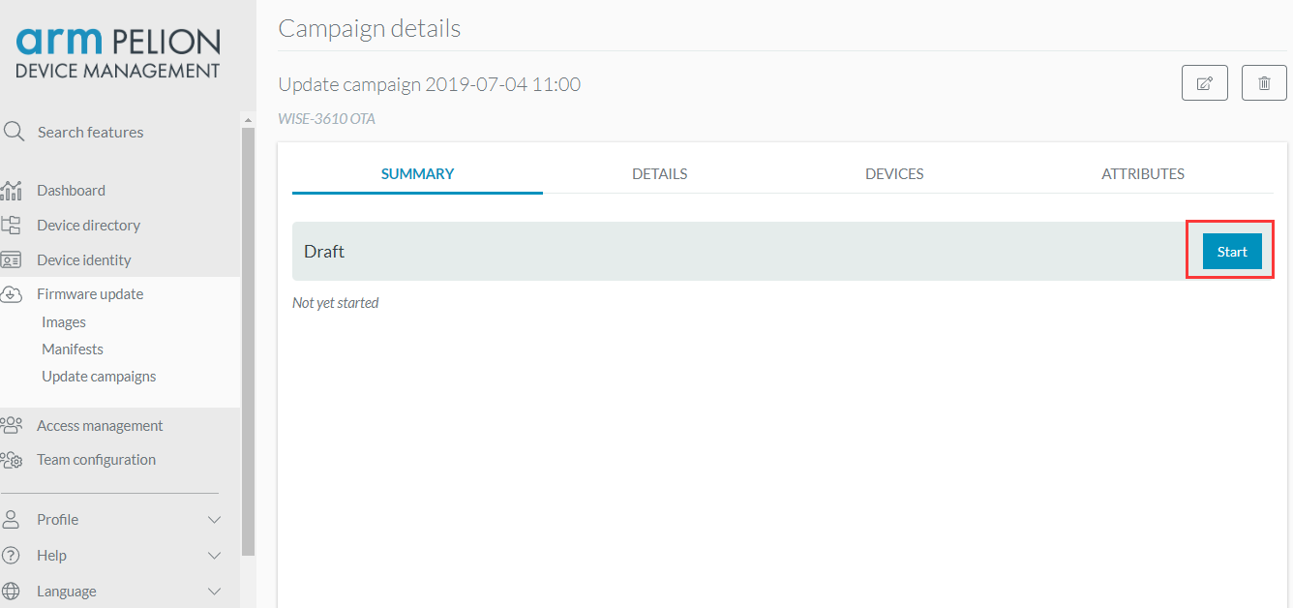

Step 10: click “Start” to check start process.

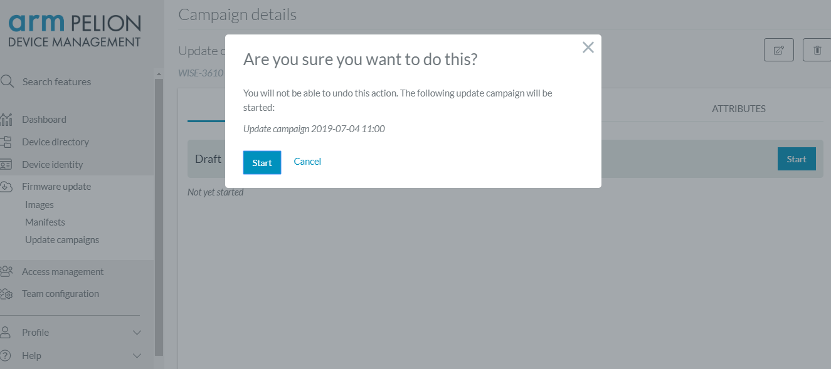

Step 11: When the OTA process is finished, the web page will show as below. It means the OTA is successful.

