**AIW(EWM) FAQ**

|  |  |  |  |
| --- | --- | --- | --- |
| **Category** | AIW | **Date** | 2023/6/7 |
| **Keyword** | AIW-344, AIW-355, AIW-356, Windows 10, MBIM mode | | |

* **Question:**

How to switch cellular network mode from default to MBIM mode on Windows 10 with AIW-344, AIW-355 & AIW-356 cellular module?

* **Instructions :**

1. Download tool package via below link.

[USBProbe_20230413.7z](https://advantecho365-my.sharepoint.com/:u:/g/personal/tim_huang_advantech_com/EQOWglge25pLjyD9XyT3Z1QBt-KyZzf73WVbEAsFT3S9og?e=GxCpZc)

1. Unzip the file and go to folder AIW-344 or AIW-355_356(depending on which cellular module is inserted), then modify the file “command.ttl”.

Remove “;” then save the file so these two lines of commands will be automatically executed.

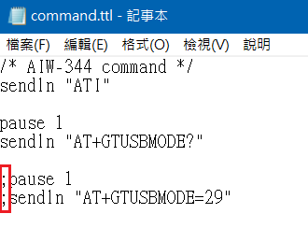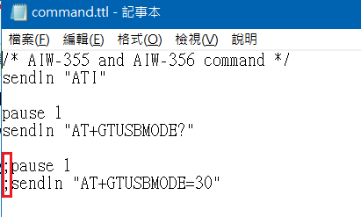

1. Execute USBProbe.bat. Then it will pop up a window automatically and ask to install driver and also tool “TeraTerm” for accessing com port to input AT commands.
2. Just follow the procedure step by step to install required driver and software.
3. Finally, cellular module should be configured as MBIM mode.

