EWM FAQ
Category | EWM | Date | 2018/08/14
Keyword | EWM-C109F6G1E ,3G Connection,GPS AT command,Ubuntu 16.04 LTS and above version

- Question:
How to enable GPS function with EWM-C109F6G1E automatically when system startup on Ubuntu Linux OS?
- Instructions :
Step 1
Before enabling GPS function on EWM-C109F6G1E,please ensure the 3G connection has established on your system already.

Step 2
Create a shell script to execute “AT commands” automatically under specific folder(/home/Desktop/Startup) <refer to attached script file below>
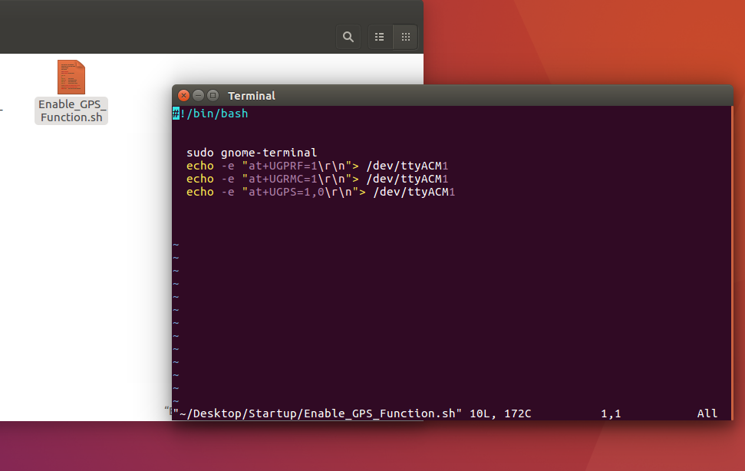

Step 3
Create a startup service under specific folder(/etc/systemd/system/)which can execute “Enable_GPS_Function.sh” script when boots up system automatically <please refer to attached service file below>
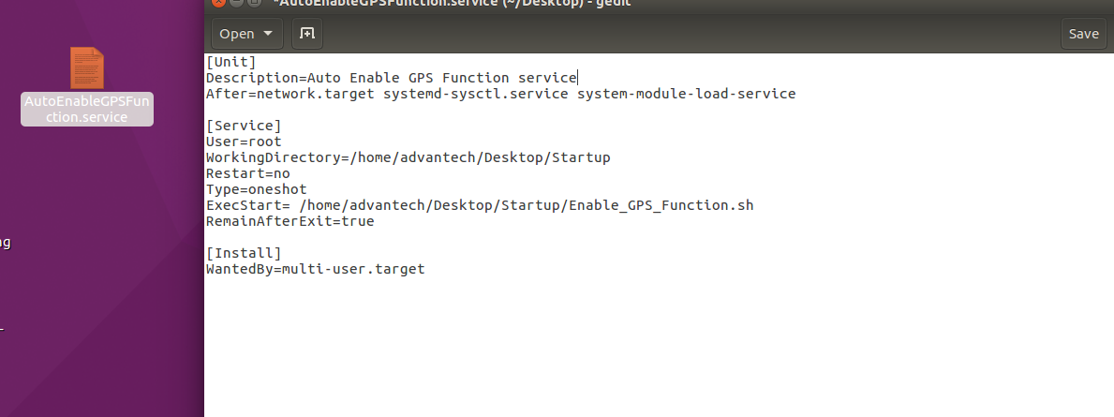
<Directory modification>
/etc/systemd/system/AutoEnableGPSFunction.service
[Unit]
Description= Auto Enable GPS Function service
After=network.target systemd-sysctl.service systemd-modules-load.service

[Service]
User=root
WorkingDirectory=/home/advantech/Desktop/Startup
Restart=no
Type=oneshot
ExecStart=//home/advantech/Desktop/Startup/Enable_GPS_Function.sh
RemainAfterExit=true

[Install]
WantedBy=multi-user.target

Step 4
Double check if the service has created under specific folder
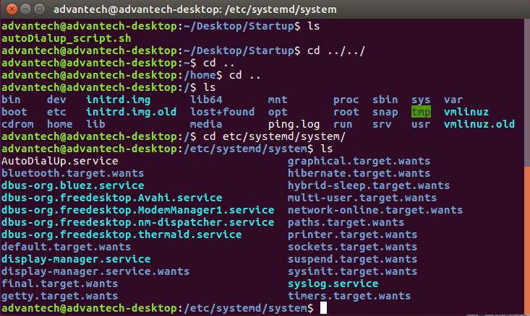
Step 5
Shut down your system and confirm if the GPS data can output on specific Port (ttyACM3) in minicom after booting up
