EWM FAQ
Category | EWM | Date | 2020/04/23
Keyword | LTE 4G network ,UTX-3117,EWM-C117FL0XE,Linux OS, Fedora 31

- Question:
How to establish 4G cellular network with EWM-C117FL0XE module on Fedora OS?

- Instructions :

Step 1
Confirm if the network interface has generated in network setting
- Enter “ifconfig” command on terminal
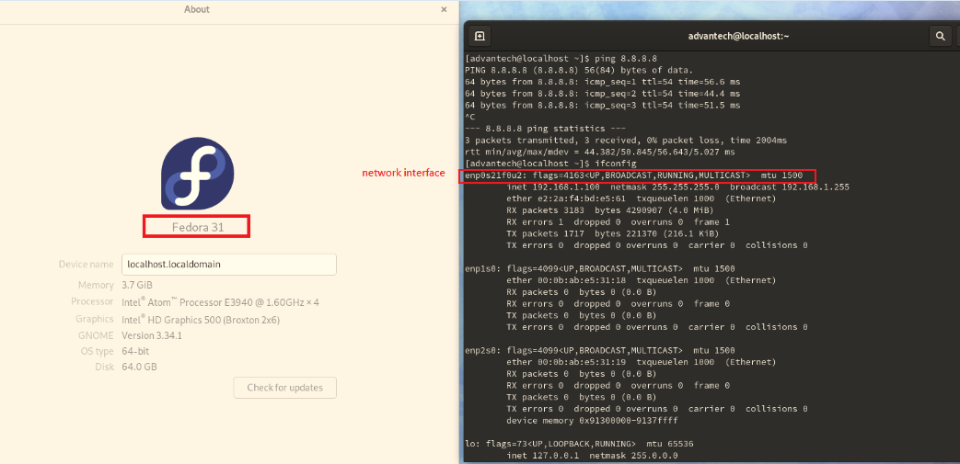

Step 2
Enter to GUI network setting to create your own connection
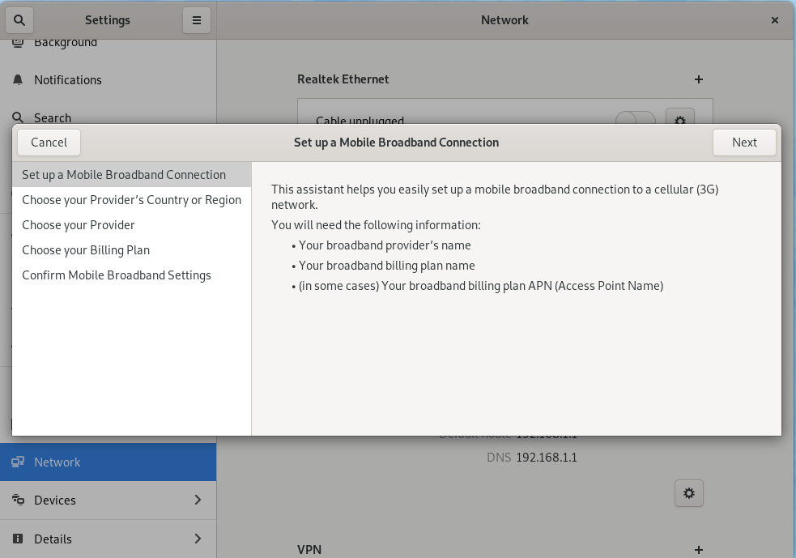
Step 3
Choose your provider’s country or region
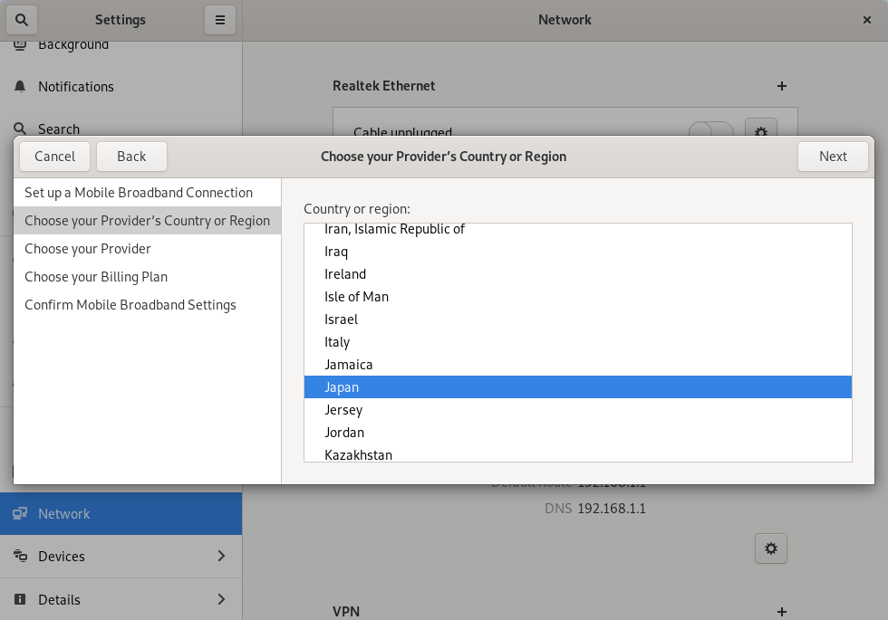

Step 4
Select your provider from list (if the provider is not appeared in list, please input by yourself)
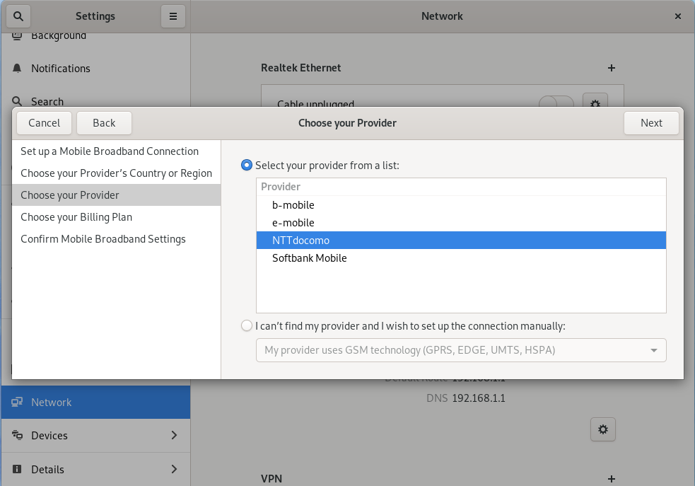
Step 5
Double Confirm if the APN is used for your sim card or not
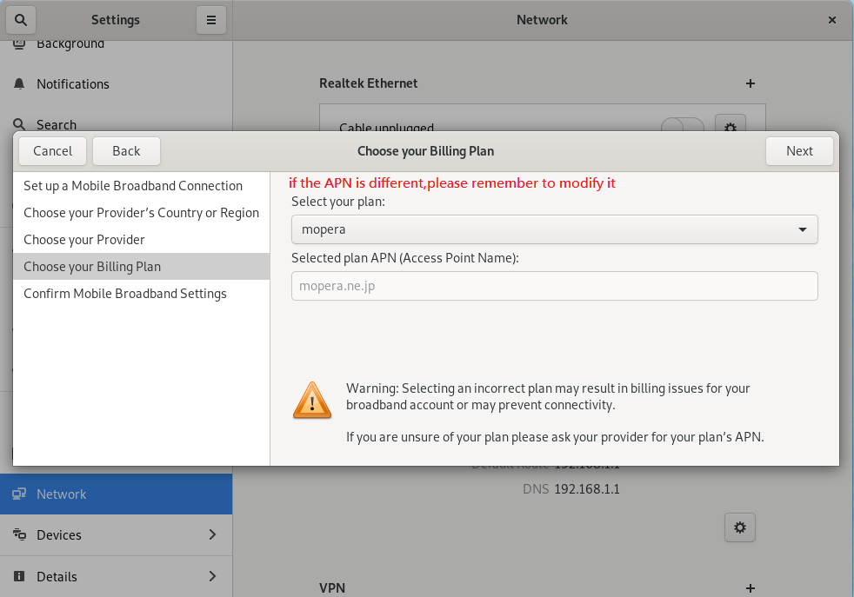
Step 6
If you would like to auto connect when system boots up, please tick up following option in general section
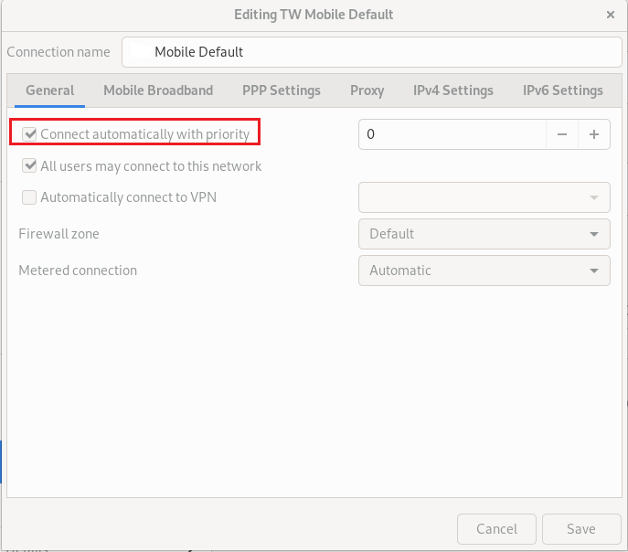
Step 7
Save your setting and enable your network connection on mobile broadband feature, then do ping test to confirm connection status
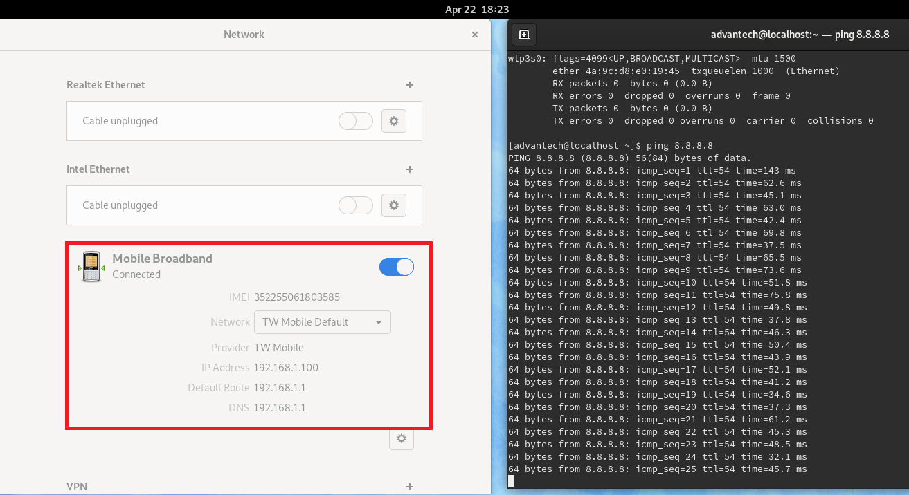
Step 8
If the mobile broadband cannot control by GUI button, please try to restart the mobile broadband service by following command to recovery it
- Enter “ sudo systemctl restart ModemManager” command on terminal
