User / Functional Requirement

Alleantia co-creation program

Revision History

Revision | Date | Notes | Owner
Project (*) | Alleantia co-creation | Apply Date (*) |  | 2018/07/24
Customer (*) | Alleantia | Business (*) |  | IoT co-creation program
PM (*) | Kurt.Ou | AE (*) |  | Kalvin.Yang
 |  | OS (*) |  | Windows10 & Linux (ubuntu16.04)
Peripheral | Name | Purpose
User /  Functional Requirements | Description |  | Evaluate Solution |  | Version
 | Alleantia SRP development
 | Custom plugin which is able to communicate with Alleantia ISS based on MQTT protocol.
 | Defining a suitable IPSO data format which is capable to cover different industry data model from Alleantia.
 | SRP dashboard development
Others
Integration plan and Architecture
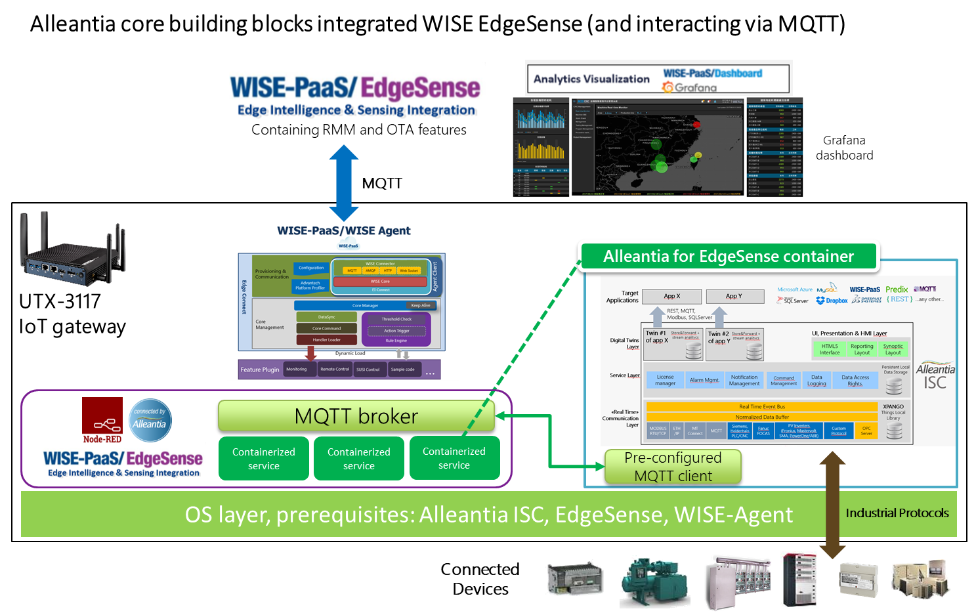
(*): Must

