How to Setup Network with AIW-341
Prerequisite
- MIO-5393 and setup Windows 10 on it
- AIW-341 module.

Install Driver
- Device driver
Please run the installer “FbUSBDeviceSetup.exe” (version v2.1.2.5) and follow the prompt to install driver.
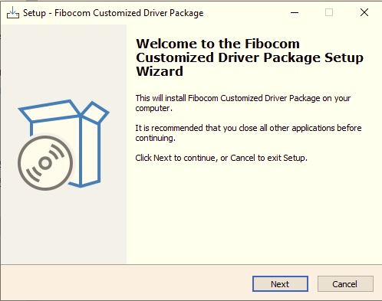

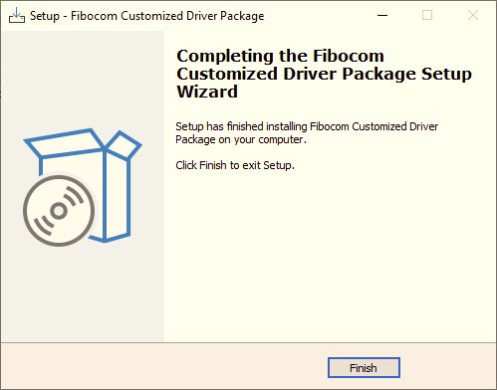

Check Device
After driver installed, you will see the snapshot as below.
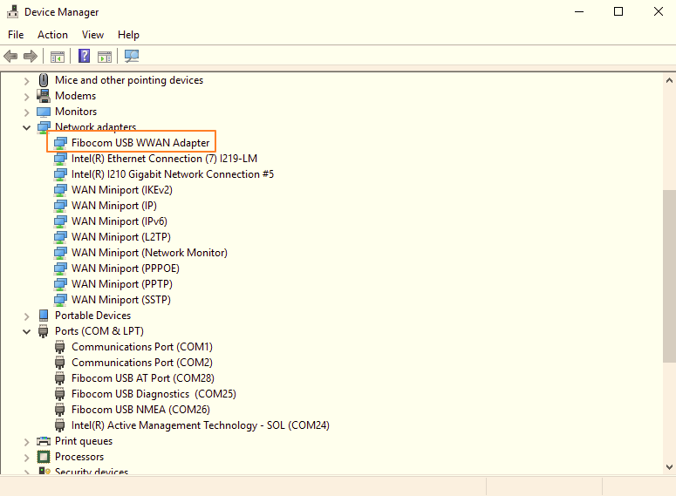

Function Test
- Speed test
This is only for reference.
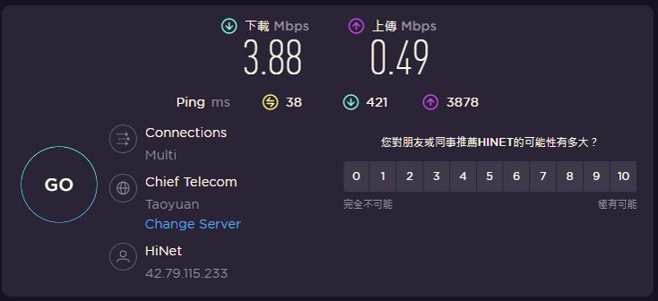

- Reliability
Observe the ping test at least 6 hours.

- AT command
- Check the number of COM port with AIW-344 in device manager.
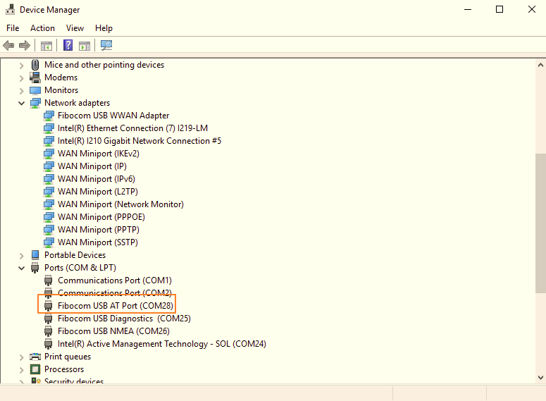

- Access to AT command through terminal like putty.
Please make setting as below:
  - Baud Rate “9600”
  - Data bits "8"
  - Stop bits "1"
  - Parity "None"
  - Flow Control "None"
