EWM FAQ
Category | EWM | Date | 2020/09/18
Keyword | Compile driver package, X86 platform,Ubuntu 18.04 LTS,Linux kernel 5.3.0-62

- Question:
How to compile EWM-W157M201E's WiFi driver package on Ubuntu 18.04 OS?

- Instructions :

Step 1
When inserting EWM-W157M201E module on your device, please ensure the module can be recognized on PCIE bus interface
- Enter “lspci” command on terminal
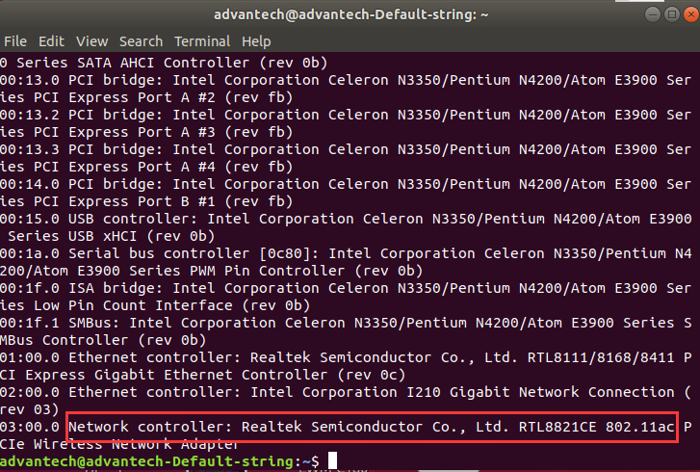
Step 2
Confirm if the WiFi function is workable or not
<Example>
The following capture image is unworkable
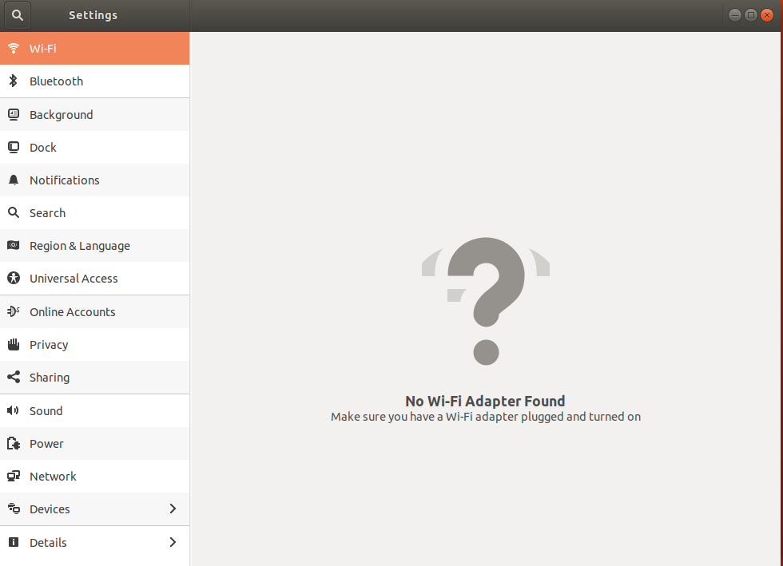
Step 3
Download driver package from following url
https://www.dropbox.com/sh/cdgxv4401otjk7l/AABkd875BssK2dziQ3kg2wEza/WiFi%2BBT/W157M2/driver/Linux/rtl8821ce-master.zip?dl=0
Step 4
Install related software packages in order to install driver by DKMS
- sudo apt install bc module-assistant build-essential dkms
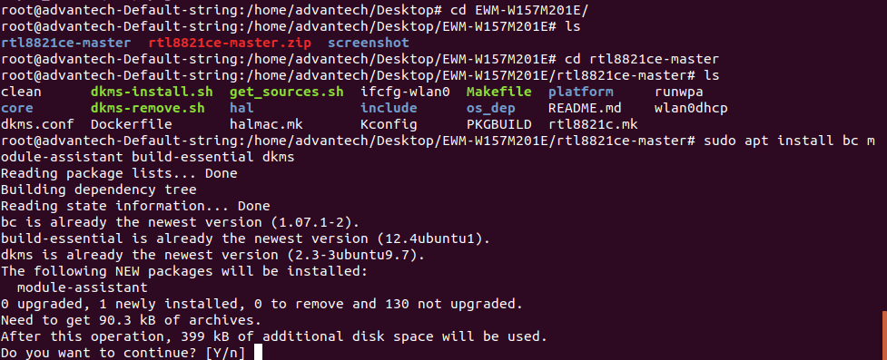
- sudo m-a prepare
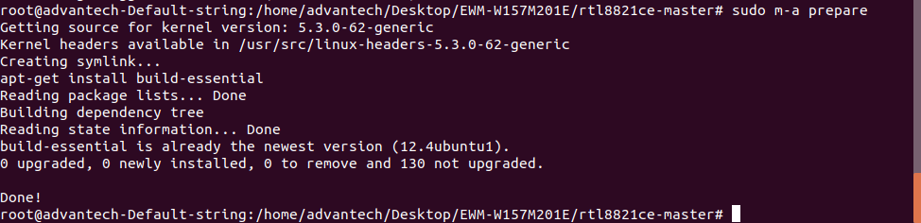
- download RTL8821CE’s firmware
(sudo git clone https://aur.archlinux.org/rtl8821ce-dkms-git.git)
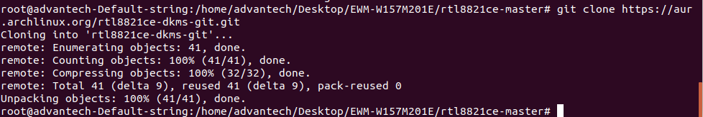
Step 5
Try to enter “./dkms-install.sh” command on terminal to install Driver
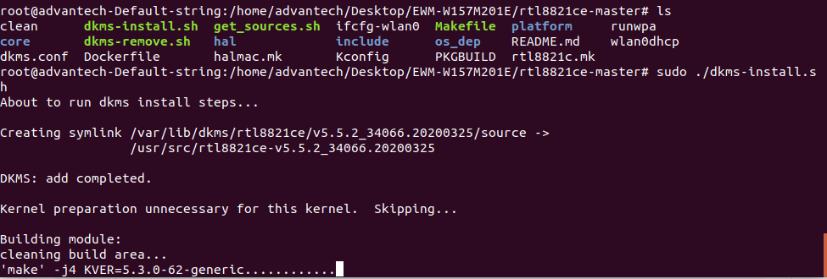
Step 6
If there is any compile error which appear during building driver as below, try to add extra CONFIG in “MakeFile”in specific directory (/var/lib/dkms/rtl8821ce/v5.5.2_34066.20200325/build)
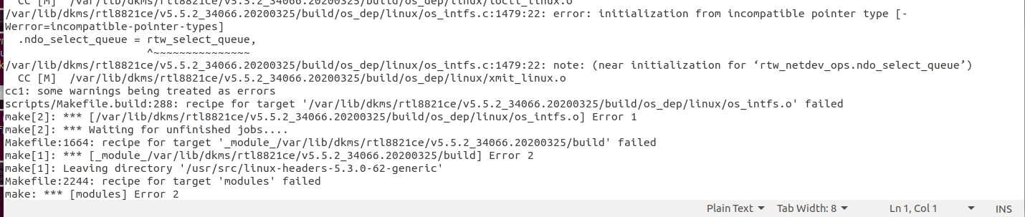
- add Extra Config “USER_EXTRA_CFLAGS=-Wno-error=incompatible-pointer-types” in the top of Makefile
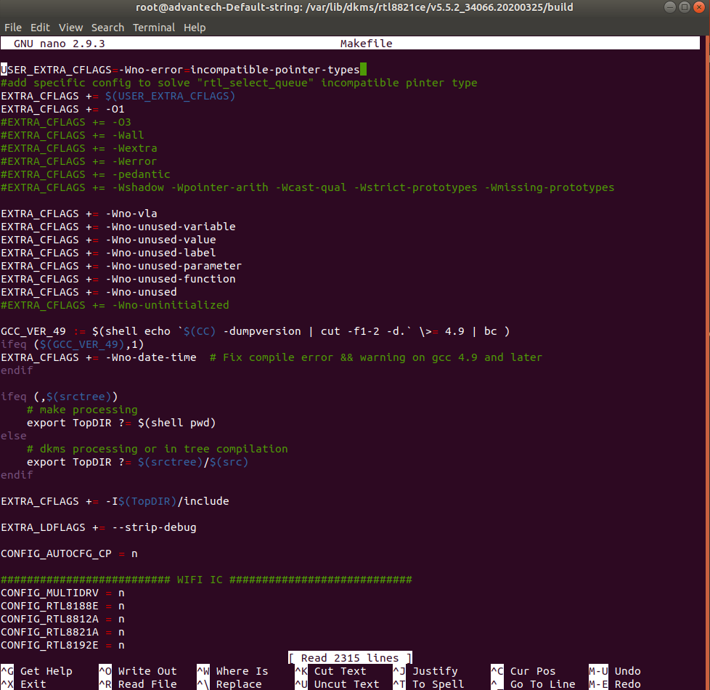
Step 7
Execute“./dkms-install.sh” command again on terminal and ensure the prompt of message “DKMS: install completed”
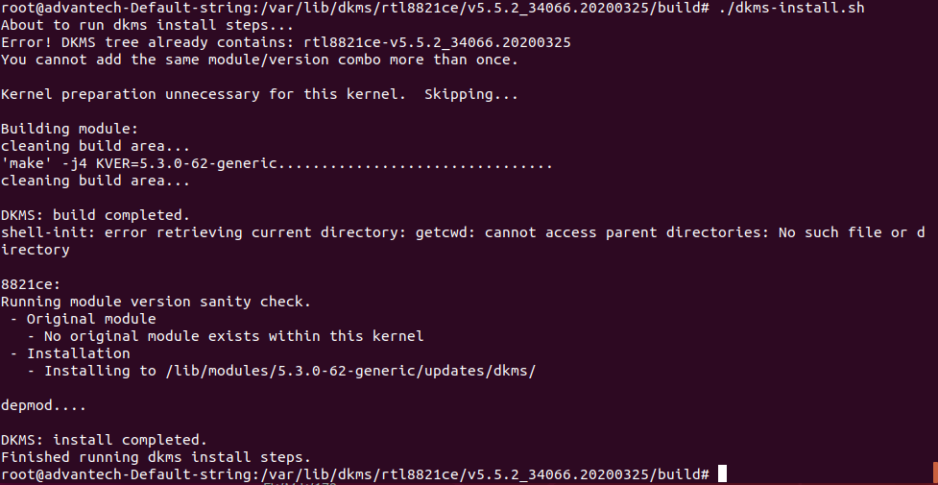
Step 8
After installing, reboot the system and you will see the wifi function is activated on wifi section
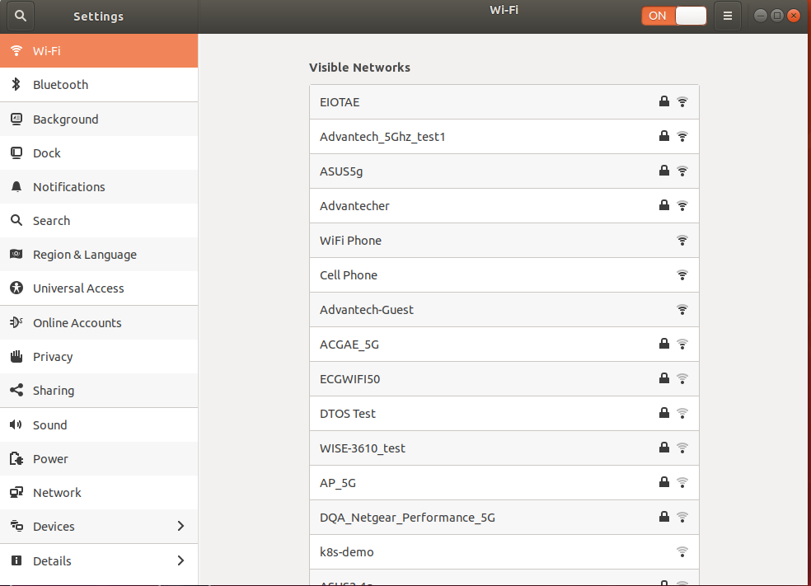
Note: if customer would like to know more detail about this package, please enter following gIthub url to obtain information.
https://github.com/tomaspinho/rtl8821ce

