**How to Setup Network with AIW-356**

**Prerequisite**

* UNO-148 and setup Windows 10 Enterprise LTSC Version 1809 on it
* GNSS passive antenna
* AIW-356 module with the below version

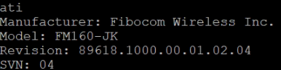

**Install Driver**

* Device driver

Please run the installer “FbUSBDeviceSetup.exe” (version v2.1.2.5) and follow the prompt to install driver.

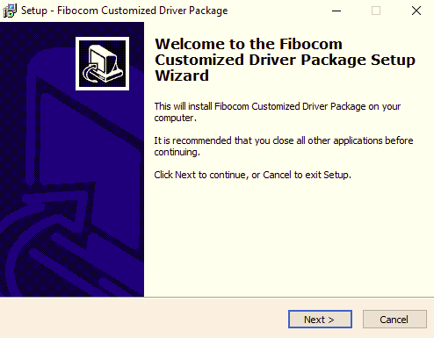

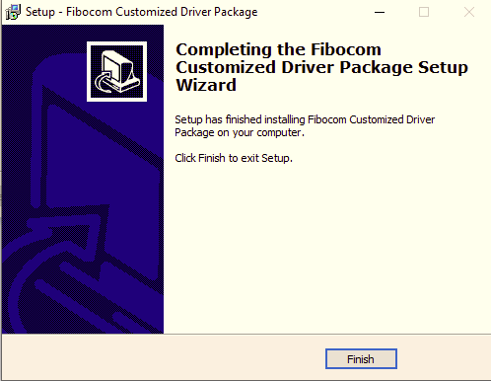

**Check Device**

After driver installed, you will get AT com port number in Device Manager as below.

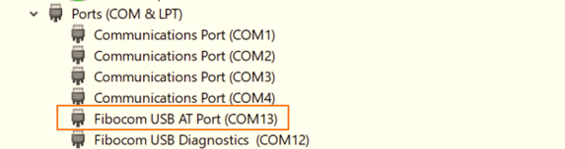

Open terminal to change usbmode to MBIM protocol

* Access to AT command through terminal like putty.

Please make setting as below:

* + Baud Rate “9600”
  + Data bits "8"
  + Stop bits "1"
  + Parity "None"
  + Flow Control "None"
* Check AT command console

# at

After command done, you will get response “OK”.

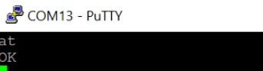

* Set usbmode to MBIM protocol

# at+gtusbmode=30

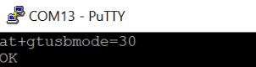

Double check usbmode that is set to 30

# at+gtusbmode?

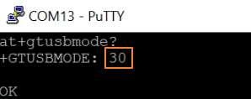

After usbmode is set to MBIM, you will see the “Generic Mobile Broadband Adapter” in Device Manager as below.

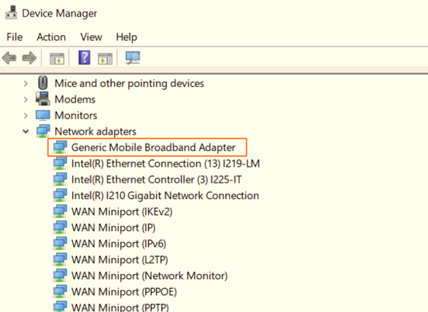

**Function Test**

* Speed test

This is only for reference.

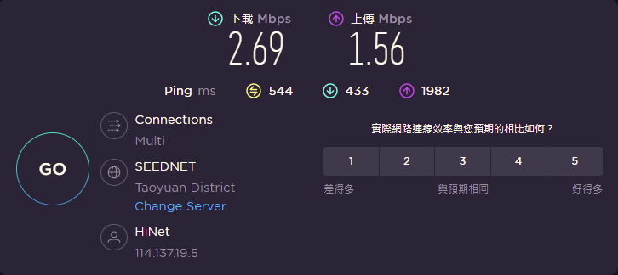

* Reliability

Observe the ping test at least 6 hours.

* GNSS test

Please follow the below commands to input by AT command on the terminal.

Noted that please use passive antenna on AIW-356.

1. Set supl server and port

at+gtagpsserv="supl.qxwz.com",7276

1. Set supl version

at+gtgpscfg=0,1

1. Check the device attach to network

at+cops?



1. Enable AGPS.

at+gtgpsepo=1

1. Start GPS.

at+gtgpspower=1

1. at+gtgps?

Get longitude and latitude by checking NMEA data.

Noted that please waiting for 3 minutes for sync.

