AIW(EWM) FAQ
Category | AIW(EWM) | Date | 2022/04/28
Keyword | AIW-343FQ,sim card not detect

- Question:
How to solve sim card not detection when inserting on external sim card slot with AIW-343FQ?
- Description:
AIW-343FQ supports sim holder at the bottom of module card, but some user is used to inserting sim card on mother board’s original sim holder in their application.
<AIW-343FQ>
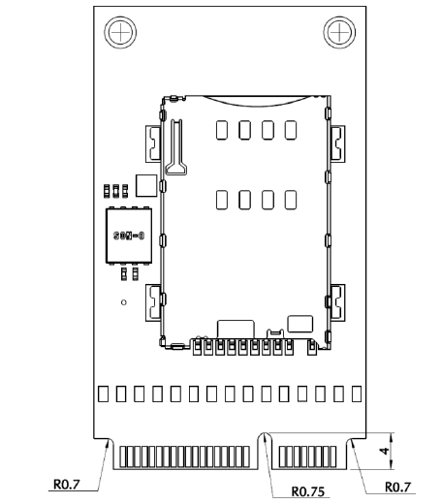

- Instructions :
Step 1
Make sure if your sim card is inserted correctly but the prompt message still show “Insert SIM”
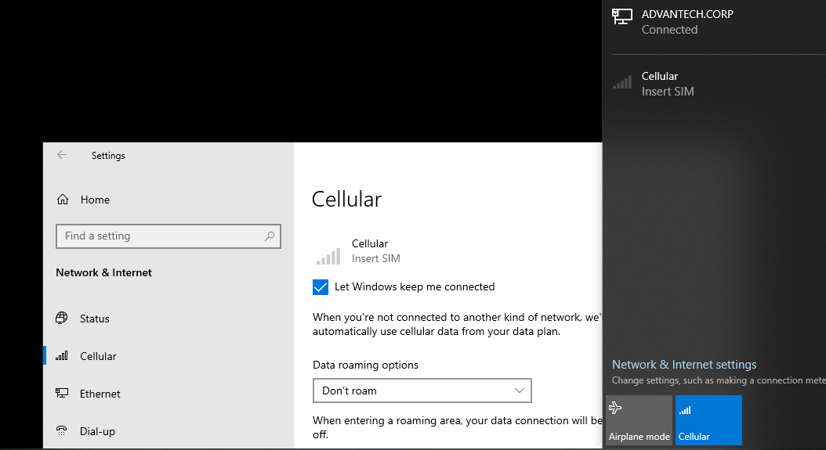
Step 2
Confirm the specific serial port which system assigns
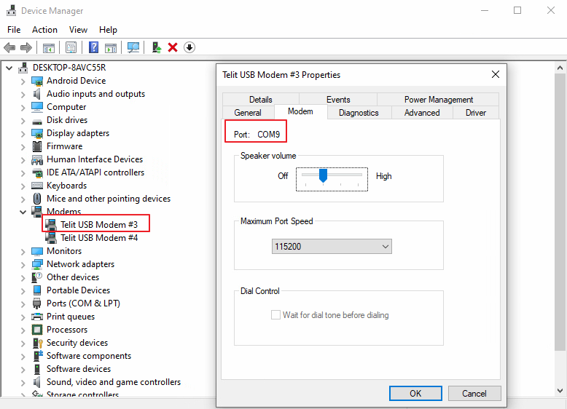

Step 3
Execute putty utility to enter AT command
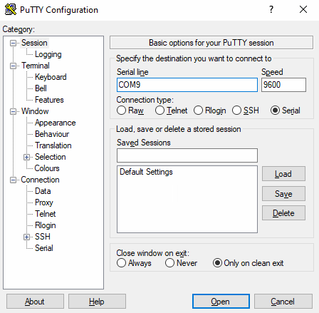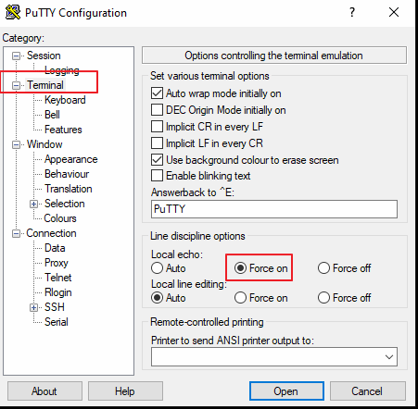
Step 4
Enter following AT commands
- AT#HSEN=0
- AT&W
- AT#REBOOT
Step 5
After setting activating, the sim card can be recognized and the carrier provider will show on the cellular connection
