[AIW-Tool]

NPI with AIW-356

Released Version:V1.0.00
Released Date: 2022.11.30

Advantech Co., Ltd.

Version History
Date | Version | Part no | Remark
2022-11-30 | 1.0.00 | Will Chen | Initial Release

Table of Contents
1. Introduction 4
2. Prerequisites 5
3. Source Tree 6
4. Setup 7
4.1 Setup with AIW-3xx 8
4.2 Setup with AIW-1xx 12
5. AIW Tool 14
5.1 AIW Tool with AIW-3xx 15
5.2 AIW Tool with AIW-1xx 16
5.3 Monitor 17
5.4 Log 17
6. GNSS test 18

Introduction
This document is used for AIW modules. There are two topics we prepare for user included driver and tool. For the driver, the user can learn how to install it to make AIW module ready to work. For the tool, we can use it to communicate with AIW module, and the user can use it to get information form AIW module or set configuration to AIW module.

Prerequisites
Please prepare your platform and install OS on it. The below is the information about that.
- With the module in AIW-3xx series (AIW-356 )：
- OS：Ubuntu 20.04.1 LTS
We expect the user to install Ubuntu 20.04.1 with normal installation. The kernel version is 5.15.0-53-generic.
- Verification on Platform
We have verified the tool and it’s workable on ARK-1250.

- Ethernet
Please make sure the platform has capability to connect to internet by Ethernet during setup procedure. After install Ubuntu OS, it will obtain IP address through DHCP as default.

Source Tree
The user can find out the source tree as below after the file “AiwTool_XXX.tar.bz2” is extracted.
Directory | Description
Aiw-1xx/ | The main folder of Wi-Fi modules
Aiw-3xx/ | The main folder of 3G/4G modules
driver/ | Driver and some scripts for setup
tool/ | Some scripts used for module
template/ | Some templates of scripts
version | The file of version

Setup
The user can find out the script “setup.sh” in the driver folder that can executed to setup and install driver. The “setup.sh” will help user to install some packages, build driver automatically and it provides interactive interface to prompt user what information needed to fill in. We have another script “dialout.sh/connect.sh” in the driver folder. It’s used to establish connection. If setup done and all setting are correct, the module will obtain IP address automatically by “dialout.sh/connect.sh” while system booting. By the way, the user can run “dialout.sh/connect.sh” to establish connection manually and check out whether obtain IP address or not by Linux command “ifconfig’ in Ubuntu.

First please open the terminal on Ubuntu or third party tool such as putty or teraterm that can used to connect to the platform by SSH protocol, then we can run both scripts on terminal.

Setup with AIW-3xx
- Setup
You will see the screenshot as below while you run the command：
$ cd /the_path_to_AiwTool_xxx/Aiw-3xx/driver
$ sudo ./setup.sh
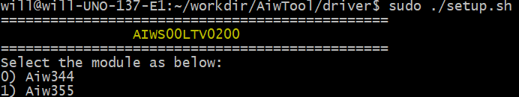
Choose the model name

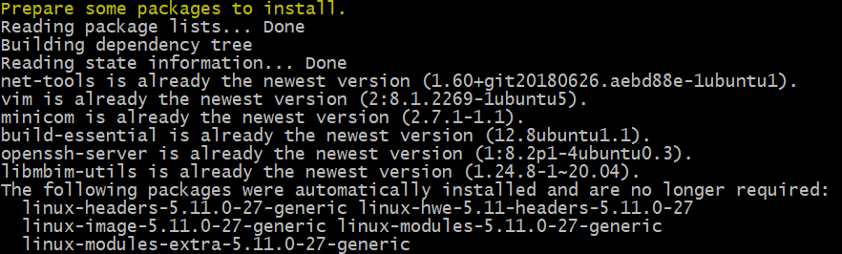
Install some packages

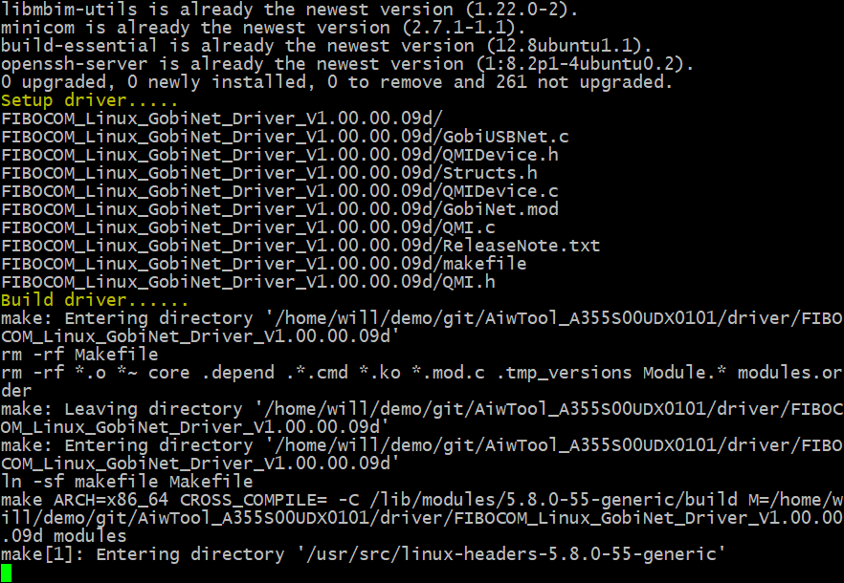
Build driver

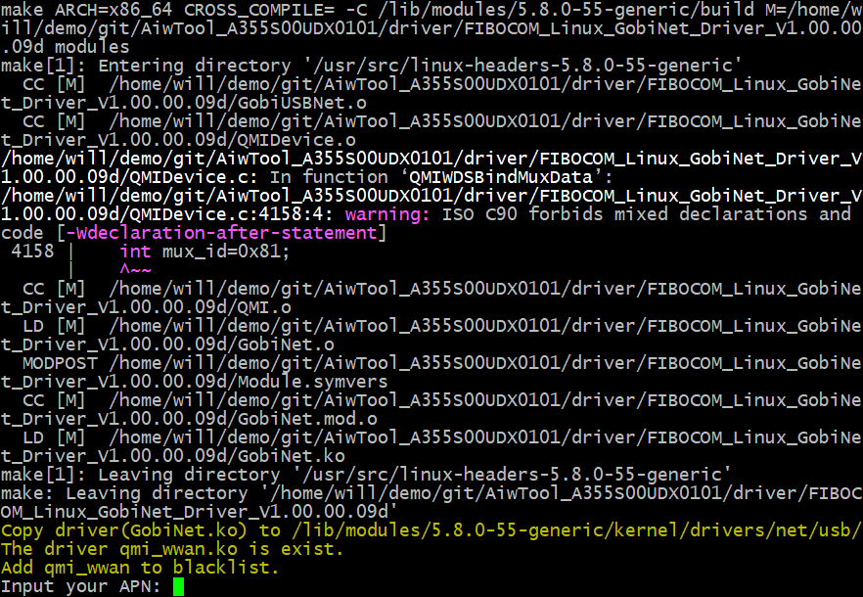
Prompt user to fill in some information

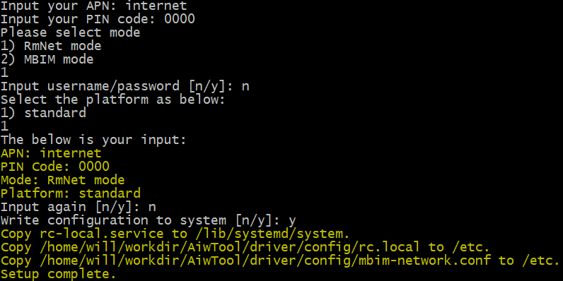
Setup complete

- Remove AIW-Tool
Please note that this function is supported from X0202 and later version. you will see the screenshot as below while you run the command：
$ cd /the_path_to_AiwTool_xxx/Aiw-3xx/driver
$ sudo ./setup.sh clean

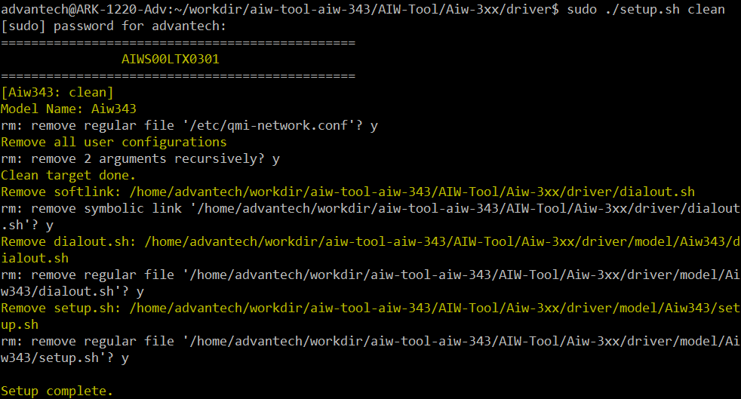
Prompt user to press “y” to delete some files in uninstall procedure.

- Dial out to establish connection
You will see the screenshot as below while you run the command：
$ cd /the_path_to_AiwTool_xxx/Aiw-3xx/driver
$ sudo ./dialout.sh

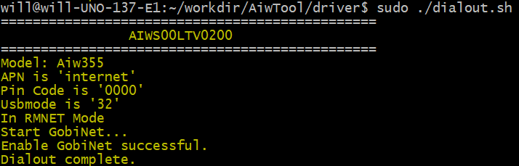
Dial out complete

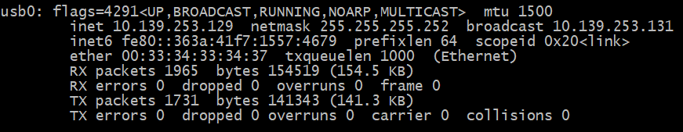
Check IP address by ifconfig

- Disconnection
Please run the command：
$ cd /the_path_to_AiwTool_xxx/Aiw-3xx/driver
$ sudo ./dialout.sh stop

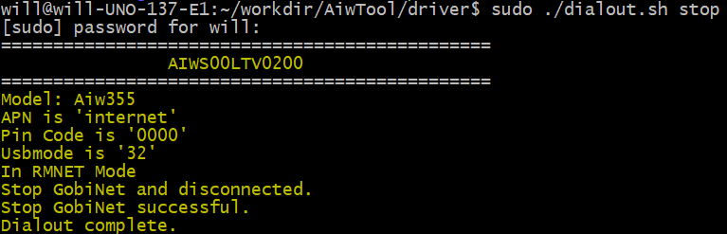
Disconnection complete

Setup with AIW-1xx
- Setup
You will see the screenshot as below while you run the command：
$ cd /the_path_to_AiwTool_xxx/Aiw-1xx/driver
$ sudo ./setup.sh
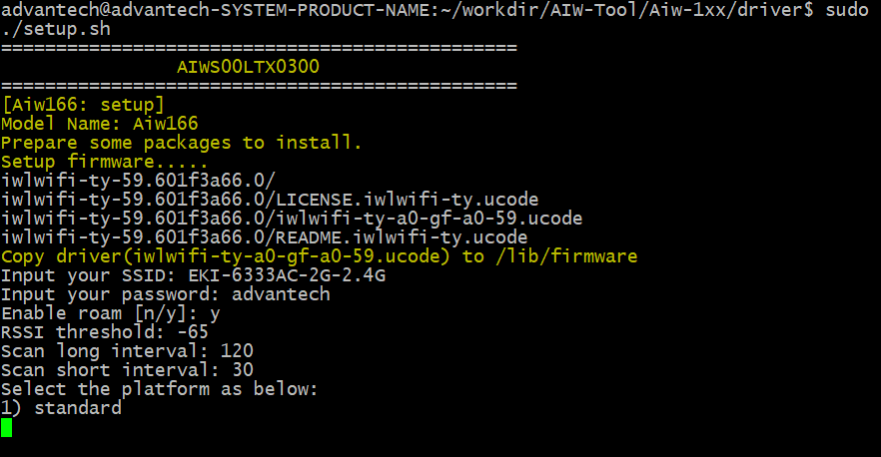
Prompt user to fill in some information

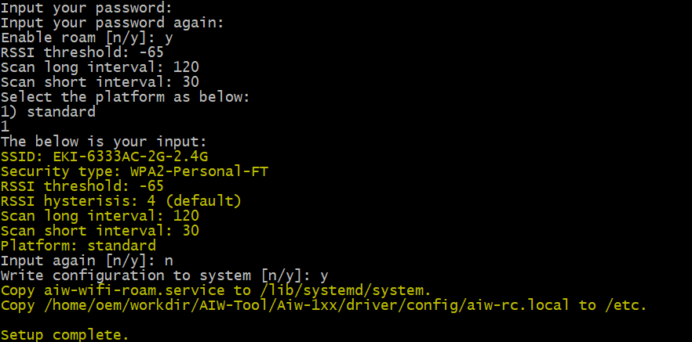
Setup complete

- Establish connection
You will see the screenshot as below while you run the command：
$ cd /the_path_to_AiwTool_xxx/Aiw-1xx/driver
$ sudo ./connect.sh
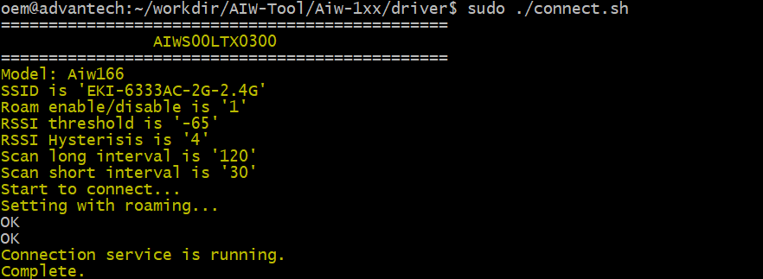
Connection complete

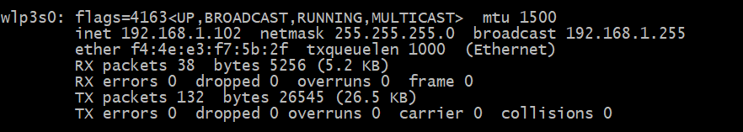
Check IP address by ifconfig

- Disconnection
Please run the command：
$ cd /the_path_to_AiwTool_xxx/Aiw-1xx/driver
$ sudo ./connect.sh stop
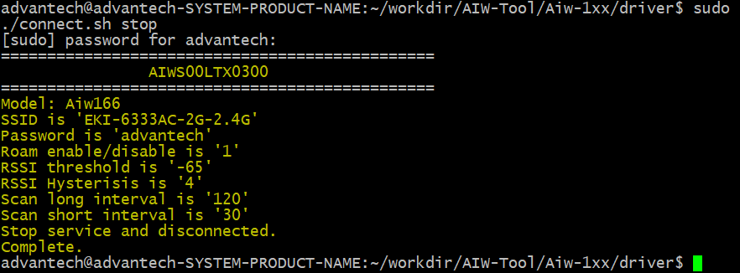
Disconnection complete

AIW Tool
The script “tool.sh” provides command set that has the unified interface to communicate with module. The user can use “tool.sh” to set configuration for connection such as APN, PIN, etc. and get information such as revision, signal strength, etc.

AIW Tool with AIW-3xx
The user can run the command to check out what command are supported：
$ cd /the_path_to_AiwTool_xxx/Aiw-3xx/tool
$ sudo ./tool.sh
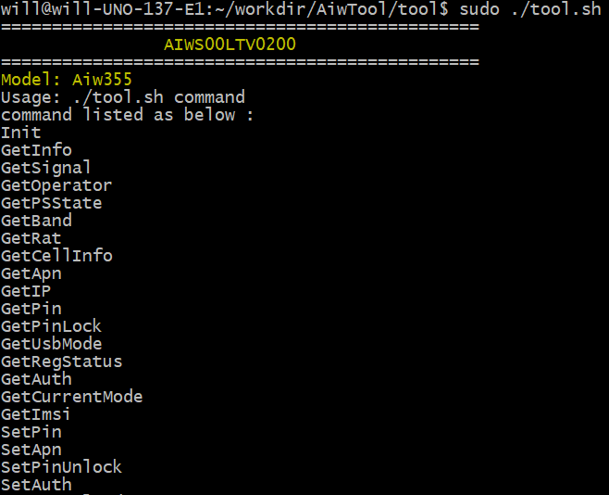

For example, the user can get revision by command “GetInfo”.
$ sudo ./tool.sh GetInfo

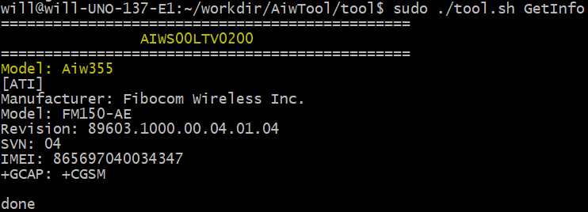

AIW Tool with AIW-1xx
The user can run the command to check out what command are supported：
$ cd /the_path_to_AiwTool_xxx/Aiw-1xx/tool
$ sudo ./tool.sh
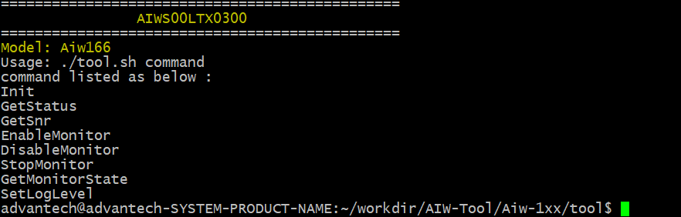

For example, the user can get revision by command “GetInfo”.
$ sudo ./tool.sh GetInfo
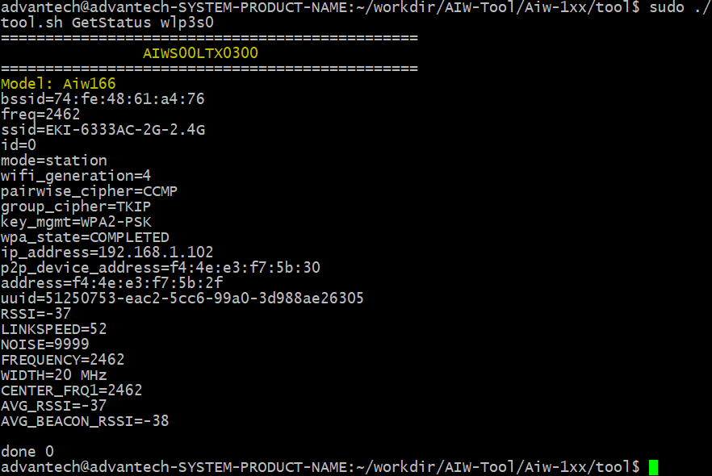

Monitor
The “monitor.sh” in source tree has been running automatically while booting after setup done by “setup.sh”. It aim to check IP address whether is exist or not. If not obtained IP address, it will try to reconnect to telecom and update IP address. The user can refer to below commands for how to control with “monitor.sh”。

- Enable monitor
$ sudo ./tool.sh EnableMonitor

- Disable monitor
$ sudo ./tool.sh DisableMonitor

Log
The user can set log level to decide to enable/disable log. The log file “/tmp/monitor.log” will be outputted when log level greater than 0。

- Set log level
$ sudo ./tool.sh SetLogLevel 1

- Disable log
$ sudo ./tool.sh SetLogLevel 0

GNSS test

6.1 Setting with minicom
- Start to run minicom and select the “Serial port setup”
$ sudo minicom -s
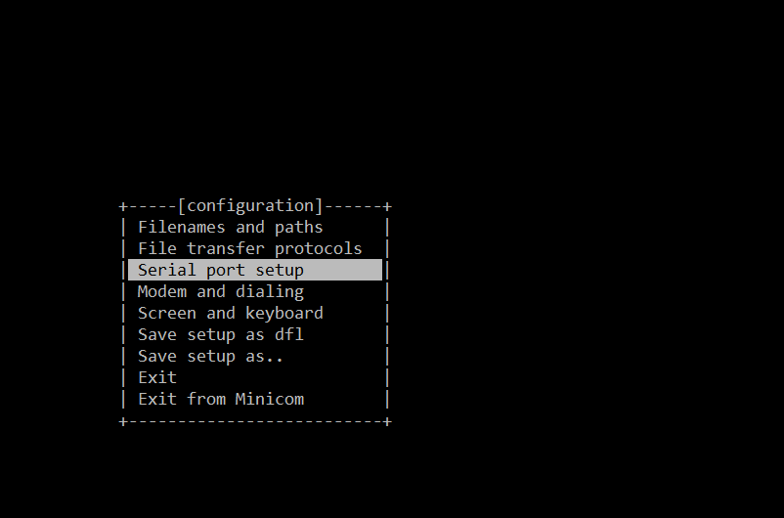
- Please set serial setting as below screenshot.
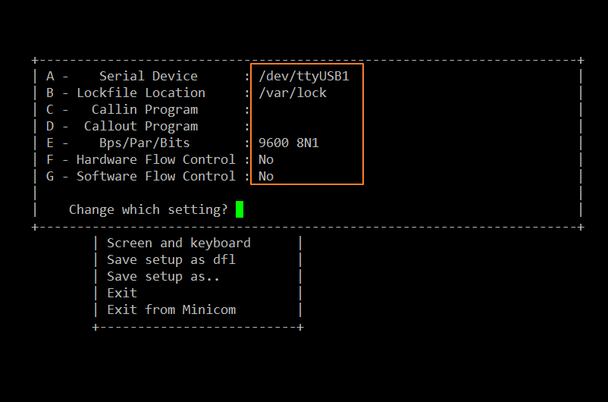
- Exit the setting and get into minicom console.
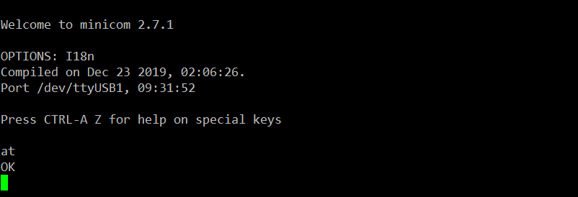

6.2 GNSS test
Please follow the below commands to input by AT command on the terminal.
Noted that please use passive antenna on AIW-356.
- Set supl server and port
at+gtagpsserv="supl.qxwz.com",7276
- Set supl version
at+gtgpscfg=2,14
- Check APN setting, there should be a correct APN
at+cgdcont?
- Check the device attach to network
at+cops?
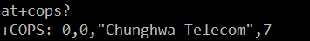
- Enable AGPS.
at+gtgpsepo=1
- Start GPS.
at+gtgpspower=1

