WISE-PaaS FAQ
Category | EPD | Date | 2021/5/12
Keyword | EPD-023, EPD-053, EPD-132, WISE-3240, WISE-1840

- Question:
How to update WISE-3240, WISE-1840 FW and OTA the EPD device FW?

- Steps:

Step 1. When log in the ePaper Manager, click “OTA” and select “Storage”. Then click “edit”.
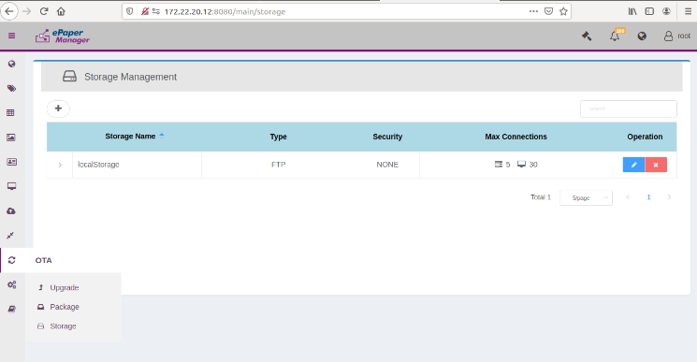
3
2
1
Step 2. Modify the Domain IP as the server IP.
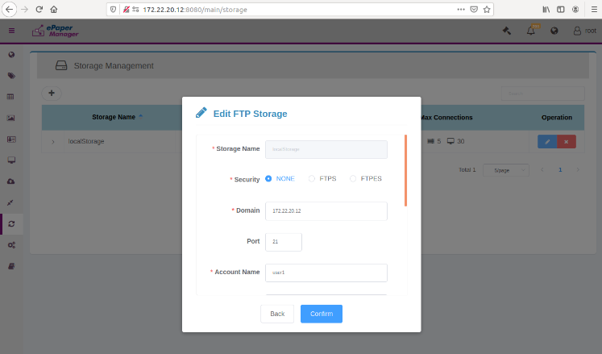
Step 3. Select “OTA” and select “Package”. Then click “Upload”
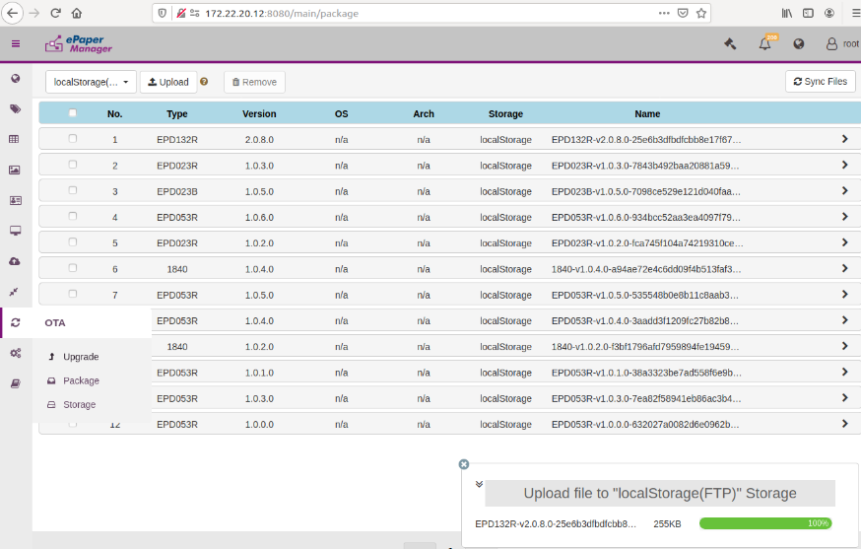
3
2
1

Step 4. Select the FW which you want to upload to ePaper Manager.
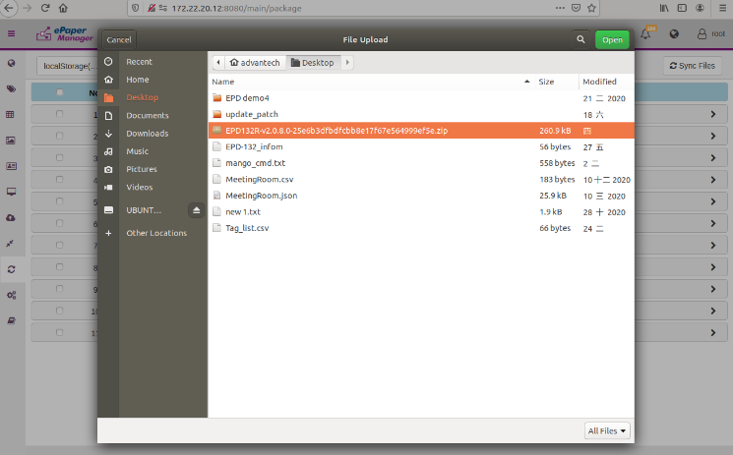
Step 5. Click “OTA” and click “Upgrade”
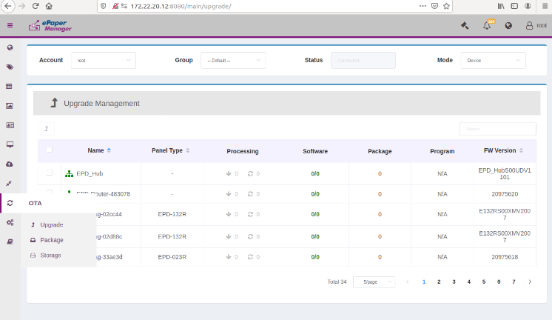
2
1
Step 6. Click the “Device” which you want to do OTA. Click “ “ and select your EPD model. Finally, select the FW version and click “OK”. The OTA will start to do FW upgrade.
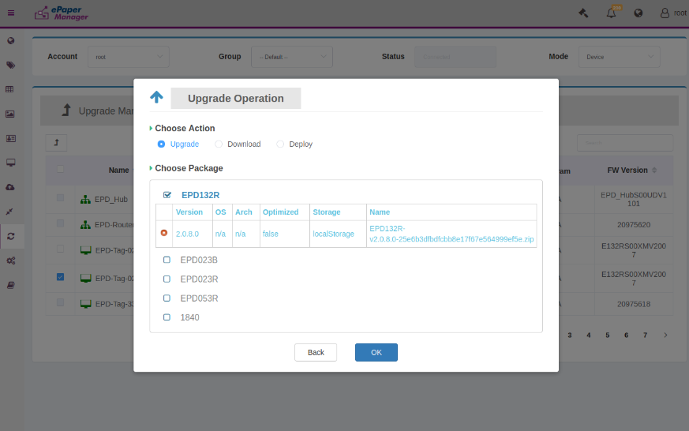
3
2
1

Step 7. Regarding update WISE-1840 FW, you have to upload the FW to the ePaper Manager. It likes Step3 and step4.
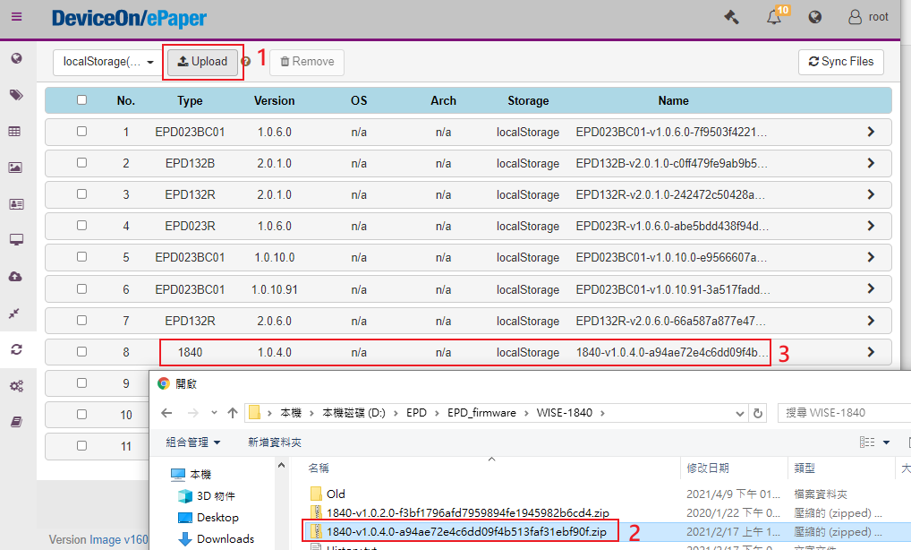
Step 8. Click “OTA” and click “Upgrade”
Step 9. Follow the below steps to select the “router”, the “router” is WISE-1840.
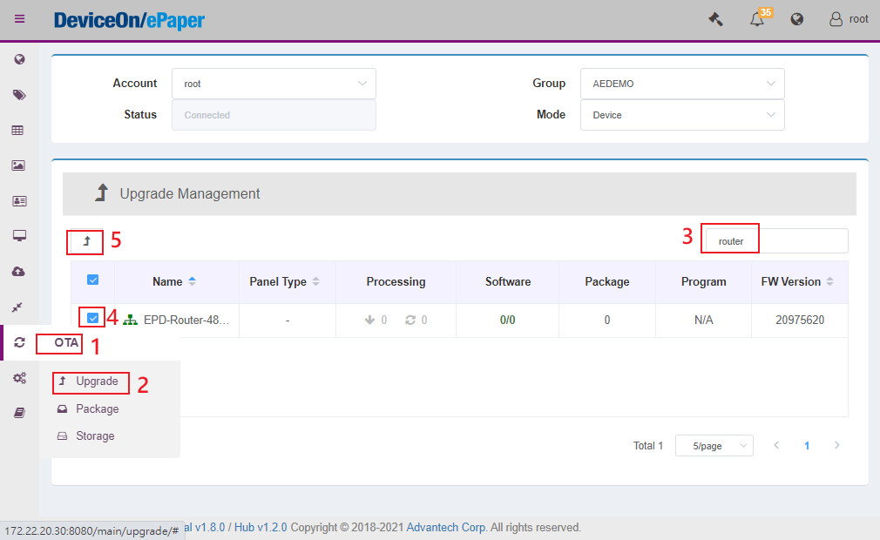
Step 10. Click the “Upgrade” then select 1840 FW. Finally, select the FW version and click “OK”. The OTA will start to do FW upgrade.
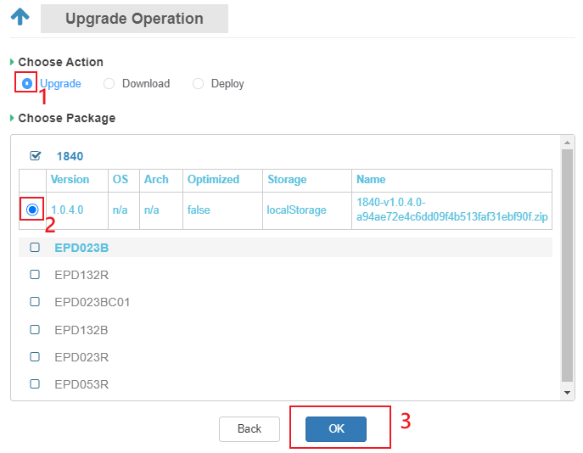

Step 11. Following is start to update WISE-3240 FW. Login the WISE-3240 web. The account is root and the password is ePaper.
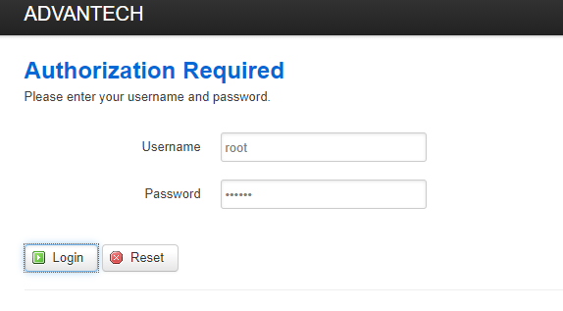

Step 12. Click “System” -> “Backup/Flash Firmware”-> “Select file”-> “Flash image”
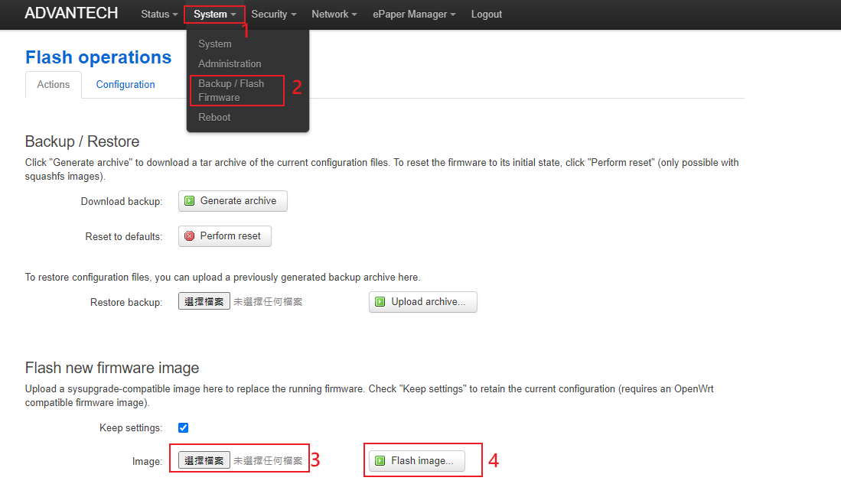
Step 13. When you click Flash image, it will show the check sum value. Please check the check sum first. If the check sum are correct, you can click “Processed”.
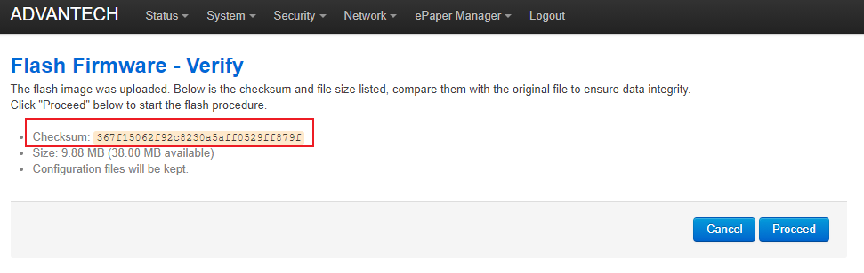
After click “Proceed”, the WISE-3240 will restart. You can check the version in the “Status”-> “Overview”.

