AIW FAQ
Category | ePaper Manager, EPD-230,EPD-332, WISE-3240 | Date | 2021/9/17
Keyword | ePaper Manager, EPD-230, EPD-332, EPD-662, WISE-3240

- Question:
EPD FAQ - How to modify TX power, Channel, status report period and data request period?

- Steps:
In the WISE-3240, you can modify TX power and Channel.
In the EPD-230 and EPD-332, you can modify status report period and data request period.

Step 1: Log in ePaper Manager and click Device list

Step 2: Click “Get/Set” to the configuration web page and select the tag to modify status report period and data request period.
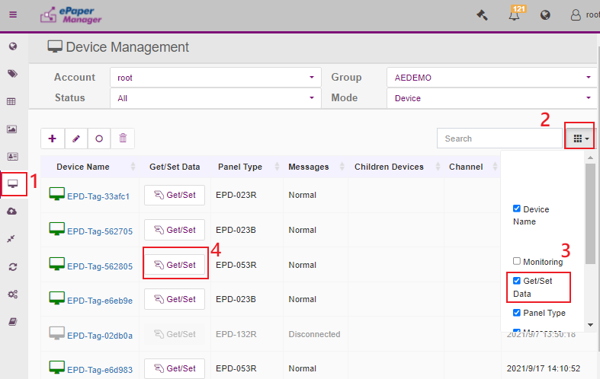

Step 3: Click “SenHub”
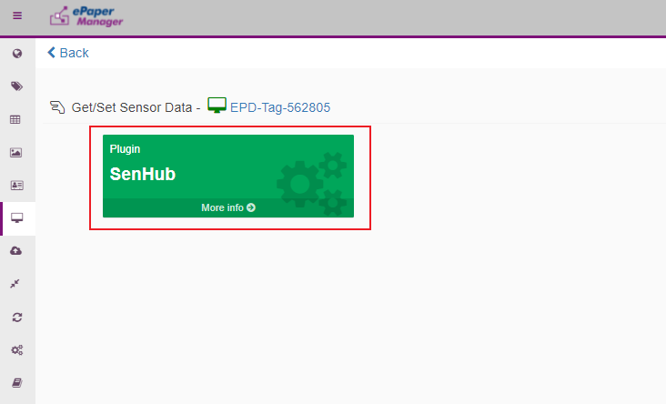

Step 4: Finding “data-request-period” to modify data request period.
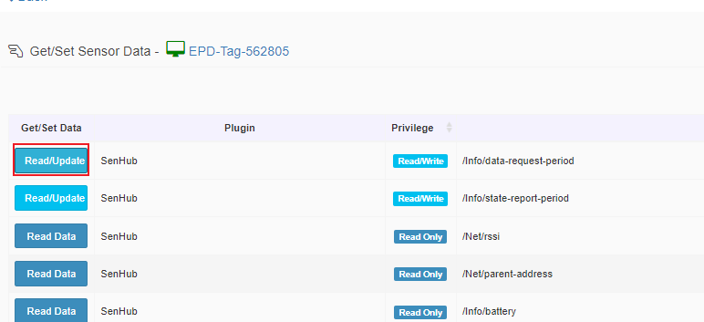
Step 5: Modify the value and the unit is second.
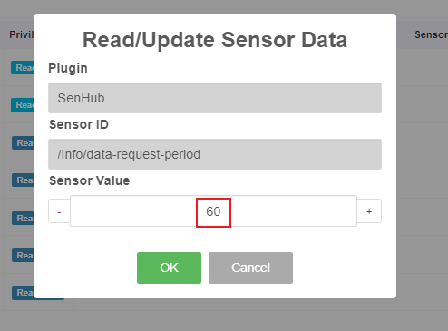

Step 6: Finding “state-report-period” to modify data request period.
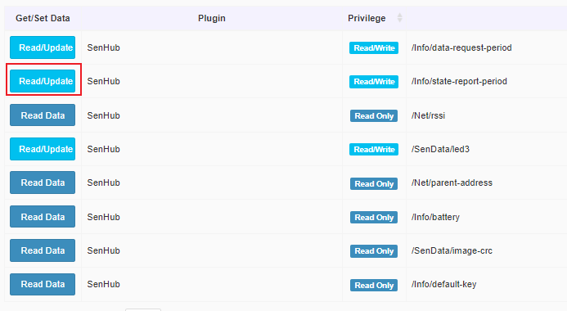
Step 7: Modify the value and the unit is second.
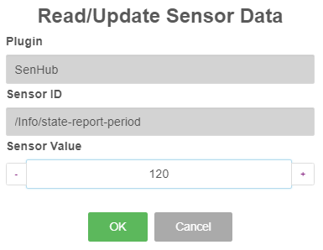

Step 8: Regarding modify TX power and Channel, select router’s “get/set”
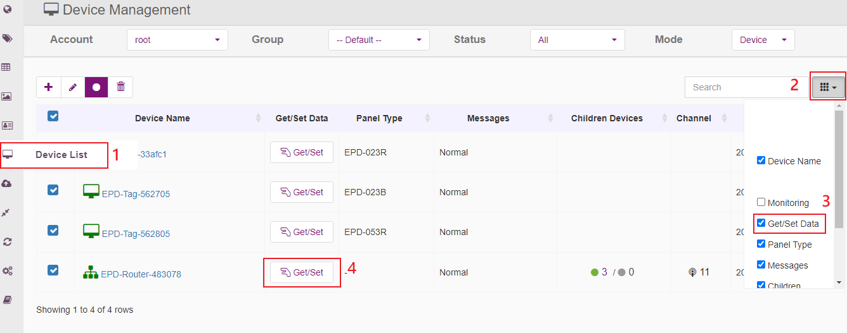

Step 9: Select IoT GW
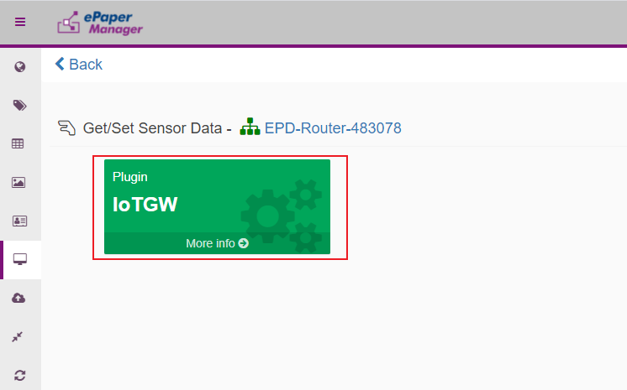
Step 10: Modify TX power, please select “tx-level-r”
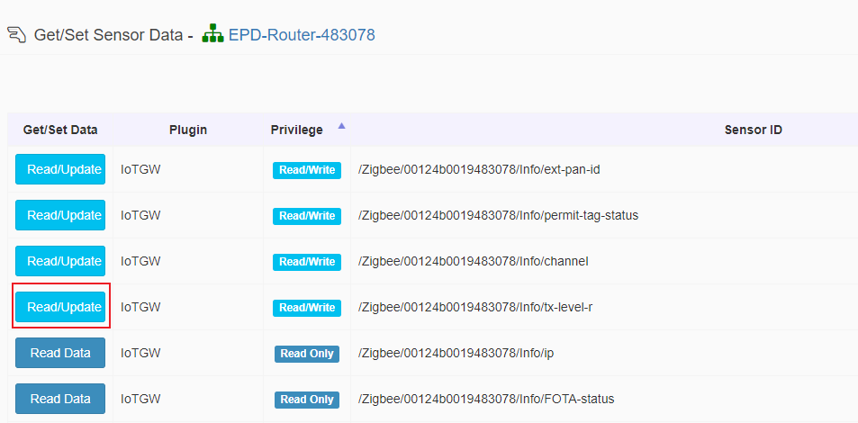
Step 11: Change the value and the unit is dBm.
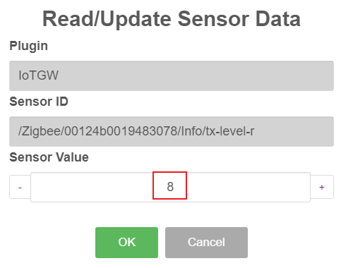
Step 12: Go back to select “Channel”
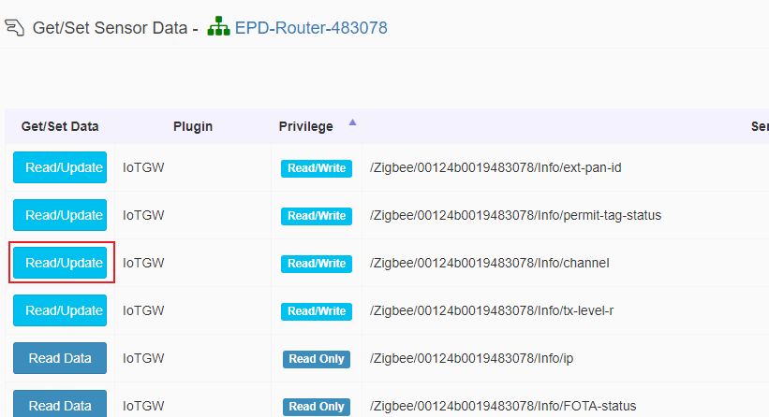
Step 13: You can change the WISE-3240 Channel. Regarding how to select the channel, please reference the other document “EPD Deploy Guide - How to estimate the deployment of ePaper Manager system.pdf”
